
APOSTLESHIP OF MARY HELP OF ORPHANS STATIONS OF THE CROSS

Composed by Kennethmary Ebuka Akachukwu. Founder Apostleship of Mary Help of Orphans)
Opening Prayer (all knees)
ALL: My Lord, Jesus Christ, who’s mercy is endless, You undergone this journey of suffering that leads to Your death for my sake, this journey of agony which no one has ever pass and can never pass through. I beseech You to grant me the strength and heart of pity and love to carry my crosses, which sins of immortality and negligence over the Orphans and less privilege, has caused to weigh me down and journey with You. It was my sins and ungratefulness towards Your redeeming love that kept You on this unmerited condition. I am now ready to journey with You to die with You, and to live with You forever and ever. Amen

FIRST STATION: Pilate condemns Jesus to die

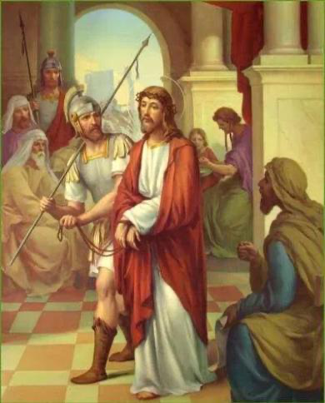

V: We adore You, O Christ, and we praise You. (all Genuflect)
ALL: Because, by Your holy cross, You have redeemed the world.(all Rise)

V: Behold, Jesus Christ, the father to the fatherless, the voice of the voiceless, after being scourged, crowned with thorns, and was unjustly condemned by Pilate to die on the cross.(all kneel)

PRAYER
ALL: My lovable saviour, it was my sins and sins of whole world, which condemned You to die not Pilate. I am sincerely sorry, and implore Your mercy over my lukewarmness attitude, and by the merits of this sorrowful, journey. Let me entirely be consumed by Your love, and at the end, may I dwell with You forever. I promise to return this true love through this wonderful gift which You have given to the mother church, devotion to Your beloved mother, Apostleship Mary Help of Orphans, I pray that all the devotees, may be united as one body, one spirit in Christ, forever and ever Amen.
I love You Jesus more than I love myself, Whole heartedly I repent of ever having offended You never allow me to detach from You again.
Grant that I may love You always; and then do with me whatever You wish. Amen

Our Lord Jesus Christ……………(1)

Hail Virgin Mary Help of Orphans……………..(1)

Adoration to blessed Trinity……………(1)

SONG
Through Her heart, His sorrow sharing,
All His biter anguish bearing,
Now at length the sword has passed,
Jesus our Lord crucified.

SECOND STATION: Jesus Accepts His Cross

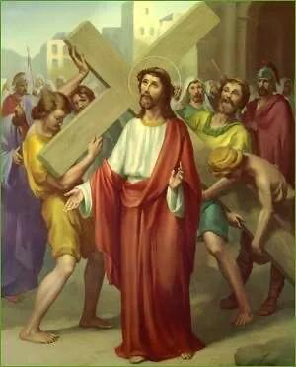

V: We adore You, O Christ, and we praise You. (all Genuflect)
ALL: Because, by Your holy cross, You have redeemed the world.(all Rise)

V: Behold Jesus Christ, the one who carries our burden, as He walked this road with heavy cross on His shoulders, thinking of us and offering to His father for our sake, an unmerited suffering and death which He was willingly accepted.(all kneel)

PRAYER
ALL: My suffering saviour, I pledge wholeheartedly to welcome every sufferings You have destined for me as part of my journey with You till death.
O my most precious saviour, I beseech You to implore Your unfailingly help in carrying my own crosses daily and follow You. May I never go back again to old self, for a day with You is more than a thousand years in the world of sin, I must journey with You forever and ever. Amen
I love You Jesus more than I love myself. Whole heartedly I repent of ever having offended You, never allow me to detach from You again.
Grant that I may love You always; and then do with me whatever You wish. Amen

Our Lord Jesus Christ……………(1)

Hail Virgin Mary Help of Orphans……………..(1)

Adoration to blessed Trinity……………(1)

SONGS
O, how sad and sore distressed,
Was that Mother highly blessed,
Of the sole Begotten one,
Jesus our Lord crucified.

THIRD STATION: Jesus Fall the First Time
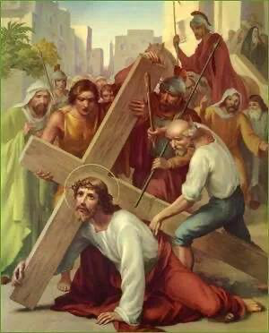

V: We adore You, O Christ, and we praise You.(all Genuflect)
ALL: Because, by Your holy cross, You have redeemed the world.(all Rise)

V: Behold Jesus Christ, who walked on water, He who raised Lazarus from dead, He who walked from binging of the world to the end going about doing good, He who falls for us to rise. At this first falling His physical strength failed Him due to loss of blood from scourging and crowning with thorns had so weakened Him that He could hardly walk; and yet He had to carry that heavy cross upon His shoulders.
As the soldiers struck Him, He fell several times under the weight of the cross.(all kneel)

PRAYER
ALL: Almighty king Lord Jesus Christ, whose kingdom has no end. It is my sins of not answering Your calls to holiness, not following Your commandments which made You suffer so much and fall. By the merits of this first fall, save me from falling into mortal sins, which alone can condemn me to death, save me and save the world forever and ever. Amen
I love You Jesus more than I love myself. Whole heartedly I repent of ever having offended You, never allow me to detach from You again.
Grant that I may love You always; and then do with me whatever You wish. Amen

Our Lord Jesus Christ……………(1)

Hail Virgin Mary Help of Orphans……………..(1)

Adoration to blessed Trinity……………(1)

SONGS
Christ above in torment hangs,
She beneath beholds the pangs,
Of Her dying, glorious Son,
Jesus our Lord crucified.

THE FOURTH STATION: Jesus meets His Afflicted Mother



V: We adore You, O Christ, and we praise You.(all Genuflect)
ALL: Because, by Your holy cross, You have redeemed the world.(all Rise)

V: Behold Jesus Christ, the lover the poor. See how the Son met His Mother on His way to Calvary. Jesus Christ and Mary Help of Orphans gazed at each other and their faces seemed like so many arrows to wound those hearts which loved each other so uniquely.(all kneel)

PRAYER
ALL: My Lord Jesus Christ, since it pleases You to endure this suffering and pain for my sake, at this meeting grant me the grace to atone for my sins, and sincerely devoted to Mary Help of Orphans Your Mother and my Mother, who was overwhelmed with sorrow, grant me by Your prayers a true and lasting remembrance of the passion of Your only Son forever and ever. Amen
I love You Jesus more than I love myself. Whole heartedly I repent of ever having offended You, never allow me to detach from You again.
Grant that I may love You always; and then do with me whatever You wish. Amen

Our Lord Jesus Christ……………(1)

Hail Virgin Mary Help of Orphans……………..(1)

Adoration to blessed Trinity……………(1)

SONGS
Is there one who would not weep,
‘Whelmed in miseries so deep,
Christ’s dear Mother to behold,
Jesus our Lord crucified.

FIFTH STATION: Simon Help Jesus Carry His Cross
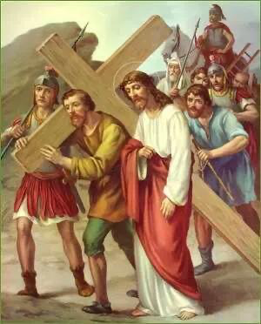

V: We adore You, O Christ, and we praise You.(all Genuflect)
ALL: Because, by Your holy cross, You have redeemed the world.(all Rise)

V: Behold Jesus Christ, the mighty healer, who carries all our diseases and infirmities, the one who heals without costs. As He journeyed with heavy cross which The weight are our sins the more He walk the more He is physically weak and weary. And was fearing that He would die on the way when they wish Him to die the infamous death of the cross, they forced Simon of Cyrene to help carry the cross after our Lord and saviour.(all kneel)

PRAYER
ALL: O mighty defender of Israel, my hope of life, who never rejects me even due sinful I am, I will never refuse to assist You in carrying the cross as Simon did: I will accept it and embrace it. I accept every single death You destined for me and all pains that may accompany it. I unite it to Your death and offer it to You. You died for love of me, I shall die in loving You, help me always to prepare for happy death, so to live with You forever and ever. Amen
I love You Jesus more than I love myself. Whole heartedly I repent of ever having offended You, never allow me to detach from You again.
Grant that I may love You always; and then do with me whatever You wish Amen.

Our Lord Jesus Christ……………(1)

Hail Virgin Mary Help of Orphans……………..(1)

Adoration to blessed Trinity……………(1)

SONGS
Can the human heart refrain,
From partaking in Her pain,
In that Mother’s pain untold?
Jesus our Lord crucified.

SIXTH STATION: Veronica offers Her veil to Jesus
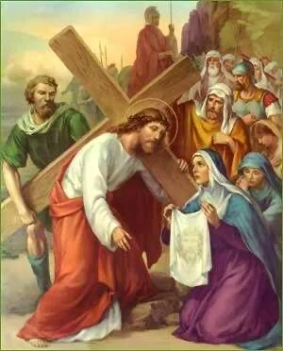

V: We adore You, O Christ, and we praise You.(all Genuflect)
ALL: Because, by Your holy cross, You have redeemed the world.(all Rise)

V: Behold Jesus Christ, Our Lord, whose face at mount Tabor, Peter, James and John during transfiguration couldn’t behold, the same face which great Moses couldn’t behold at mount Sinai, was now bathed with sweat and blood due to our sins. Veronica was moved with pity, she offered Her veil to wiped the tears and blood from the face of our Lord and left upon the cloth the image of His sacred countenance.(all kneel)

PRAYER
ALL: Lord Jesus Christ, only begotten Son of the Father, Your face was beautiful before You began this sorrowful journey; but now, it no longer appears beautiful as it was at mount Sinai and mount Tabor. This beautiful face was disfigured with wounds and blood. Alas, my soul was once beautiful when it received Your grace in Baptisms; but now sins have disfigured it, I am no longer seeking for face of the world, rather I am seeking for Your face. I beg you to Redeem my soul and restore my faces to its former beauty by the merits of Your passion forever and ever. Amen
I love You Jesus more than I love myself. Whole heartedly I repent of ever having offended You, never allow me to detach from You again.
Grant that I may love You always; and then do with me whatever You wish. Amen

Our Lord Jesus Christ……………(1)

Hail Virgin Mary Help of Orphans……………..(1)

Adoration to blessed Trinity……………(1)

SONGS
Bruised, derided, cursed, defiled,
She beheld, Her tender child,
All with bloody scourges rent,
Jesus our Lord crucified.

SEVENTH STATION: Jesus Falls the Second Time
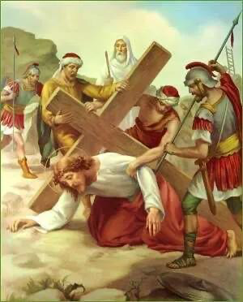

V: We adore You, O Christ, and we praise You.(all Genuflect)
ALL: Because, by Your holy cross, You have redeemed the world.(all Rise)

V: Behold the Son of God, who committed no crimes, how He fall under His cross renews the pains in all the wounds it started again bleeding seamlessly from head to other members of the wounds.(all kneel)

PRAYER
ALL: My Humble saviour, Jesus Christ, uncountably I have been fallen into sins and uncountably You have been forgiven me, I was born in sin and redeemed by Your blood through Baptism, help me I beseech You by the merits of this second fall grant me Your Holy Spirit to persevere, to rise from my old state of slumber and fallen into mortal sins, to state of Holiness and newness to serve You faithfully forever and ever. Amen
I love You Jesus more than I love myself. Whole heartedly I repent of ever having offended You, never allow me to detach from You again.
Grant that I may love You always; and then do with me whatever You wish. Amen

Our Lord Jesus Christ……………(1)

Hail Virgin Mary Help of Orphans……………..(1)

Adoration to blessed Trinity……………(1)

SONGS
For the sins of His own nation,
Saw Him hang in desolation,
Till His spirit forth He sent,
Jesus our Lord crucified.

EIGHTH STATION: Jesus Speaks to the Woman

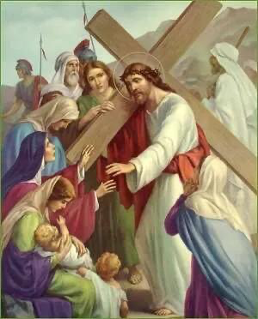

V: We adore You, O Christ, and we praise You.(all Genuflect)
ALL: Because, by Your holy cross, You have redeemed the world.(all Rise)

V: Behold Jesus Christ, as He moved with compassion to speak, on seeing the women
weeping emotionally at their meeting with Him. Jesus distressed and dripping with blood as
He walked through caused them to wept. Jesus said to them, “weep not so much for Me, but rather for Your children, and Your children, children.”(all kneel)
PRAYER
ALL: My Lord Jesus Christ, I am weeping for the sins I committed against You, for neglecting Your presence in Holy Eucharist, for breaking Your heart, for the punishment attached to every of my sins, for displeasure of my sins have caused You, but in return You still love me deeply. It is Your love, more than the fear of hell, which makes me weep for my sins. Grant me shears in Your suffering so to live with You forever and ever. Amen
I love You Jesus more than I love myself. Whole heartedly I repent of ever having offended You, never allow me to detach from You again.
Grant that I may love You always; and then do with me whatever You wish. Amen

Our Lord Jesus Christ……………(1)

Hail Virgin Mary Help of Orphans……………..(1)

Adoration to blessed Trinity……………(1)

SONGS
O sweet Mother! Fount of Love,
Touch my spirit from above,
Makes my heart with Yours accord,
Jesus our Lord crucified.

NINTH STATION: Jesus Falls the Third Time
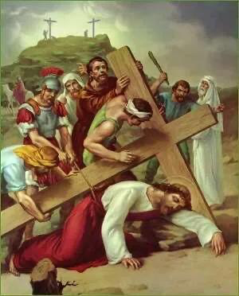

V: We adore You , O Christ, and we praise You.(all Genuflect)
ALL: Because, by Your holy cross, You have redeemed the world.(all Rise)

V: Behold Jesus Christ, the mighty Man who left His throne in Heaven, denied Himself His divine nature, and come down on earth to make peace with man. At this third fallen His physical strength disappointed Him. His executioner was excessive; they tried hasten His steps even though He hardly had strength to move. (all kneel)

PRAYER
ALL: Lord Jesus Christ, You were tempted and unjustly condemned for my sake, please pardon me, pardon Your church, and let Your Holy Spirit take over my heart. In human form You embrace the suffering and experience human weakness on Your way to cavalry. I am willingly now to consecrate myself under this devotion, Apostleship of Mary Help of Orphans, Your spirit to honour Your Mother, and the strength to overcome all human weaknesses, and all my evil desires which have led me to neglect Your call to holiness, forever and ever. Amen
I love You Jesus more than I love myself. Whole heartedly I repent of ever having offended You, never allow me to detach from You again.
Grant that I may love You always; and then do with me whatever You wish. Amen

Our Lord Jesus Christ……………(1)

Hail Virgin Mary Help of Orphans……………..(1)

Adoration to blessed Trinity……………(1)

SONGS
Make me feel as Thou have felt,
Make my soul to glow and melt,
With the love of Christ, my Lord,
Jesus our Lord crucified.

TENTH STATION: Jesus stripped of His Garments

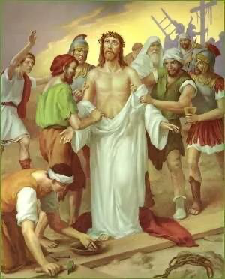

V: Weadore You, O Christ, and we praise You.(all Genuflect)
ALL: Because, by Your holy cross, You have redeemed the world.(all Rise)

V: Behold Jesus Christ our Lord, one who feed five thousand men with two fish’s and five bread, and has twelve full of baskets broken left over. He feeds the Hungry, raised the dead and clothed the naked, was now publicly, violently stripped of His clothes by His executioners. The inner garment adhered to His lacerated flesh and the soldiers tore them off roughly that the skin came with them. O merciful Lord grant us pardon for our sins. (all kneel)

PRAYER
ALL: O Lord Jesus Christ, who transcends to the land of death and conquered. You who are naked for me to be clothed, you who are wounded for me to be healed, you who carried my burdens for me to be free. Son of Mary and only begotten Son of God, help me to strip myself of sin of immoralities and all attachments for the things of earth, that I may be pure total totalitarian, to place my love in You, who are so worthy of my love forever and ever. Amen
I love You Jesus more than I love myself. Whole heartedly I repent of ever having offended You, never allow me to detach from You again.
Grant that I may love You always; and then do with me whatever You wish. Amen

Our Lord Jesus Christ……………(1)

Hail Virgin Mary Help of Orphans……………..(1)

Adoration to blessed Trinity……………(1)

SONGS
Holy Mother, pierce me through,
In my heart each wound renew,
Of my saviour crucified,
Jesus our Lord crucified.

ELEVENTH STATION: Jesus Is Nailed to the Cross

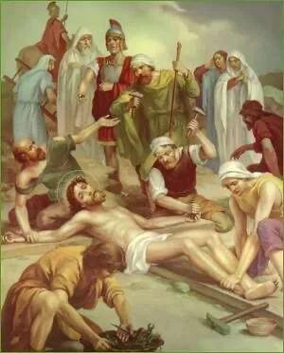

V: We adore You, O Christ, and we praise You.(all Genuflect)
ALL: Because, by Your holy cross, You have redeemed the world.(all Rise)

V: Behold the king of kings, and Lord of lords, the only one that has the key to my destiny, the one who reigned forever, the supreme majesty, the meta physical God, the unmoved mover. It is my sins that kept You on this agony, You stretched out Your arms and offered to eternal Father the sacrifice of Your life for my redemption. Your hands and feet were nailed on the cross, and Your glorious body left to die in sorrow. (all kneel )

PRAYER
O’ mighty defender of Isreal, all the devotees of Apostleship of Mary Help of Orphans all over the world, are atoning for our sins and imploring thy aid to never let us go astray. As You nailed on cross, please Lord Jesus, nails my sinful nature, my ingratitude, and my negligence towards Your redeeming love, on that wood of the cross so my hearts may found joy and remain with You forever and ever Amen.
I love you Jesus more than I love myself. Whole heartedly I repent of ever having offended You, never allow me to detach from You vvagain.
Grant that I may love You always; and then do with me whatever You wish. Amen

Our Lord Jesus Christ……………(1)

Hail Virgin Mary Help of Orphans……………..(1)

Adoration to blessed Trinity……………(1)

SONGS
Let me share with You His pain,
Who for all our sins was slain,
Who for me in torments died,
Jesus our Lord is crucified.

TWELFTH STATION: Jesus Dies Upon the Cross
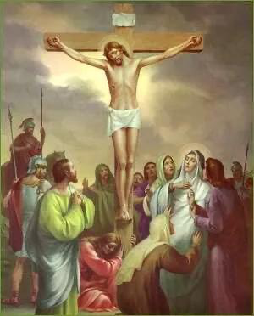

V: We adore You, O Christ, and we praise You.(all Genuflect)
ALL: Because, by Your holy cross, You have redeemed the world.(all Rise)

V: Behold Jesus Christ, the life given God, as He exhausted after three hours of agony on the cross, finally He overwhelmed with suffering, and abandoning Himself to the weight of His body, this road of agony which no one has ever gone through, and no one can ever gone through. The death of the cross He died for us to live, taking penalty of our iniquities, His physical strength fails Him, and He bow His head and dies. (all kneel)

PRAYER
O’ My dying saviour, I entrust my sacrifice and prayers, my ten decades of Mary help of Orphans Rosary, my nine days monthly Novena, my thirty three days consecration classes, my every Thursday Gethsemane night, I offer them to You, use them as source of conversion to the whole world. I deserve to die a shameful death, but You have paid the price, I promise to suffer with You on earth, so to gain eternal happiness, may Your Mother intercede for me forever and ever. Amen
I love You Jesus more than I love myself. Whole heartedly I repent of ever having offended You, never allow me to detach from You again.
Grant that I may love You always; and then do with me whatever You wish. Amen

Our Lord Jesus Christ……………(1)

Hail Virgin Mary Help of Orphans……………..(1)

Adoration to blessed Trinity……………(1)

SONGS
Let me mingle tears with thee,
Mourning Him who mourned for me,
All the days that I may live,
Jesus our Lord is crucified.

THIRTEENTH STATION: Jesus Is Taken Down From the Cross

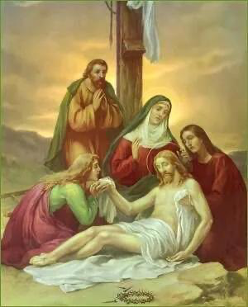

V: We adore You, O Christ, and we praise You.(all Genuflect)
ALL: Because, by Your holy cross, You have redeemed the world.(all Rise)

V: Behold Jesus Christ the light of the world, the peace maker and wonder working God, He who died for our sake, as He was taken down from the cross by two of His disciples, Joseph and Nicodemus, and placed in the arms of His afflicted Mother. She accepted Him as She accepted Him before She was conceived, through the message of an angel, She carried Him as she one’s carried Him in Her divine womb.(all kneel)

PRAYER
O’ my Mother, Mary Help of Orphans, for the sake of Your love to Your Son our Lord Jesus Christ, accept me as Your servant and pray for me to conquered, to place my trust in Your care. Grant me the strength and heart to love You more forever and ever Amen.
I love You Jesus more than I love myself. Whole heartedly I repent of ever having offended You, never allow me to detach from You again.
Grant that I may love You always; and then do with me whatever You wish. Amen

Our Lord Jesus Christ……………(1)

Hail Virgin Mary Help of Orphans……………..(1)

Adoration to blessed Trinity……………(1)

SONGS
By the cross with You to stay,
There with You to weep and pray,
Is all I ask of You to give,
Jesus our Lord is crucified.

FOURTEENTH STATION: Jesus Is Placed in the Sepulcher
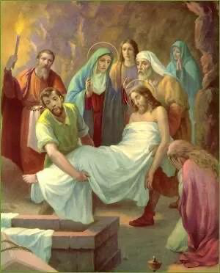

V: We adore You, O Christ, and we praise You.(all Genuflect)
ALL: Because, by Your holy cross, You have redeemed the world.(all Rise)

V: Behold Jesus Christ, who died and rise after three days, as the God of living and death. See how the disciples carried His body to it’s burial, while His adorable Mother went with them and arranged the Sepulcher by Herself. They then closed the tomb and all departed. (all nailed)

PRAYER
O’ Lord Jesus Christ, whose Only begotten Son descended to the realm of the dead, and rose from there to glory, grant that all the souls of the faithful departed, who were buried with Him in Baptism, may by His resurrection, obtain eternal life. I beseech You to grant me share in Your death and resurrection, that I may gloriously on last day be united with You in heaven my eternal reward forever and ever. Amen
I love You Jesus more than I love myself. Whole heartedly I repent of ever having offended You, never allow me to detach from You again.
Grant that I may love You always; and then do with me whatever You wish. Amen

Our Lord Jesus Christ……………(1)

Hail Virgin Mary Help of Orphans……………..(1)

Adoration to blessed Trinity……………(1)

SONGS
Virgin of all virgins blest!
Listen to my fond request ,
Let me share Your grief divine,
Jesus our Lord is crucified.

CONCLUDING PRAYER (all kneel)
My adorable Jesus Christ, the word made flesh and dwell among men. I kneel before Your throne of mercy, I surrender my innermost being body and soul to You, I empty myself beseech You to filled me with Your strength. I reunite myself again with You, my life is meaningless without You, my soul is restless until it rests in You. What is it that can separate me from Your love, is it love of money, is it lost of flesh, is it love for materialism, is it power and authority, in all I am more than conquerors. My old self has died and buried with You, grant me share in Your kingdom my eternal reward forever and ever. Amen

For the intention of the Holy Father
Our Lord Jesus Christ……………(1)
Hail Virgin Mary Help of Orphans……………..(1)
Adoration to blessed Trinity……………(1)

