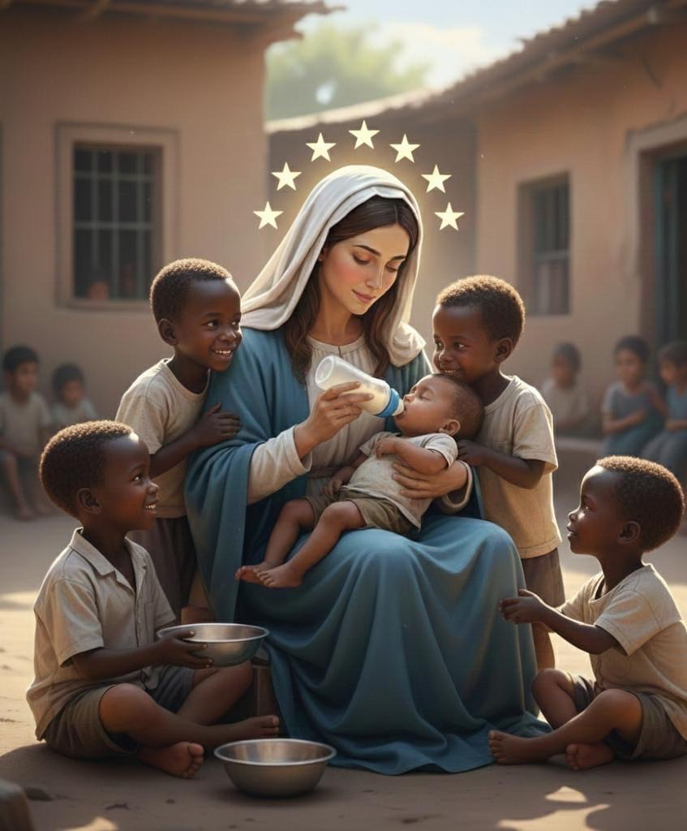
INTRODUCTION
Apostleship of Mary Help of Orphans (AMHO) is an International Roman Catholic charitable mission and devotional prayer group, among many other Marian devotions. It started when I, KENNETHMARY EBUKA AKACHUKWU the founder, received a divine call to establish mission to care for Orphans at age of (24) in 200 level of microbiology. On 31 May 2017. God appear to me during my usual Wednesday evening silent moment with the Lord at hour of 5pm, at chapel of adoration, at osisatech polytechnic (chaplaincy owo campus Nkanu East L.G.A Enugu state Nigeria) on that vision God showed me multitudes of Children and Orphans crying for help and He ask me to lead them that He is going to protect me. I observed the prayer privately till five years while composing the prayer resources, after completing the first edition I traveled to my home town and gathered children at grotto of our our Lady at St Mary Catholic Church Ihuokpara my home Town, after mass on Sun-21-Nov-2021, the feast day of presentation of the Blessed Virgin Mary. The second place was at Lokoja diocese, Sacred Heart parish kabba during my youth service (NYSC) at St John Catholic hospital kabba, with only four members, later move to St Paul Catholic Church korede quarters kabba. The devotion has spread throughout Lokoja diocese and other dioceses in Nigeria and abroad. Four categories of membership, are consecrated members, non consecrated members, active and auxiliary members. Two pillars of this devotion are Corporal works of mercy (practically cares for Orphans and widows) and Spiritual works of mercy (praying for Orphans and widows with all our prayer resources).

• OUR LOGO: By inspiration of the Holy Ghost, and the founder as a
vessel, this logo came to being and was designed by Mr SAMUEL ADEMOLA AIDOO. A friend of Mary Help of Orphans. The seven (7) Stars round our Lady head symbolize seven gifts of the Holy Spirit. The four children by the two sides and little baby She is feeding represent Orphans and motherless babies. One of the child at Her right is holding bowel containing water for our Lady to clean up the baby after feeding. Those children’s are black, which means that Mother Mary loves us and ever ready to be the Help of Orphans.
•OUR MOTOR: GOD’S SERVICE TO HUMANITY. (James 1:27, John 2:5, Matthew 25:40)
• OUR SLOGAN: Our Lady Mary Help of Orphans…….(R) Pray for us and of the whole world Amen.
- OUR COLOUR: Navy blue and white. Navy blue symbolises Authority, trust and stability while white symbolises purity, innocence, spirituality and light, holiness and new beginning.
- MEMBERSHIP IDENTIFICATION:
1.Our uniform Shall be Navy-blue and white. Ladies shall put on,Navy-blue skirt on white T-shirt and veils with our logo printed at back, Navy-blue and white round the front.and Men’s shall put on Navy-blue trousers on white T-shirt.
2. Only the executives are allowed to put on medium sashe with our logo on it, but only the heads of the executives are permitted to have Stars on their sashe according to their respective ranks.
Go through the consideration for the list of the executives and their respective responsibilities.
Note. Some officers are by merit and appointment not by election such officers are all the chaplains from National to the local level by Bishop of the diocese. National chief administrator is by merit, when the president retires he/she becomes chief administrator to his/her Diocese and can be appointed to serve the National Board as National Chief administrator. At national board all diocesan chief administrators are vice national chief administrator.
- HEAD OFFICERS AND ASISTANT IDENTIFICATION: From local to the national levels: All my head-executives must be identified by their respectivs ranks.
1.The outstations heads shall be called Watch leader/assistant and ladies shall be identified with one star⭐️on forehead of their veils, and men’s, one star ⭐on both sides of their sashe.
2.The Parish heads shall be called Promoter/assistant and ladies shall be identified with two stars ⭐️⭐️on forehead of their veils, and men’s two stars ⭐️⭐️on both sides of their sashe.
3.The Denary heads shall be called Coordinator/assistant and ladies shall be identified with three stars ⭐️⭐️⭐️on forehead of their veils, and men’s three stars ⭐️⭐️⭐️ on both sides of their sashe.
4.The Diocesan heads shall be called President/assistant and ladies shall be identified with four stars ⭐️⭐️⭐️⭐️on forehead of their veils, and men’s four stars ⭐️⭐️⭐️⭐️ on both sides of their sashe.
5. The National heads shall be called Chief
administrator/assistant and ladies shall be identified with five stars ⭐️⭐️⭐️⭐️⭐️on forehead of their veils, and men’s five stars ⭐️⭐️⭐️⭐️⭐️ on both sides of their sashe.
- OUR TEN (10) DECADES OF ROSARY: The (12) beads navy blue at each segment represent, Hail Virgin Mary help of Orphans, and the spaces before white beads represent Adoration to blessed trinity while the single white beads at each segment represent our Lord Jesus Christ.
- THE TWO PILLARS OF THIS DEVOTION: Apostleship of Mary Help of Orphans. Corporal works of mercy and spiritual works of mercy.

THE CORPORAL WORKS OF MERCY.
- To feed the hungry. (Matthew 25:35)
- To give drink to the thirsty. (Matthew 25:35)
- To clothe the naked. (Matthew 25:36)
- To shelter the homeless. (Matthew 25:35)
- To visit the sick. (Matthew 25:36)
- To visit the imprisoned. (Matthew 25:35)
- To bury the dead. (Matthew 25:40)
THE SPIRITUAL WORKS OF MERCY.
- To instruct the ignorant. (Matthew 16:15)
- To counsel the doubtful. (John 14:27)
- To admonish sinners. (Luke15:7)
- To bear wrongs patiently. (Luke 6:27-28)
- To forgive offences willingly. ( Matthew 6:12)
- To comfort the sorrowful. (Matthew 11:28)
- To pray for the living and the dead. (John 17:24)
OUR APOSTOLATE
1.Orphanage home Apostolate, living with Orphans and motherless babies in our Orphanage homes.
2. Hospitals Apostolate, working at hospitals and supporting the poor financially to ge good medical care.
3. Visiting and praying for the Old and sick at old peoples homes.
4. Education building the feature generation on morality, Christian values and sound academic standards to face the reality.

OUR SPIRITUALITY/ACTIVITIES
1. Prayer and mortification.
2. Wholeheartedly devotions to Mary using our ten decades of Mary Help of Orphans rosary at every of our gatherings.
3.First Saturday devotion.(twenty decades of Marian rosary, ten decades of Mary help of Orphans rosary and Mary help of Orphans station of the cross).
4. Monthly Nine Days novena, from the first day of the month to Nineth day.
5. Communion feeding ( at the ends of every monthly novena all members expected to gather at their respective parishes to eat and wine at same pot and cup eating together purpose of making peace.
6. Every Thursday Gethsemane night ( Matthew 26:36-46) all members are expected to observe Gethsemane night either as a group or individually.
7. Every Wednesday evening Silent moment with the Lord.(5-6pm).
8. Twenty one (21) days Free-will wholehearted Consecration class to Jesus Christ through the hands of Mary.

OUR CHARISM
1. As an Orphans advocacy, we are committed to advocate for the rights and justice of humanity more especially the poorest of the poor, widows, Orphans and vulnerable in society, through our prayers and orphanage services.
2.Free-will wholehearted Consecration to Jesus through the hands of Mary.
3.Consecrated members are eligible for all the offices and qualified to apply for the MMF and MMS at due time.
4. Non Consecrated members are entitled only for membership.
5. Auxiliaries.(old and young).

DEDICATION
This prayer resource is dedicated to all the devotees, Apostleship of Mary Help of Orphans (AMHO) both in Nigeria and abroad. To the Missionary of Mary Help of Orphans Fathers (MMF) and To the Missionary of Mary Help of Orphans Sisters (MMS). To all Catholicism, Children of Mary and those who believed that God lives amongst the poorest of the poor.

ACKNOWLEDGEMENT
This prayer resource and devotion has gone far beyond because God willed it. I would like to thank my present diocesan Bishop, Most Rev C.V.C Onaga, Catholic Bishop of Enugu diocese and his Chancellor Very Rev Fr Wilfred Chidi Agubuchie, for their directive and support when visited them with hand written of this prayer resource on 20th December 2020. To my mentor Monsignor Christopher Enem of Enugu Diocese, the first to see the hand written of this prayer resource, I appreciate his guidance, prayers and fatherly support towards this spiritual resource. To my editor Very Rev Fr Simeon Avajara, Liturgical priest Catholic diocese of Lokoja,for editing every single part of this prayer resource. To my Dean of kabba deanery, very Rev fr Joseph Tolorunsagba, the first at Lokoja diocese I presented this resource while working under him as my CEO St John Catholic hospital kabba during my youth service (NYSC). To Lokoja diocesan chancellor, very Rev fr Augustine Okafor who lead me to the diocesan Marian chaplain Rev Fr Isaiah. To my able parish priest Rev Fr Jude Olowonihi, parish priest St Paul korede kabba and to my spiritual father, Rev fr Peter Daudu parish priest Our Lady Queen of Peace kabba, who always welcomed us whenever we observed our first Saturday devotion at his parish. To my beloved and humble brother, Seminarian Christian Emmanuel from Lokoja diocese, the first National chife administrator. Others here are first Acting Promoters: Chioma Nnamani(St Mary Parish Ihuokpara).brother Peter Collins(St Paul korede). Sister Emmanuel Shola Mwuese(St Monica’s College/Chaplaincy kabba).Perpetual Arokoyo and Oloruntoba Mercy Adenike(Sacred Hearts Parish kabba).Mis Anthonian(Holy Family Odoru).Mis Grace(St Clement Iya).Mis Kehinde(Our Lady queen of Peace).Mis Angelina(St Timothy Ogedi).and to others which time and space may not permit me to mention here may God of Orphans bless and reward you all. Amen

CHAPTER ONE
SECTION ONE
Kennethmary Ebuka Akachukwu pattern of devotion is known as “Free-will wholehearted Consecration,” or Orphans Advocacy, This pattern of devotion below are rooted in prayers and practical (James 1:27, John 2:5) Spiritual and Corporal works of mercy.

Part 1A: You must be a Roman Catholic to become a member.
B: You must be a Baptised and Practicing Catholic to be Consecrated.
C: Read "Free-will wholehearted devotion to Mary Help of Orphans"

First of all go through our guide “Free-will wholehearted devotion to Mary Help of Orphans,” written by founder Kennethmary Ebuka Akachukwu. Join the prayer devotion at your church, participate fully in all our spiritual activities such as monthly nine days Novena, first Saturday devotion, every week Thursday Gethsemane night, Wednesday evening silence moment with the Lord and weekly prayer meetings. and decide for certain whether to consecrate yourself as an Orphans Advocacy to Jesus through the hands of Mary Help of Orphans or to remain as an ordinary member. Note ordinary members are not eligible to hold any office in this devotion. Read carefully, and don’t take this lightly; consecrating oneself is an oath, vows which are spiritual commitment.

Study the introduction of Kennethmary Ebuka Akachukwu

Learn how to pray our ten (10) decades of Mary Help of Orphans Rosary.

Know the significance of Devotion to Our Lady and to the mother Church.

Part 2: Choose a day for the Consecration and your Consecration name. For instance my Baptismal name was Kenneth, and on the day of my Consecration Mary was added, so from that day I start bearing Kennethmary. To make it official I did Newsbpaper publication and I went to Court to sworn affidavit. Remember it’s not mandatory to undergo this process, you can bear it religiously.
You must choose the date of a Marian Feast on which to make the consecration. Whichever Feast you choose will determine the date to begin a twenty one (21) day period of spiritual preparation, i.e., you follow spiritual exercises for 21 days, and the next day 22nd day will compulsory exams and interviews, then the next day 23rd day will be the Marian Feast on which you consecrate yourself.

It is a tradition that you must consecrate on any feast of our Lady and most of our religious orders follow the same post conciliar calendar. So follow this Marian feast calendar I listed below to plan for your free-will wholehearted consecration to Jesus Christ through Mary Help of Orphans.

Below is a list of more popular Marian feast days you could chose from that details when you would begin your preparation.
Marian Feast StartDate Consecration Day
Lady of Lourdes January 20 February 11
Annunciation March 3 March 25
Lady of Fatima April 21 May 13
The Visitation April 9 May 31
Immaculate Heart Saturday after Sacred Heart Saturday after Corpus Christi
Lady of Mt. Carmel June 24 July 16
The Assumption July 24 Aug 15
Queenship of Mary July 31 Aug 22
Nativity of Mary Aug 17 Sept 8
Holy Name of Mary Aug 21 Sept 12
Our Lady of Sorrows Aug 24 Sept 15
Our Lady of the Rosary Sept 15 Oct 7
Presentation of Mary Oct 30 Nov 21
Immaculate Conception Nov16 Dec8
Our Lady of Guadalupe Nov20 Dec12
Mother of God Dec 10 January 1
Presentation of the Lord Jan11 Feb2

Part 3: Begin the Twenty one (21) Day Preparation for Consecration
Now begins the Twenty one (21) day period of spiritual journey. Kennethmary Ebuka Akachukwu has breaks these days into sections of days, each section having its own prayers, and each particular day having its own brief teaching and bible reference.

Day 1-7, mortification of body and mind.Days of preparation period that consists of emptying oneself of the spirit of the world in penance and mortification. Fast and pray, visit Hospitals and prisons, visit our orphanage homes offer a gift of sacrifice feed and play with motherless babies. Pray Kennethmary Ebuka Akachukwu prayer to Jesus each day.

Day 8-14, Existence of God. Days of discovering, spending more time in studying scripture. Visit blessed sacrament frequently this period. Pray Kennethmary Ebuka Akachukwu Prayer to Mary each day.

Day 15-21, Marian doctrine and dogma. Begins each day with Mary Help of Orphans Rosary. Pray my confession in union with Mary Help of Orphans. Pray Emmanuel Christian prayer for seminarians.

Part 4: Day 22, Examination and interview. Every participant must score at least 70% in both exams and interview to qualify to be consecrated. Go to confession during this period, last week of your consecration class (compulsory), be in the state of grace while preparing for this great day. And then receive Communion with the intention of giving yourself to Jesus Christ wholeheartedly.

Part 5: Day 23, The day of consecration, every participant must offer their support to the projects going on in our Orphanages.

The consecration shall be administered by the Roman Catholic Priest.

Now the candidates are ready for consecration, beautifully dressed with our veil on their heads. Make sure you arrive early to the church, seat at front row and meditating on the spiritual commitment you about to make. After the Homily the priest will invite the promoters to present their candidates to be consecrated. When you hear your name, you stand and answered…HERE I AM LORD, I WISH TO SERVE YOU AS AN ORPHANS ADVOCACY. Then you proceed to the altar with a copy of an oath of consecration and a stick of candle.
After all the candidates assembled, the promoters help to light up their candles.
Now the candidates kneel facing Jesus Christ at tabernacle.
Recites aloud the consecration oath while the old members who wished to renew their consecration vows stand behind them also with lighted candles.

THE CONSECRATION OATH:
O God of Orphans and widows, the word made flesh in the womb of Virgin Mary, and dwells among us. The God of the living and death. The Son of Mary and Son of God. I thank and honour you, for your unending love for the Orphans, widows and the poorest of the poor. I thank You for saving me through your passion, death and resurrection. I beseech you to grant me the necessary grace to suffer and to die for others, through this service to Orphans. I praise and glorify you for giving me your mother to be my mother also. I am sincerely sorry for the pain and agony I have caused you. For not keeping to my baptismal promises. For my ingratitude and unfaithfulness towards your redeeming love. For my hatred of those who do not believe in you. For my neglect shown to you in the blessed sacrament. For my irreverence and sacrilege’s which profane the sacrament of your love. For my insults to your divinity. For my manifold offence against Christian modesty and holy purity. For my frequent violation of sundaay’s and holy days. In all I promise not to break your heart again, but keep loving you all my life. Take consolation my queen, my mother, the love of my heart, my strength in difficulties, the queen of heaven and earth. Here I am, rejoice, O mother of sorrow, if the whole world rejected and refuses to honour you, over the sorrow and pain, your speechless and uncontrollable tears on the road to Calvary with your Son my redeemer.
I, N_____, your unworthy servant, kneeling before you and your Holy church this day, renew and ratify in your hands the vows of my Baptism; I hereby free-will wholeheartedly renounce forever Satan, and his empty promises; and I submit my entire being to my saviour Lord Jesus Christ, to live the rest of my life making reparations for my sins and of the whole world, and to be more faithful to Him than I have ever been before. O Mary Help of Orphans, I present myself without reservation before the just on earth and saints in heaven, I choose you this day and consecrate myself to you as an Orphans advocacy and a member of this charitable Marian devotional family, Apostleship of Mary Help of Orphans. Receive, my vows O Virgin of Virgins for your love for Orphans and poorest of the poor. I declare that I wish henceforth, as your Orphans advocacy, to seek your honor and to obey you all my life. My noble queen, present me to your Son as His eternal Orphans advocacy, so that as He has delivered me by you, and through you He may receive me, as one of your Orphans advocacy.
My adorable mother grant me your spirit of absolute purity, as an Orphans advocacy, to practice what I preach, and preach what I practice, so help me Lord. Amen

Priest. Promoter’s. Place of consecration
Name… Name… Name……
Sign…Date… Sign…Date..Sign…Date……

Part 6: Priest bless the medals and the rings and investe the candidates with following words (RECEIVE THIS MEDAL AS A GARMENT OF HONOUR AND THIS RING AS A SIGN OF YOUR PURITY TO OUR LADY) you will reply (AMEN). In a case where candidates are much, the promoters can assist the priest to invest the candidates.

Part 7: Priest offers his final blessing to the candidates:
Lord Jesus Christ, the Son of God and Son of Mary, I present before you, your Sons and Daughters whom you have chosen as an Orphans advocacy, to bear you witness to the world. Grant them the spirit of love through your mother, Mary Help of Orphans. Accept this day their hearts and their vows, in the hands of the founder Kennethmary Ebuka Akachukwu. O divine master Stay always with them, to remind them this free-will wholehearted commitment they have made this day to you, through your mother. Help them to live forever loving you in their service to Orphans through Christ our Lord. Amen

Then stand up and go back to your seat. The mass continues, after mass the newly consecrated members shall be welcome with brief prayers, leading by the faith formator, then finally the social activities like entertainment if there any.

It is very important after you have consecrated yourself to Jesus through Mary, live that consecration. Kennethmary Ebuka Akachukwu recommended the following:

- Make sure you observe every monthly nine days novenas.
- Every first Saturday devotion.
- Every Thursday Night, Gethsemane hours.
- Weekly prayer meetings at your church.
- Wednesday evening, a silent moment with the Lord.
- Frequently recitation of Mary Help of Orphans Rosary.
Note: only the consecrated members are eligible to hold office.
Wear your medal and purity ring as an outward sign and reminder of divine engagement to Christ through Mary. This practice is optional, you can choose to be an ordinary member, but very recommended by Kennethmary Ebuka Akachukwu.
Renew the consecration once a year on the same date chosen above, and by following the same 21 day period of exercises. If desired, also renew the consecration monthly at end of the monthly novena to Mary Help of Orphans.

CHAPTER TWO
SECTION ONE
21 DAYS CONSECRATION CLASS
This class shall be divided into three (3) phases. Day one to seven (1-7) THE MORTIFICATION OF BODY AND MIND. Day eight to fourteenth (8-14) THE EXISTENCE OF GOD. Day fifteenth to twenty one (15-21) THE MARIAN DOCTRINE AND DOGMA.
DAY ONE TO SEVEN (1-7, shall be handled by the Promoters or any other senior officers) THE MORTIFICATION OF BODY AND MIND.
If we really want to achieve holiness, if we really want to be saints, if we really want to consecrate ourselves wholeheartedly to Jesus Christ through this devotion, Apostleship of Mary Help of Orphans, to achieve this mandate of serving the Orphans that Christ has given to our founder, Kennethmary Ebuka Akachukwu, we must take up more fleshly crosses and mortify our flesh.
Who are the saints?: saints are those who sacrifice their lives for the sake of Christ. Saints are not strangers to this practice, let look at some of the saints and how they mortify themselves, saint Benedict is said to have jumped into a thorn bush to quit thinking lustfully. Philip Neri wore hot, itchy shirts made of horse hair. Saint Gemma wore a thin belt of knots tightly under her clothes. There are less severe mortifications performed by the saints, like when Saint John Paul 11 slept on the floor.
The word “mortification” is rooted from the Latin word, mors and mortis or mortificare, which can be translated as “death” or killing off old, worldly habits and selfish desires. In Christian religion and spiritual life therefore mortification means a voluntary commitment of gradually killing or putting to death of all our vices, sinful behaviours and our self centred tendencies that is hidden beneath them. Mortification also simply means saying “NO” to certain good things in order to say “YES” to a better things, through prayers and fasting, self control and dependence on God.

MORTIFICATION OF BODY: This is total subjections for ones own self/ body to physically disciplinary measures in order to gain virtue that sustained genuine Christian life. Let look at some of these measures.
Discomfort and endurance: willingly to submit our comfortable life and position by discomforting ourselves through physical activities such as walking to church even due you have car. kneeling down to pray even when your clothes is expensive. avoiding using face mirrors for a while. avoiding using body cream for a while. cultivating the habit of going to mountain or pilgrimages. avoiding any forms of artificial wearing for a while such as painting or fixing of finger nails, attachments, lipstick, eyelashes, earrings, nose rings and others.
Physical self denial : permit me to use the word abstinence . Abstinence which is literally means “avoiding “ keeping distance from some certain person or things. These things could be Food, you may choose to cook your food without salt, meat, oil for a while even due you has the money. It could be Fasting at every of our monthly novena to our Lady Mary Help of Orphans. It could be Sex, avoiding any form of sexual immorality such as homosexuality, lesbianism, pornography, masturbation. It could be dressing avoid any form of indecent dressing. It could be drink, avoiding alcohol. It could be gossip, avoiding some friends that may lead you astray to gossip. It could be drug habit or any other addiction avoid them whenever the thought came replace them by constant studying the word of God. Avoid staying in an enclosure with opposite sex. It could be social media, avoid social media for a while, watching videos or television any form of entertainment avoid them for a while.

MORTIFICATION OF MIND: permit me to use computer analysis; Human mind is like a computer, central processing unit (cpu). Before every human action can be executed it must have been concluded by the mind. Beforea young lady committ an abortion she must have concluded it by mind. Before the non married adults engage in adulatory they have conceived and sealed it by mind. Before a pastor fornicate with his or her members, he or she must have concluded it by mind. So human mind is centre for good and bad, therefore our mind must be mortified to focus and to glorify God.
Resisting mental distractions: Training our mind to focus always on choosing virtues and patience at atime of stress, frustration or hardship. Ask our Lady Mary Help of Orphans for virtue of Her heroic patience, to make the best decision in the face of challenges.
I would preferably like to use seven capital sins to explain this. We must avoid at all costs and all time.
- Pride ( superbia): An excessive desires and love of one’s own self to be greater than others. You must cherish and love others accept them as yourself. We need to surrendering all our egos, setting our minds on God. Don’t be deceived my children, no one has everything on earth, there is no perfect man on earth, no perfect world, the only perfect world is heaven, where the perfect beings dwell, every thing there is perfect, so don’t make yourself whom you are not.
- Envy (invidia): Resentment or sadness at every happiness, every good fortune or another person properties and possessions. sharing the happiness of others is like sawing a seed of joyous harvest. My people ( in Igbo land Nigeria) always say “if you are looking or admiring someone who is laughing or smiling, you will never know when you will start laughing or smiling.” It encouraging us to always be happy when good things happen to our neighbours so that God will bless us. The key to activate your success is being happy with yourself and others always, crown with forgiving spirit.
- Lust (Luxuria): An extremely, strong disordered craving for sexual pleasure. Lust is like a full force bullet of destruction penetrating our soul, blinding our spiritual eye, making us to desire wrongly. As a devotees of Mary Help of Orphans mortification is necessary to subject our flesh, to control our eyes, our emotions which alone can destroy us to hell. Our elders always say “my child look but don’t see” as my sons and daughters if you must consecrate yourself to Jesus Christ through this devotion to become a true Orphans advocacy or Apostleship of Mary Help of Orphans, you must take a disciplinary measure to your sexual urge.
- Greed / Avarice (Avaritia): A strong, very intense, inappropriate desire for wealth such as money and properties. Proverb says “ the love of money is the root of all evil,” it encourages us to be contented with what we have. In our country Nigeria today, many sensitive offices are occupied by old staffs, who have over stayed their age of retirement but refuse to retire, instead being greedy gatherings wealth for their unborn generation thereby depriving the new vibrant graduate job opportunities. To make a good consecration my children you must mortified by your actions of greediness. Be contented with little you have so that God will bless you.
- Sloth (Acedia): The scholars says that “a lazy mind is a devil work shop.” Sloth can be defined as the spiritual apathy that neglects duty and goodness or physical laziness. The scripture tells us that “No food for lazy man.”I can categorically tell you that physical laziness is a spiritual poverty. We must fixed our mind on God, thinking positively. Mortification of senses and minds plays a vital role here, by constantly studying scripture, as Jesus Christ tells Joshua, in Joshua 1:8, “He said be sure that the book of law never departs from you, study it day and night and obey what is written.”physical laziness is a disease. Let look at it this way, Joseph the foster father of Jesus, he is hard working, Jesus work with him and Mary his wife is always with them. If every family would work together like Holy family of Nazareth the world would be a better place.
- Wrath / Anger (Ira): Anger can be defined as an uncontrolled, malicious feelings of hatred, fury or over revenge. My people (Igbo people of Nigeria) always say that a man with anger issue is reliable to die first before a sinner. And also there’s an adage that says “an angry man is a hungry lion. My children you must Imitate our Lady Mary Help of Orphans, in Her virtues of blind obedience, divine wisdom, profound humility, universal mortification, continually mental prayer, advent charity, heroic patience, divine purity, lively faith and angelic sweetness.
- Gluttony (Gula): Gluttony can be defined as excessive of everything. It could be Overconsumption, overindulgence, either food or drink. An adage says too much of everything is bad. as a devoted member of this devotion, you must learn how share with others. Some people usually said instead the food to remain in pot, it is better, it stored in stomach. Science made us understand that we are entitled to eat one egg per day and moderate meat, but some people are eating five eggs per day instead of sharing with others. What happens when we attend parties an opportunity for free food, did you mortified your senses by eating and drinking responsibly or are you among those that desperately need to over consumed food and drink and stealing some to take home, not considering those who have not eaten, and the consequences of lost of bottles that will be facing by the celebrant, remember nothing is free what goes around comes round, what you did to another person, someone else will definitely do to you, it’s matter of time.

SCRIPTURAL GUIDANCE:
Luke 9:23, Jesus Christ emphasis on mortification as absolute necessity for Christian growth into maturity. He said,“if anyone wants to be a follower of mine, let him renounce himself and take up his cross every day and follow me.”
John 12:24, Jesus said “In all truth I tell you, unless a wheat grain falls into the earth and dies, it remains only a single grain; but if dies it yields a rich harvest.
Mark 8:35, Christ said “anyone who wants to save his life will lose it; but anyone who loses his life for my sake, and for the sake of the gospel will save it.”
Roman 6:11-12, “You must see yourself as being dead to sin but alive for God in Christ Jesus.”
Ephesians 4:22-24, You were to put aside ( put to death) your old self, which belongs to your old way of life and is corrupted by following illusory desires. You mind is to be renewed in spirit so that you could put on the new man that has been created on God’s principles, in the uprightness and holiness of the truth.”
Hebrew 12:1, As for us, (we too) then should throw off everything that weighs us down and the sin that clings so closely, and with perseverance keep running in race which lies ahead of us.
Roman 8:13, For if you are living according to the flesh, you must die; but if by spirit you are putting death the deeds of the body, you will live.
Colossians 3:5, Therefore consider the members of your earthly body as dead to immorality, impurity, passion, evil desires, and greed which amounts to idolatry.
Galatians 5:24, Now those who belong to Christ Jesus have crucified the flesh with its passions and desires.
Galatians 6:14, As for me, however, I will boast only about the cross of our Lord Jesus Christ; for by means of His cross the world is dead to me, and I am dead to the world.
1 Corinthians 9:27, I harden my body with blows and bring it under complete control, to keep myself from being disqualified after having called others to contest.

SECTION TWO
DAY EIGHT TO FOURTEENTH (8-14, shall be handled by Priests or a lay person who has undergone philosophical training) THE EXISTENCE OF GOD.
The Doctrine of Existence
We were thought in the beginning of our catechism class a reality of God existence, inform of questions and answers. Let look at them here:
Who made you? God.
Why did God made you? He made me to know Him, to serve Him, worship and honour Him and to be with Him in this life and life to come. This is a proof that God exists, if He existed not we wouldn’t have been made, for He made us.
My Children, you need to give absolutely attention on this section, it requires rigorously and critical thinking to understand how something, u don’t see existed or not.
One day in a year 2022, towards the end of my youth service, I encountered a man, at mummy Alice’s shop, opposite St Paul Catholic Church korede kabba Event Hall,who told me there’s no God, but when I started philosophy in year two, we were thought the Existence of God. So Journey with me as we go deeper, at the end of this section, you will definitely know that God exists.

The existence of God is foundational to the study of theology. The Bible does not seek to prove God’s existence, but rather takes it for granted. Scripture expresses a strong doctrine of natural revelation: the existence and attributes of God are evident from the creation itself, even though sinful human beings suppress and distort their natural knowledge of God. The dominant question in the Old and New Testaments is not whether God is, but rather who God is. Philosophers both Christian and non Christian have offered a wide range of arguments for God’s existence, and the discipline of natural theology (what can be known or proven about God from nature alone) is flourishing today. Some philosophers, however, have proposed that belief in God is rationally justified even without theistic arguments or evidences. Meanwhile, professing atheists have offered arguments against God’s existence; the most popular is the argument from evil, which contends that the existence and extent of evil in the world gives us good reason not to believe in God. In response, Christian thinkers have developed various theodicies, which seek to explain why God is morally justified in permitting the evils we observe.

It's the most significant reality in the universe. It's the glue that holds every aspect of theology together. It's the place where the content of Scripture finds both its rationality and its reliability.

This doctrine provides vital information for the scientist, the psychologist, the mathematician, the business executive, the educator, the physician, the politician, and the plumber. You either recognize it as true and humbly submit your life to its foundational implications, or you reject it as false and live in some form of rationality denying delusion.

DID HUMAN BEINGS THINK ABOUT EXISTENCE OF GOD?
Yes, Human beings long for God to exist. This longing doesn't always result in religious activity, but it's inescapable regardless of your philosophical point of view.

THE HOLY BIBLE DOESN'T ARGUE FOR GOD'S EXISTENCE
If you think about it, the Bible doesn't lay out a logical, point by point argument for the existence of God. One reason for that is because the Bible wasn't written as a systematic theology textbook. But I believe there's another, more fundamental reason: the Bible doesn't contain a section proving God's existence because the Bible declares it.

You can agree with me that every chapter of the Bible is a historical declaration of the existence of God. Every form of literature in the Bible is a creative means of announcing his existence. Every command is a direct proof of what his existence means for human existence. Every theological discussion unfold the meaning of His existence.

The story of the Bible is God's story; it never surrenders center stage to anyone else. Just like a gripping Broadway play, nothing in the Bible would make sense if you removed the central character from the plot.

The Bible doesn't wait very long to begin its page after page declaration of God's existence; in fact, it doesn't wait at all! As soon as the curtains are pulled back and the lights come on, the leading character walks to central stage to deliver his most important lines: "In the beginning God…" (Genesis 1:1)

From there on out, the script begins to reveal to the audience God's power, holiness, sovereignty, wisdom, justice, grace, and much, much more. The declaration not only makes the Bible his book, but makes life and all that it contains his as well.

God exists before the story, he authors the story, and he controls the characters and the plot and the destiny of all who exist in the story. He never changes, but he controls all of the twists and turns of the plot. He creates glorious things, glorious people, and glorious events, all to give himself glory.

Why does the existence of God matter? I am deeply convinced that we'll only ever know ourselves if we know Him first. We'll only ever understand the depth of our need once we understand the expanse of His glory. We'll only understand the true meaning of our life when we first embrace the true meaning of his existence. We'll only know what it means to be fully human when we first live in submission to the full reality that he was, he is, and he ever will be.

In this way, the doctrine of God's existence is not some academic, distant from reality, dusty "back of the theology library" book for us to ruminate about. No, it's perhaps the most practical and formative thing we could ever analyze. We simply can't embrace this truth and walk away unchanged.

3-WAYS GOD DECLARES HIS EXISTENCE
So how does the Bible declare God's existence? Here are three themes woven throughout the Scriptures that bind the biblical story together about the existence of God;

1. GOD DECLARES HIS EXISTENCE THROUGH HIS CREATION
The existence of God is preached to us through the most visible work of his powerful hands: the physical world around us. You don't have to travel very far from where you are right now in fact, you don't have to travel at all to see and experience the amazing, multi faceted glories of the physical world in which you live.

The more you take time to use your senses, the more locations you visit, or the more you try to understand how things operate and how created things interconnect and depend on one another, the more blown away you become. Just when you think you've seen it all, something even more amazing surprises you.

The Bible is very clear that all of these physical glories are intentionally designed to point you to God (see Psalm 19 and Romans 1). All of the things you can taste, touch, smell, and see are designed not only to persuade you of God's existence, but to blow you away with his glory.

The wonders of creation that scientists are just scratching the surface of understanding are a daily argument for the astounding wisdom, power, and glory of the One who created each of those wonders.

2. GOD DECLARES HIS EXISTENCE THROUGH HIS PROVIDENCE
According to the scriptural analysis there is only three fundamental elements to describe this:
- God reveals to us what He is going to do (Prophecy)
- Then He tells us how He did it (Narrative)
- Finally He interprets what He has done (Doctrine)
Now the only way the biblical story can move in this way is if the God behind the story has absolute control over every location, event, person, and thing. There isn't any luck, fate, or chance. There are no fortunate moments where uncontrolled circumstances intersect and result in something positive.

If you study not only biblical history but the move of human history in general, you won't be confronted with the theology of chance but rather with the theology of God's providence. Of course, from street level it can often look like chaos reigns, with fate and chance interspersed, but from the helicopter level you're confronted with a story that moves according to the will of someone greater than any of us, no matter how great or powerful we may be.

3. GOD DECLARES HIS EXISTENCE THROUGH HIS GRACE
There's no doubt for God abundant blessings we all experience, even in this broken world, other than the fact that there exists a God of awesome and generous grace. He graces us with His patience, he graces us with His provision, He graces us with strength, He graces us with wisdom, Hebgraces us with moral awareness, He graces us with mercy, and the list could go on and on.

His grace is not only seen in His willingness to let His justice tarry for another day so that we would all have another opportunity to confess our rebellion and run to His mercy but it's also seen in what we experience every day. We don't deserve the warmth of the sun, the life giving rain, the luxurious taste of a good meal, the sweetness of a human kiss, the awesome beauty of a mountain range, the sound of well crafted music, the ability to paint beauty onto a canvas or write an engaging story, or to harness a bacteria and make it work for good.

These all exist and bless our lives because behind life exists a God of amazing grace. You just can't live one single day of your life without being blessed by His grace in some form.

WHY DON'T WE BELIEVE THAT GOD EXISTS?
If God works to make His existence so obvious, why don't more people acknowledge it? It's in answering this that we are confronted with one of the most tragic effects of sin: it blinds our eyes and hardens our hearts.

Sin enables us to look at the glories of creation and not see God. Sin sometimes causes us to be blindly willful and other times causes us to be willfully blind. Sometimes we look and don't see what we were meant to see and other times we look and refuse to acknowledge what we see.

Not only are we blind but we are blind to our blindness! We tell ourselves that we see, know, and understand when we don't see clearly, when we don't know deeply, and when we don't interpret well. So if you are able to see the obvious and understand it in a way that alters how you think about yourself and how you live your life, you can rest assured that the grace of God has visited you.

It takes eye opening grace to see, accept, and understand the core declaration of the Bible: that God exists and rules in power, holiness, wisdom, and grace. Knowing God begins with the operation of His grace and our acknowledgment that we need it. Without that grace, there's no argument powerful enough to convince you of His existence. Without that grace, we are left to look at a glorious display and not see the One of glory who created and controls

Cosmological arguments seek to demonstrate that the existence of the universe, or some phenomenon within the universe, demands a causal explanation originating in a necessary first cause beyond the universe. St. Thomas Aquinas (1225–1274) famously offered “Five Ways” of demonstrating God’s existence, each of which can be understood as kind of cosmological argument. For example, one of the Five Ways argues that any motion (change) has to be explained by some mover (cause). If that mover itself exhibits motion, there must be a prior mover to explain it, and because there cannot be an infinite regress of moved movers, there must be an original unmoved mover: an eternal, immutable, and self-existent first cause. Other notable defenders of cosmological arguments include G. W. Leibniz (1646–1716) and Samuel Clarke (1675–1729), and more recently Richard Swinburne and William Lane Craig.

Teleological arguments, which along with cosmological arguments can be traced back to the ancient Greeks, contend that God is the best explanation for apparent design or order in the universe. Simply put, design requires a designer, and thus the appearance of design in the natural world is evidence of a supernatural designer. William Paley (1743–1805) is best known for his argument from analogy which compares functional arrangements in natural organisms to those in human artifacts such as pocket watches. While design arguments suffered a setback with the rise of the Darwinian theory of evolution, which purports to explain the apparent design of organisms in terms of undirected adaptive processes, the so-called Intelligent Design Movement has reinvigorated teleological arguments with insights from contemporary cosmology and molecular biology while exposing serious shortcomings in naturalistic Darwinian explanations.

In the twentieth century, the moral argument gained considerable popularity, not least due to its deployment by C. S. Lewis (1898–1963) in his bestseller Mere Christianity. The argument typically aims to show that only a theistic worldview can account for objective moral laws and values. As with the other theistic arguments there are many different versions of the moral argument, trading on various aspects of our moral intuitions and assumptions. Since such arguments are typically premised on moral realism—the view that there are objective moral truths that cannot be reduced to mere human preferences or conventions—extra work is often required to defend such arguments in a culture where moral sensibilities have been eroded by subjectivism, relativism, and nihilism.

Cornelius Van Til (1895–1987) gained some notoriety for his forceful criticisms of the “traditional method” of Christian apologetics which capitulated to “autonomous human reason.” Van Til held that any respectable theistic argument ought to disclose the undeniability of the triune God revealed in Scripture, not merely a First Cause or Intelligent Designer. He therefore advocated an alternative approach, centered on a transcendental argument for the existence of God, whereby the Christian seeks to show that human reason, far from being autonomous and self-sufficient, presupposes the God of Christianity, the “All-Conditioner” who created, sustains, and directs all things according to the counsel of his will. As Van Til put it, we should argue “from the impossibility of the contrary”: if we deny the God of the Bible, we jettison the very grounds for assuming that our minds have the capacity for rational thought and for reliable knowledge of the world.

SCRIPTURAL GUIDANCE:
Proverb 1:7;9:10, To have knowledge, you must first have reverence for the Lord. Stupid people have no respect for wisdom and refuse to learn. Their teaching will improve your character as a handsome turban or necklace improves your appearance.when sinners tempt you my child don’t give it in.
Psalm 111:10, The way to become wise is to honour the Lord; He gives sound judgment to all who obey His commands. He is to be praised for ever.
Psalm 14:1, 53:1, Fools say to themselves, “There is no God.” They are all corrupt, and they have done terrible things; there is no one who does what is right.
Deuteronomy 4:35, The Lord has shown you this, to prove to you that He alone is God and that there is no other.
1king 18:21, 37:39, Elijah went up to the people and said, “How much longer will it take you to make up your minds? If the LORD is God, worship him; but if Baal is God, worship him!” But the people didn’t say a word. Answer me LORD, answer me, so that this people will know that you, the LORD, are God, and that you are bringing them back to yourself.” The LORD sent fire down, and it burnt up the sacrifice, the wood, and the stones, scorched the earth and dried up the water in the trench.
Jeremiah 10:10, But you, LORD, are the true God, you are the living God and the eternal king. When you are angry, the world trembles ; the nations cannot endure your anger.
Roman 1:20, 22-25, Ever since God created the world, His invisible qualities, both His eternal power and His divine nature, have been clearly seen; they are perceived in the things that God has made. So those people have no excuse at all! They say they are wise, but they are fools. Instead of worshipping the immortal God, they worship the images made to look like mortal human beings or birds or animals or reptiles. And So God has given those people over to do the filthy things their heart desires, and they do shameful things with each other.They exchanged the truth about God for a lie; they worship and serve what God has created instead of creator Himself, who is to be praised forever! Amen.
Acts 14:15-17, 17:22-31,Why are you doing this? We ourselves are only human beings like you! We are here to announce the Good News, to turn you away from these worthless things to the living God, who made heaven, earth, sea, and all that is in them. In the past he allowed all people to go their own way. But he has always given evidence of His existence by the good things he does: he gives you rain from heaven and crops at the right times;He gives you food and fills your hearts with happiness.”Paul stood up in front of the city council and said, “I see that in every way you Athenians are very religious. For as I walked through your city and looked at the places where you worship, I found an altar on which in written, ‘To an Unknown God.’ That which you worship then, even though you do not know it, is what I now proclaim to you. God, who made the world and everything in it, is Lord of Heaven and earth and does not live in temples made by human hands. Nor does He need anything that we can supply by working for Him, since it is He Himself who gives life and breath and everything else to everyone. From human beings he created all races on earth and made them live throughout the whole earth. He Himself fixed beforehand the exact times and the limits of the places where they would live. He did this so that they would look for Him, and perhaps find Him as they felt about for Him. Yet God is actually not far from any one of us; as someone has said ‘In Him we live and move and exist.’ It is as some of you poets have said, ‘We too are His children,’ since we are His children, we should not suppose that His nature is anything like an image of gold or silver or stone, shaped by human art and skill. God has overlooked the times when people did not know Him, but now He commands all of them everywhere to turn away from their evil ways. For He has fixed a day in which with justice by means of man He has chosen. He has given proof of this to everyone by raising that man from death!”

SECTION THREE
UNITE ONE
DAY FIFTEENTH TO TWENTY ONE (15-21, shall be handled by Promoters or any other senior officers) THE MARIAN DOCTRINE AND DOGMA.
We the Roman Catholic Church has always celebrated Mary. Everything we believe leads us closer to Jesus Christ. What Roman Catholics church believe about Mary can be summarized in five ( 5) great keys of doctrine and dogmatic teaching about Mary:
- THE THEOTOKOS / CHRISTOKOS
- THE PERPETUAL VIRGINITY OF MARY
- THE IMMACULATE CONCEPTION OF MARY
- THE ASSUMPTION OF MARY
- THE MARY’S SPIRITUAL MOTHERHOOD / HEAVENLY ADVOCATE

THE THEOTOKOS / CHRISTOKOS
In the historical context of Christianity there is a lot of Mary’s, here our key focus is Mary mother of Jesus. The noble Lady who gave Jesus Christ flesh, the biological mother of Christ, Mary Help of Orphans in whom we seek Her hand in this consecration to Jesus.

What do we believe about Mary as a Roman Catholic?
We the Roman Catholic Church cherish and honour Mary as our mother. God the father cherished and honour Her right from the creation, and appointed Her the mother of God the Son. In this devotion we Her children cherish and honour Her as our Lady Mary Help of Orphans, honouring Her ten virtues as our mysteries.

Do Roman Catholics church Worship Mary?
The simple answer is no, we Roman Catholics church don’t worship Mary. We pray to Mary, we honour Mary, but not in the same way we pray to God and not to worship Her as a god.
God the father cherished and honoured Her, appointed Her to be the mother of God the Son, Jesus (God the Son) loved Her, cherished Her and honored Her as His mother, and so we too Roman Catholic cherished He, love and honor Her as our mother in this devotion as Mary Help of Orphans, Meaning Mary is not just an instrument, object or vessel of help to Orphans, but She Herself is Help of Orphans, She is the subject the centre the Orphans advocacy.

Because of Mary's unique role in salvation history, which is emphasized today throughout the Catholic Church. Before we proceed I would like to explain the terms “doctrine” and “dogma.”

WHAT IS DOCTRINE?
Doctrine can be define as a teaching from the Magisterium pertaining to faith and morals that has been determined to be theologically true and certain. As Catholics, we are called to agree with the teachings and beliefs which the Magisterium has declared to be doctrine.

WHAT IS DOGMA?
Dogma can be define as an elevated truth that God has revealed and is to be believed. This does not make a doctrine any less true than a dogma or that we should not give our assent to doctrine; rather, it simply highlights some things as worthy of understanding at a higher level.

How can a doctrine become a dogma?
- The first way is for an Ecumenical Council to discuss the matter, come to an agreement on elevating the doctrine, and then have it confirmed by the Holy Father.
- The second way is for the Holy Father to make an ex cathedra, or infallible, statement on the matter himself. A doctrine may be further developed as more truth is revealed (though it can never change or be reversed). A dogma cannot be changed, as it is the fullness of a truth revealed by God.
The next point of clarification we need to make is regarding why we have Marian doctrines and dogmas in the first place when we only worship the Triune God the Father, Son, and Holy Spirit. Essentially, the truths that the Roman Catholic Church teach about Mary protect what is true about Jesus, and all Roman Catholic teaching on Mary is a safeguard for authentic Christology. This understanding will become clearer as we proceed, dissecting each doctrine and dogma. Remember the three sources of authority of the Roman Catholic Church: Scripture, Tradition, and the Magisterium.. We'll proceed to the first Marian dogma, beginning with the Magisterium as our source of authority.

In AD 431, Mary was declared Theotokos, or “God bearer” at the Council of Ephesus. This may seem intuitive to us now, but it was not yet clear back then. At the time, a man named Nestorius was teaching that Jesus Christ was actually two separate persons, one human and one divine. Therefore, according to him, Mary could only be the mother of the human person, so Nestorius would only refer to Her as Christotokos. This issue is rooted in a serious misunderstanding of the person of Jesus Christ. So, the Council, an example of the Magisterium in action, had to first decide the truth regarding Jesus Christ: that He has two natures in one person one human and one divine. It now becomes more evident that declaring Mary as the Mother of God is extremely important in protecting what is true about Jesus, in that He is, indeed, the Son of God.
” Again, God's Son, born of the woman Mary, would necessarily have to be divine. It is not hard to conclude from Scriptural sources that Mary was, indeed, Theotokos. We are going to see it scriptural at the end of this topic on scriptural guidance.

Now, we'll examine sources in Tradition. This is when we look back to how the earliest Christians, who lived closer to Jesus Christ’ time and around the same area, understood the matter. Before the term Theotokos was coined at the Council of Ephesus in 431, we still see other references to Mary as the mother of God. St. Ignatius of Antioch (c. AD 107) warns against the separation of the humanity and divinity of Christ who was born of Mary: “Be deaf whenever one speaks to you apart from Jesus Christ who was of the race of David, of Mary, who was really born, ate and drank, was really persecuted under Pontius Pilate…who really rose from the dead” (Ignatius to the Trallians). In other words, the same Jesus who was born of Mary and existed in His human body is the same divine Jesus who rose from the dead. Therefore, the human and divine Jesus were one in the same person, physically born of Mary.

St. Irenaeus (b. AD 130) fought against the heresy of Docetism, which held that Jesus Christ was not born of Mary but came to earth as an adult, and His body was an illusion. He was also fighting against the Gnostics, who believed Mary did not carry Jesus in a true maternal way but that He simply passed through Her. Irenaeus taught that Jesus Christ really and truly became man from the Virgin; otherwise, His saving Passion would be of no importance for us. He stated, “The Son of God was born of the Virgin” (Against Heresies). From the year AD 320, we have a letter from Alexander, the bishop of Alexandria, which states: “After this we know of the resurrection of the dead, the first fruits of which was our Lord Jesus Christ, who in very deed, and not merely in appearance, carried a body, of Mary, Mother of God, who at the end of times came to the human race to put away sin, was crucified and died, and yet without any detriment to his divinity, being raised from the dead, taken up into heaven, and seated at the right hand of Majesty.” So, through these few references, we can see how, even though the dogma had not yet been fully developed, an understanding was formed that Mary was indeed Theotokos.

Hopefully, this clearly illustrates how the dogma of Mary as Theotokos was developed through Magisterium, Scripture, and Tradition. Even more importantly, I hope you begin to see how Marian teaching is less about Mary Herself and more about protecting the truth of who Her Son is both human and divine. If we want to get to the root of who He is at the center of our worship, it is essential that we allow His mother to show us who She is.

Let look at it this way: when you got sick and asked a friend of yours to pray for you, he or she probably would do so. Our relationship with Mary operates under this same principle. We believe that Mary (and the saints) are dead to this world, but we also believe they live on with God for eternity in the next world.

It is our faith, the faith of the mother church they are our great intercessors, we are to imitate them ( Hebrews 13:7). We believe in sainthood we believe that they prayers are just as powerful now that they are in heaven even more powerful than they were when they were here on earth. We are essentially saying to them, “We have problems down here. You know what it’s like, because you’ve been here. Please, pray for us!”

Add to that Mary’s unique perspective on the life of Jesus. Imagine the incredible insights we can gain by praying to Her! Too often we squeeze the humanity out of our spiritual perspectives and exercises. Mary was a woman, a wife, a mother, an angel in human form and the mother of Jesus Christ. She laughed and cried, made dinner, changed diapers, and suffered anguish we will never know.

Nobody sees the life of a child the way that child’s mother does, not even the father. This is Mary’s perspective of Jesus’ life.

Mary has a unique perspective. It seems that every genuine Christian, not just Roman Catholics, should be interested in that perspective and not just interested, but fascinated.

Today, the Roman Catholic Church celebrates the Presentation of the Lord. According to the Jewish custom of the time, the Law of Moses required the mother to undergo ritual purification for 40 days after giving birth, completed with the sacrifice of a lamb, along with a pigeon or turtledove (Lev 12). For those parents who were too poor to afford a lamb, as in Mary and Joseph’s case, an allowance was made for the sacrifice of two pigeons or two turtledoves instead. Further, all firstborn children were to be consecrated to God in a special way (Exodus 13:2). From the Presentation story, we see that Mary and Joseph cooperated in God's plan for Jesus from the beginning. In this moment, the prophet Simeon addresses Mary directly, highlighting her unique role in Her Son’s life and ministry as He prophesies that a sword will pierce her soul.

Follow Mary to Her Son
It’s all about Jesus Christ. Just as we learn much about the life, teachings, and person of Jesus Christ from the Gospels, we can learn much about Jesus Christ from Mary. She has a unique perspective. She can tell us things about Jesus Christ, and teach us things that nobody else can. Everything Mary does and is brings us closer to Jesus Christ..

UNITE TWO
THE PERPETUAL VIRGINITY OF MARY / THREE FOLD VIRGINITY
At this section we'll take a closer look at the second Marian Dogma declared by the Magisterium, which is Mary's perpetual virginity, also called Her "three fold" virginity. This dogma was confirmed at the Second Council of Constantinople in AD 553 and later pronounced by Pope Martin I at the First Lateran Council in AD 640. The term "three-fold virginity" means that Mary was a virgin before the birth of Jesus Christ, during the birth of Jesus Christ, and after the birth of Jesus Christ. Let's look at what each of these terms means in more detail, as well as clarify some common questions about its teaching.

In the beginning Mary was a virgin before She conceived and bore Jesus Christ. This is something on which all Christian religions agree and is not hard to understand. We look to Tradition as our first source of authority on this matter. The Apostles' Creed, developed in the very early days of the Church, proclaims that we believe in Jesus Christ "…who was conceived by the Holy Spirit, born of the Virgin Mary…" This shows that even the earliest Christians understood the Savior to be born of a virgin. We can also look to Scripture for the foundations of this belief. Isaiah 7:14 tells us, "Behold, the virgin shall conceive and bear a son, and shall call His name Immanuel." Then, after the Angel Gabriel appears to Mary to tell Her She will conceive and bear a son, Her response is, "How will this be, since I do not know man?" (Luke 1:34). Here, She is alluding to Her virginity. She does not doubt the angel's word, but is merely asking how it will come about since it will not be natural. Gabriel explains that the Holy Spirit will descend upon Her for the conception to occur. So, between both Tradition and Scripture, it is easy for Christians to agree on Mary's virginity before the birth of Jesus Christ.

The second way the Church defines Mary's virginity is that it was preserved during the birth of Jesus Christ. This is a point that may sound odd. When we talk about virginity in this sense, we are not talking about anything related to the sexual act. What we mean is that Her physical, virginal integrity was kept intact during the birth of Jesus Christ. At the section one, we discussed how the truths we proclaim about Mary protect what is true about Jesus Christ. In this case, Jesus Christ is God, and it is contrary to the nature of God to corrupt or defile anything. St. Thomas Aquinas quotes St. Augustine in his Tertia, saying, "It is not right that He who came to heal corruption, should by His coming violate integrity. Jesus Christ was born by divine power without physical violation of Mary's virginity." Think about any other scenario where God enters something or someone. Does He corrupt it, or does He sanctify it? For example, when God breathed life into Adam, He did not corrupt him. When the Holy Spirit descended upon the Apostles at Pentecost, they were not corrupted. When the Eucharist enters your body, you are not corrupted, but elevated. Clearly, this truth about Mary protects the divine nature of Jesus Christ. The real challenge for us is understanding how Jesus Christ was born without corrupting Mary's virginal integrity. The early Church fathers including St. Clement of Alexandria, St. Ambrose, and St. Epiphanius describe the birth as miraculous, using the image of light passing through glass without harming the glass. We won't fully understand how the birth of Jesus Christ occurred until we get to heaven, but for now, we can have faith in the God of miracles, trusting that He did not corrupt Mary's virginal integrity.

Finally, we have the third part of Mary's perpetual virginity, which is that She remained a virgin after the birth of Jesus Christ. This is the aspect of Mary's virginity that some Christians, even Roman Catholic Christians, have trouble easily accepting. Roman Catholic Bible scholars advocate that Mary took a vow of virginity, which was not necessarily uncommon at the time. Joseph would have known this and agreed to it before the marriage. When Mary says, "I do not know man," She is actually talking about a permanent state of being for Herself. As a young woman, Mary would have known how babies were conceived. When Gabriel told Her She would conceive a son, He did not say when the event would occur. A betrothed woman who had not taken a vow of virginity would have been far less surprised by this announcement, understanding She would soon consummate Her marriage with Her husband and that children were to be expected. Her response "How can this be?" indicates that She had no intention of conceiving children in the natural way and hence had likely taken a vow of virginity.

Using Tradition to support this claim, we also have early Church fathers defending Her perpetual virginity, including Ephraim, Origen, and St. Augustine. Remember that Her virginity was sanctified by God, not destroyed, so She would want to preserve it. This does not imply that intercourse between two married people is some form of corruption. Still, instead, it made Her virginity even more special, elevated, and worthy of preservation. By preserving Her virginal state, She is saying that She values Her sexual and bodily nature and that She gives it back to the Lord as a gift. This is such a hard concept for many today due to our culture's distortion of what sex should be, but it was not unfamiliar to Mary in Her culture and Her time.

Of course, there are some of objections to Mary's perpetual virginity, which are worth
discussing. In Matthew 1:25, it is written that Joseph "knew Her not until She had borne a son…" The word "until" in this quote does not mean that relations happened after Christ's birth. We have other scriptures that support this understanding. In 2 Samuel verse 23, we read, "And Michal the daughter of Saul had no child until the day of her death." Are we to assume Michal had a child after her death? No, the word "until" only establishes what had not occurred up to that point. The second common objections to Mary's perpetual virginity are found in Mark 6:3 and Matthew 13:55, in which Jesus Christ is described as having brothers. The original Greek word in the text was adelphos, which was actually used more broadly to describe not only brothers, but also cousins, near relatives, and kinsmen. It does not necessarily indicate a blood brother. Again, we see in other places in Scripture where the word adelphos is used in reference to someone who is not a blood brother. In Genesis 13:8, Lot is called Abraham's adelphos in Greek, but you will probably see kinsman in your translation. In Genesis 29:10, Jacob is referred to as the adelphos of Laban, which again is not a blood brother, but rather more like a cousin. Remember, we also call fellow Christians our brothers and sisters in Christ!

The final common objection to Mary's perpetual virginity is the idea that it negates the marriage of Mary and Joseph because the marriage was never consummated. The objection is rooted in a misunderstanding of marriage to imply that sex is a necessary component. While it is a beautiful gift to be enjoyed in marriage, it is not required for a marriage to exist. Marriage is, ultimately, uniting two wills with Christ in an unconditional gift of self "until death do us part." Think of it this way: after a wedding ceremony, when the priest pronounces the bride and groom as husband and wife, are they not truly married because the union has not yet been consummated? Of course not. They are already bound to one another for the rest of their lives. Yes, a marriage can be annulled when it has not been consummated, but that is more of an indication that their wills and hearts were not really united in the first place.

Hopefully, you now have a deeper understanding of Mary's virginity. The Roman Catholic Church teaches this because it protects our understanding of who God is by highlighting how He goes beyond just avoiding corrupting that which is good, but instead, He sanctifies, elevates, and glorifies it. Meditate on this dogma and take note of how it moves or inspires you as you prepare for this consecration.

UNITE THREE
THE IMMACULATE CONCEPTION OF MARY
It is not uncommon for people to think the Immaculate Conception refers to the conception of Jesus Christ in Mary’s womb by the Holy Spirit. That was certainly a miraculous conception, but it is not what we mean by the Immaculate Conception. Using the Magisterium as our first source of authority, on December 8, 1854, Pope Pius IX gave us a very succinct yet meaty definition of the Immaculate Conception in his apostolic constitution entitled Ineffabilis Deus, which reads:

We declare, pronounce, and define that the doctrine which holds that the most Blessed Virgin Mary, at the first instant of Her conception, was preserved immune from all stain of sin, by a singular grace and privilege of the omnipotent God in view of the merits of Jesus Christ, the savior of the human race, was revealed by God and therefore must be firmly and constantly believed by all the faithful.

why is this teaching so important to us as Marian devotees.?

First, we must understand what it means to be born with the stain of original sin. Before the fall of Adam and Eve in the Garden of Eden, humanity had three preternatural gifts: infused knowledge, absence of concupiscence, and bodily immortality. That means, firstly, we were intended to have an intimate understanding and knowledge of God, His plan, and supernatural realities. Secondly, we were intended to have a perfect balance of our passions, senses, emotions, intellect, and will, to aid us in avoiding sin. Finally, it means our bodies were not meant to become ill or die. The first sin resulted in the loss of these preternatural gifts, not just for our first parents, but as a condition to be passed on to every generation afterward. I’m sure you can see in your own life, as I can in mine, how the loss of these gifts has affected humanity over time. The stain of that original sin and its consequences is present at the moment of everyone’s conception, and we deal with it as quickly as possible in the Sacrament of Baptism.

In the case of the Blessed Virgin Mary, this stain of original sin was withheld from Her soul at the moment of Her conception, allowing Hee to maintain all the preternatural gifts that were intended for us from the beginning. Since Her preternatural gifts were preserved at conception, She was able to remain free from sin Her entire life, and therefore, Jesus Christ and Mary were the only two humans on Earth to have never sinned.

If we go back to Pope Pius’ definition, we see that Mary was spared from the stain of original sin and its effects by the merits of Her Son, Jesus Christ. Skeptics of this dogma ask how this is possible since Mary was conceived long before Jesus Christ was ever born and, indeed, before He completed His saving work in His Passion and Resurrection. If Mary was saved before She was born, wouldn’t this negate Jesus Christ as the Savior of the World? The Roman Catholic Church answers this with a term called “preservative redemption.” Indeed, Mary needed to be saved as a member of humanity. However, there are two ways one can be saved. One is that you can fall and then have the grace restored at your Baptism, and the other is that you can be prevented from falling in the first place. Think of it this way: You can fall into a hole in the ground, and your savior can rescue you from that hole, or your savior can prevent you from falling into the hole in the first place by pulling you back before you fall. You are saved either way. Since God is outside of time and exists on an eternal plane, the merits of Christ’s saving work were applied to Mary in a preservative way, and She was spared from original sin and its effects long before Jesus Christ was born.

Now, why was it necessary that Mary be conceived without sin? We can first look to Scripture for some answers. Beginning with Genesis 3:15, we read that God tells Satan that He will fix the mess that was made in Eden by putting a woman and Her seed at enmity with Satan and his seed. Satan’s seed is sin, and the woman and Her seed that will defeat them is Mary and Jesus Christ. If Mary and Jesus Christ are to be directly pitted against Satan and sin, there is no room for sin to exist in either of them. Jesus Christ and Mary must be in direct opposition to Satan and sin for the battle to be clearly good vs. evil. Secondly, when the Angel Gabriel comes to Mary in Luke 1:28, he says, “Hail, full of grace.” There are two things to note here. Gabriel uses “Full of Grace” as a title. He does not say, “You, who are full of grace.” Secondly, there is no room for anything else when something is full of something. So, if Mary is full of grace, there is no room for sin. This title effectively translates back to the title of the Immaculate Conception, which represents the same reality.

As I move on to the next scriptural reference in defense of the dogma of the Immaculate Conception, please remember that what the Roman Catholic Church teaches about Mary protects what is true about Jesus Christ. If you recall from the Old Testament, the Ark of the Covenant was the most holy object of the Israelites, and in it were kept the Ten Commandments (representing the law), the rod of Aaron (the priesthood), and the manna from the desert (the bread of life). Because the Ark was supremely holy, God forbade anyone to touch it directly, requiring it be carried by poles to preserve its sanctity. In 2 Samuel 6:6, we see the Ark of the Covenant being moved improperly (on a cart), and the oxen stumble, causing the Ark to shake. Uzzah instinctively reached his hand out to steady the Ark, and God struck him dead then and there for even daring to touch it. In the New Testament, we have Jesus Christ the new law, the new priesthood, and the new bread of life. He is the fulfillment of everything contained in the most holy Ark of the Covenant. This means that Mary became the New Ark of the Covenant. It would make very little sense if the earthly items representing the Old Covenant could not be touched by sinful humans, but then the Son of God the fulfillment of the New Covenant would be carried around for nine months in a dirty, stained, unworthy vessel. Having been given the privilege of being the Immaculate Conception, Mary protects the truth about who Jesus Christ is, therefore providing an immaculate vessel so as not to defile His holy body.

Of course, our other source of authority is Tradition. Let’s review a few quotes from early Christianity that indicate the Roman Catholic Church has always considered the Immaculate Conception a fitting dogma of Mary rather than a recent development in a modern Church.
“…Lift me up not from Sarah but from Mary, a virgin not only undefiled, but a virgin whom grace had made inviolate, free of every stain of sin.”
St. Ambrose, Commentary on Psalm 118, 22:30 (387 AD)
“Come, let us wonder at the virgin most pure, wondrous in Herself, unique in creation, She gave birth, yet knew no man; Her pure soul with wonder was filled, daily Her mind gave praise in joy at the twofold wonder: Her virginity preserved, Her child most dear. Blessed is He who shone forth from Her.”
St. Ephraim the Syrian: Songs of Praise (d. 373)
On this section meditate on the dogma of the Immaculate Conception and consider why it was fitting for Jesus to be carried in a worthy vessel, preserved holy and blameless. Contemplate what it might be like to have all the preternatural gifts and perfect balance of your passions and senses. Find opportunities to imitate Mary pray for that grace to remain a virgin until marriage, and for the married couple to remain fidelity to each other, when you feel imbalances creep up.

UNITE FOUR
THE ASSUMPTION OF MARY
We have now reached the fourth Marian Dogma as defined and taught by the Magisterium of the Roman Catholic Church the Assumption of Mary. In a sense, the Assumption is the natural culmination of the previous three dogmas. If you accept, as the Roman Catholic Church teaches, that Mary is the Mother of God, that Her virginal purity and integrity were kept intact, and that She is the Immaculate Conception, the dogma on the Assumption is nothing less than fitting.

On November 1, 1950, Pope Pius XII proclaimed the fourth Marian dogma in his document Munificentissimus Deus. In this document, Pope Pius says, “We pronounce, declare, and define it to be a divinely revealed dogma that the Immaculate Mother of God, the ever virgin Mary, having completed the course of Her earthly life, was assumed, body and soul, into heavenly glory.” In other words, Mary is currently enjoying Her bodily resurrection in heaven with Jesus Christ, which is what we all look forward to one day me and all my children (devotees of Mary Help of Orphans). As with the dogma of the Immaculate Conception, Pope Pius refers to Genesis 3:15 as part of the foundation for the Assumption. In Genesis, Satan and his seed are put in direct opposition to the woman and Her seed. Again, if Satan brings about sin and death, then to be in direct opposition to that necessarily means no sin and no death. Mary and Jesus Christ must triumph over death.

Remember previously at last section when we discussed how Genesis 3:15 and Luke 1:28 are good scriptural foundations for the Immaculate Conception? Mary remained free from the stain of original sin and its effects by virtue of the Immaculate Conception. She maintained the preternatural gifts given to Adam and Eve, which they had lost for all future generations. The preternatural gifts are infused knowledge of God and the divine mysteries; absence of concupiscence through a balance of passions, intellect, and will; and bodily immortality free from corruption. When God created mankind, He did not intend for our bodies to suffer corruption. Since Mary was born without original sin, She retained the gift of bodily immortality from Her conception. Therefore, it logically follows that Her body would have been assumed and glorified in heaven, where it exists to this day. It is the only acceptable and natural conclusion to the dogma of the Immaculate Conception.

There are other places in Scripture where we can find additional clues to Mary's bodily Assumption into heaven. Psalm 132:8 says, “Arise, Oh Lord, to your resting place. You and the Ark which you have sanctified.” The first sentence in that statement foreshadows the ascension of Jesus Christ. The second sentence of the verse refers to the Ark in which He was carried, which was Mary, His mother. Mary physically followed Jesus Christ to their final resting place in heaven. There is a distinction to be made here: Jesus Christ ascends by His own power, whereas Mary's Assumption is passive and a privilege She receives from God, proper to Her other gifts. God is still God, and Mary is not in control of Her assumption, which is yet another indication of how what happens to Her points to and glorifies Son and not Herself.

We also have Revelation 11:19, where we see the Ark of the Covenant in the heavenly Jerusalem. This vision of the Ark is immediately followed by Revelation 12:1, which reads, “And a great sign appeared in heaven: a woman clothed with the sun, with the moon under Her feet, and on Her head a crown of twelve stars.” These two verses, in immediate succession, suggest a connection between the Ark and the woman, representing Mary, who carried God within Her and therefore merited Her place in heaven. Some argue that the “woman” of Revelation represents the Church or Israel and not Mary, but the Roman Catholic understanding is that Scripture can have different levels of meaning, and all can be true. The woman is Mary in the literal sense and represents the Church or Israel in the symbolic sense.

Elsewhere in Scripture, we have other examples of bodily “assumptions,” proving that this is not the first time God has offered this privilege. Both Enoch in. (Gen 5:24) and Ellijah (II Kings 2:11) were described as being taken up into heaven. Similarly, in Revelation 11:3-13, two witnesses are killed by the beast, and after three and a half days, the breath of God enters them, and they are called up to heaven. If God had done this for others, why wouldn't he have done the same for the mother of His Son, who is even more worthy?

We have one other insight into Mary's Assumption, and although it is not explicitly stated, it is not a far stretch to imagine. Since Jesus Christ was perfect, as a faithful Jewish man, He would have perfectly followed God’s law. Therefore, Jesus Christ would have followed the Fourth Commandment to “Honor thy father and mother.” He had already sanctified Her womb and body by dwelling in it, and She had been present for His passion and crucifixion, standing at the foot of His cross when He died. What better way could He honor Her than by not allowing Her body to suffer corruption but, rather, glorifying Her body with His in heaven?

Of course, as always, we should also look to early Christianity, or Tradition, for their understanding of what happened to Mary after Her earthly life was over.

The Apostles took up Her body on a bier and placed it in a tomb, and they guarded it, expecting the Lord to come. And behold, again the Lord stood by them; and the holy body having been received, He commanded that it be taken in a cloud into paradise: where now, rejoined to the soul, She rejoices with the Lord's chosen ones. Gregory of Tours, (d. 593 AD)

You are She who, as it is written, appears in beauty, and your virginal body is all holy, all chaste, entirely the dwelling place of God, so that it is henceforth completely exempt from dissolution into dust. Though still human, it is changed into the heavenly life of incorruptibility, truly living and glorious, undamaged and sharing in perfect life. St. Germanus of Constantinople, In Sanctae Dei Genetricis Dormitionem, Sermon I. (d. 730 AD)

Your stainless and wholly immaculate body has not been left on earth; the Queen, the Mistress, the Mother of God who has truly given birth to God has been translated to the royal palaces of heaven. St. John Damascene in a homily (d. 749 AD)

We know that Mary's body was assumed into heaven because it was fitting, given what is true about Her and what is true about Her Son. We can't be certain whether Mary died before being assumed into heaven. There are two primary theories on this issue mortalists and immortalists and it is left to each of us as individuals to decide, as the Church does not officially say either way. The mortalists hold that Mary died and experienced a temporary separation of body and soul, as Jesus Christ did, in discipleship of Him. To be clear, She would not have died by disease or corruption of the body due to Her immaculate conception; rather, She would have died peacefully. After a short period, Her soul was reunited with Her body in heaven. The immortalist position holds that Mary did not die, but at an appointed time, She was assumed by God into heaven, body and soul at the same time. The answer to this question is not imperative to believe in the dogma since She was assumed either way. Most Roman Catholic theologians hold the mortalist theory. However, you are free to contemplate the question and conclude what might have happened. The answer awaits you in heaven!

One of the great things that the Assumption of Mary does for us is to illustrate what the future holds when our bodies and souls are reunited. After the second coming of Jesus Christ, all our bodies will be resurrected and reunified with our souls. This section , contemplate what heaven might be like in your soul only, and then contemplate what it might be like when your body returns with all your senses. Think about how Mary is enjoying that reality now through the privilege Her Son has given to Her because of Her perfection and sanctification, which came about through Him. Remember, everything about Mary reflects the glory of Her Son, our Lord Jesus Christ.

UNITE FIVE
THE MARY’S SPIRITUAL MOTHERHOOD / HEAVENLY ADVOCATE
Gradually We are now at the unite five (5) of this lecture, Marian doctrine and dogma. This unite will also bring us to the end of this consecration class. Promoters should take Every participant on revisions from all we have discussed on this 21 days and the History of this devotion, Apostleship of Mary Help of Orphans. Compulsory written Examination and Oral interview on 22 day, next day after the class, then 23 day shall be your consecration day, and must be on any feast of our Lady.
We covered the four Marian dogmas and will now conclude with the one doctrine the Church teaches regarding our Blessed Mother. If you remember from the first section, doctrine is to be held as true and a matter of our Faith to be believed, but it has not yet been elevated to the level of dogma, which could be for any number of reasons. This doctrine defines Mary's spiritual motherhood over the Body of Jesus Christ through Her three fold role of coredemptrix, mediatrix, and advocate.

Generally, it makes sense that we should call Mary our spiritual mother. After all, She gave (physical) birth to Jesus Christ, who is the head of the mystical body, the Church. If we are all members of that mystical body, joined to the head, then, by extension, She's a mother to the entire body. In his encyclical Ad Diem Illum Laetissimum on the Immaculate Conception, Pope Pius X says:

For is not Mary the Mother of Christ? Then She is our Mother also…all we who are united to Christ…are members of His body, of His flesh, and of His bones…issued from the womb of Mary like a body united to its head. Hence, though in a spiritual and mystical fashion, we are all children of Mary, and She is Mother of us all.

Again, notice how this teaching protects the reality of who Jesus Christ is and the cohesive unity between Him and His Church.

We also use Scripture to understand that Jesus gave his Mother to all of us before his death. In John 19:25-27, Jesus Christ tells John, "Behold your mother" and tells His Mother to behold Her Son. This passage should not be simply interpreted to suggest that Jesus Christ is ensuring His Mother is cared for after His death and that John has been assigned the task. After all, it would be doubtful that Jesus Christ, knowing far in advance what His fate would be, would not have made provisions for His Mother long before He was there hanging on the cross. In the final moments before Jesus’ death, it is more likely that He was thinking about all of His people for whom He was dying and how they needed a spiritual mother like Mary. Therefore, the Church interprets that passage to mean that John represents the entire Church and Jesus Christ is giving all of us His Mother as a gift. Also, note that Jesus' words are not phrased as an invitation. He is not inviting John or us to accept His Mother. "Behold your mother" is not ambiguous; rather, it is a statement of theological fact. Now, we will dive deeper into three specific ways Mary is a spiritual mother to us.

Mary the Co Redemptrix
This title, given to Mary by the Church, means that Mary cooperates with Jesus Christ in His redemptive work and is, therefore, a co redeemer with Him. Before we go further, let's clarify the language. The Latin prefix “co” literally means “with.” It does not mean “equal to.” Think of it this way: A plane is flown by a captain and a co pilot. The co pilot is always subordinate to the captain but works with the captain to fly the aircraft. Jesus Christ is the Redeemer, and no one is equal to Him, but we all participate and cooperate in His work.

As His Mother, Mary has a unique and special cooperation with Jesus Christ, earning Her the title “co redemptrix.” We see in Genesis 3:15 that God tells Satan that a woman and Her offspring will destroy Him. He could have left the woman out altogether but left them together as a cooperative unit. We also see Mary's literal cooperation with the Holy Spirit when She gives Her fiat in Luke 1:38. Her body is the vehicle by which the Savior enters the world, which only happens because She agrees to cooperate with God's will. Finally, we see Mary’s cooperation in Her suffering, united to Her son’s. It is a mother’s instinct to want to protect Her child from the horrific suffering that Jesus Christ went through, yet we don’t see Mary pleading with Pontius Pilate or attempting to fight off Roman soldiers. She knows that His redemptive work must take place, and She silently cooperates to the point where She stands at the foot of the cross until the very end. Her suffering is severe but united with Jesus’; it is co redemptive.

Looking at Tradition, we have many examples of how Mary has been understood as working with Her son to bring about salvation. The following are just two of them. St. Irenaeus of Lyons (b. c. 130 AD) said, “Just as Eve having disobeyed, became the cause of death for herself and the entire human race, so Mary being obedient became the cause of salvation for Herself and the entire human race.” An Eastern Akathist hymn dedicated to Mary from around 525 AD refers to Mary as “redemption of the tears of Eve.”

Mary the Mediatrix of All Graces

To mediate something is to act as a “go between” for two parties. Jesus Christ is the author and source of all grace, and Mary mediated between Him and us by agreeing to bring Him forth into the world. It is through Her intercession that Jesus Christ was brought to us in the first place. We would not have that source of grace had She not agreed, so it is, therefore, part of Her co redemptive work to mediate grace to us. We see an example of this at the wedding at Cana (John 2:1-11). Mary places Herself between the couple and Her son to point out their needs and bring about a miracle. Using the couple as a representation of mankind, Pope John Paul II explains in his encyclical Redemptoris Mater:

Thus there is a mediation: Mary places Herself between Her Son and mankind in the reality of their wants, needs and sufferings. She puts Herself “in the middle,” that is to say She acts as a mediatrix and not as an outsider, but in Her position as Mother. She knows that as such She can point out to Her Son the needs of mankind, and in fact, She has the right to do so. Her mediation is thus in the nature of intercession: Mary “intercedes” for mankind.

We have abundant resources from the early Church that show this is not a new understanding of Mary’s role in our lives. St. Irenaeus refers to Mary as the “cause of salvation for Herself and the entire human race.” She is the cause of our salvation insofar as She brings us Jesus Christ. From the 4th Century, St. Ephrem says, “After the mediator, you (Mary) are the Mediatrix of the whole world.” And from the 8th Century, St. Andrew of Crete refers to Her as “Mediatrix of the law and grace.” St. Louis de Monfort (1673-1716) uses the image of an aqueduct through which grace flows from the head to the rest of the body. Another way to think about it is that Mary is the neck of the body, which connects the head to the rest of the members. All the grace that flows from the head passes through Her on the way to the rest of the body.

Mary as our Advocate
Mary's third role in Her spiritual motherhood is that of Advocate. This is an ancient role that finds its precedent in the Old Testament. The kings of the time would often have many wives, so the Queen Mother would be the one to sit at the king’s right, a place of honor. The Queen Mother had three roles: advisor to the king, choosing dynastic succession should the king die, and advocate for the people. 1 Kings 2:19-20 says, “So Bathsheba went to King Solomon to speak to him on behalf of Adonijah. And the king rose to meet her and bowed down to her. Then he sat on his throne and had a seat brought for the king's Mother, and she sat on his right. Then she said, ‘I have one small request to make of you; do not refuse me.’ And the king said to her, ‘Make your request, my mother, for I will not refuse you.’” The king honors his Mother and does not wish to deny her anything she asks on behalf of the people. Again, we go back to the wedding at Cana, where Mary advocates for the wedding couple and brings their needs to Her son, which He does not deny Her. While Jesus Christ is God and not dependent on anyone to tell Him what someone needs, it was still Jesus’ will for Mary’s role as advocate to be established at that moment. Whenever we need something, it is good practice to bring those needs to Mary and allow Her to intercede for us and act as our advocate before Her Son.

Like all of the other teachings about Mary, many examples from Tradition support Her role as Advocate. Let’s look at one profound example here. The most ancient prayer to Mary is called the Sub Tuum Praesidium. Found on a piece of Egyptian papyrus from the third century, it reads, “We fly to thy protection, O holy Mother of God. Despise not our petitions in our necessities, but deliver us always from all dangers, O glorious and blessed Virgin.” Clearly, there was an understanding amongst early Christians that it was efficacious to ask the Queen Mother to intercede and advocate on their behalf.

Whether you have always had a sense of Mary being your spiritual Mother, or if this is a more foreign concept, I hope you are inspired to deepen that relationship. After reviewing all the ways She can be a mother to you, how can you lean into Her motherhood and love for you a little more? Jesus Christ gave you a gift out of divine love in giving you Her Mother. How might being more receptive to that gift bring you closer to Him and His will for your life? As for Her grace to make a good consecration.
I wish you all, successful Examination and Congratulations on the day of your Consecration…..Sign, Kennethmary Ebuka Akachukwu ( Founder)

CHAPTER THREE
SECTION ONE (ALL STANDING)
HOLY ROSARY TO OUR LADY MARY HELP OF ORPHANS
1. Start by making sign of the cross, while kissing the crucifix of the rosary: ➕
In the name of the Father, and of the Son, and of the Holy Spirit Amen

2. INTRODUCTORY HYMN ( Catholic Hymn book 276)
All to Jesus I surrender:
All to him I freely give,
All to Jesus I surrender,
Humbly at his feet I bow.

Refrain:
I surrender all, I surrender all,
All to thee, my blessed Saviour
I surrender all.

I will ever love and trust him,
In his presence daily live.
Worldly pleasure all forsaken,
Take me Jesus, take me now.

All to Jesus I surrender,
Lord, I give myself to Thee;
Fill me with Thy love and power,
Let’s Thy blessing fall on me.

All to Jesus I surrender,
Now I feel the sacred flame;
O the joy of full salvation!
Glory, glory to his name!

3. Five minutes examination of conscience with the intercession of our Lady Mary Help of Orphans ( pause for brief recollection)
All. I confess to almighty God,
and to you, my brothers and sisters,
that I have greatly sinned
through my thoughts and in my words,
in what I have done, and in what I have
failed to do;
through my fault, through my fault,
through my most grievous fault;
therefore I ask blessed Mary ever Virgin,
all the Angels and Saints,
and you, my brothers and sister,
to pray for me to the Lord our God,

L. May almighty God, have mercy on us, forgive us our sins, and lead us to life everlasting. Amen (to adjoin by senior officer / priest)

4. Greeting to our Lady Mary help of Orphans
(Recite it immediately it clock an hour)
O Mary help of Orphans,
Remember I am thine own.
I fly to thy care,
Keep me, guard me and watch over me
As thy property and possession Amen.

5. Introductory Prayer
O Mother Mary, our hope of life the light of aborted children, we beseech you dear Mother to obtain for us the grace of patients and mortifications to pray with one voice and one mind. We come against the spirit of distractions from the environment or amongst us. Guide our eyes, hearts and minds from evil. O my divine master, in order to praise and adore you worthily and honor your sweet Mother. We invoke all the heavenly hosts, Angels and Saints to pray with us. We implore you O Queen of holy rosary to present our petitions to your Son our Lord Jesus Christ who alone is worthy of our praise we ask this through Christ our Lord, Amen.

6. Rosary intention:
Father Lord, as we have gathered here at this moment, to offer thee this mortifying sacrifice of ours, and to beseech thy lovely Mother, Mary Help of Orphans to purify our souls and minds and make it tabernacle to Holy Spirit. We take dominion to subdue any evil spirits around this vicinity, let every contaminated atmospheric forces, ungodly elements on earth and beneath, that may high jacked this prayer or introduced any form of distraction be rendered ineffective. We invoke thee the spirit of most high God as a gentle bliss as u did on the day of Pentecost to over shadow us, this and many more we asked through Christ our Lord Amen.

7.The Act of sorrow to (AMHO)
Forgive me my sins O Lord,
Forgive me my sins;
The sins of my youth,
The sins of my age,
The sins of my soul,
The sins of my body,
My idle sins,
My serious voluntary sins,
The sins I know, the sins I have canceled so long, and which are now hidden from my memory. I am truly sorry for every sin, mortal and venial for all the sins of my childhood up to this present hour.
I know my sins have wounded thy tender heart O my savior, let me be freed from the bonds of evil through the most bitter passion of my redeemer. O my Jesus, forget and forgive what I have been, Amen.

8.Prayer for Aborted Babies
Heavenly Father, thou hast given is the gift of freedom to love and to follow in thy ways and commands. Some young ladies and parents choose to abuse this freedom by destroying the gifts of life which thou hast given to their offspring. Please forgive those who destroy human life by aborting their unborn babies. Give these unborn children the opportunity to enjoy thee for all eternity, if it according to thy ordinance. Assist me in being one in solidarity with thy little ones by taking to heart the words of thy Son, “whatever you did for one of these least brothers of mine, you did for me.”(Matthew, 25:40) therefore allow me to today, Father, to adopt spiritually an unborn child and to offer my prayers, works, joys and sufferings for that little one, so that child will be able to be born and live for thy greater honor and glory. We pray this in Jesus name, in union with the Holy Spirit one God forever and ever, Amen.
(This prayer should be said daily 6am, 12noon and 6pm)

9. Prayer to Rosa Mystical Mary Help of Orphans
Rosa mystical, immaculate virgin, Mother of grace help of Orphans, in honor of your divine Son, we prostrate ourselves at your feet to implore God’s mercy. We beg for help and grace, not relying on any merits of ours, but on the kindness of your Motherly care and confident that you will grant our urgent requests, Amen.

L. Hail Virgin Mary help of Orphans,
R. Holy Mary strengthen us to serve God through the Orphans, Amen

Rosa mystical Mother of Jesus the savior, queen of Orphans, and innocent children and queen of holy rosary, Mother of the Church of the mystical body of Christ. We implore the gifts of unity and peace for the anxious world, and those graces so able to convert the souls of your erring children, Amen.

L. Hail Virgin Mary help of Orphans,
R. Holy Mary strengthen us to serve God through the Orphans, Amen

Rosa mystical, seat of wisdom, queen of the Orphans and queen of the Apostles pray that many men and women may hear Christ’s call to priestly and religious vocations, and help in spread the kingdom of Jesus Christ throughout the world by the holiness of their lives and their burning zeal for the salvation of souls. Pour out your heavenly grace upon us, Amen.

L. Hail Virgin Mary help of Orphans,
R. Holy Mary strengthen us to serve God through the Orphans, Amen

SECTION TWO (ALL KNEEL )
10. prayer of the Holy Spirit: (1x)
Come, Holy Spirit, fill the hearts of Your faithful and kindle in them the fire of Your love.
V. Send forth Your Spirit O Lord, and they shall be created.
R. And You shall renew the face of the earth.
Let us pray: O God, Who by the light of the Holy Spirit, did instruct the hearts of Your faithful, grant that by the same Holy Spirit, we may be truly wise and ever rejoice in His consolation through Christ our Lord. Amen.

V. You O Lord, shall open our lips.
R. And our tongue shall announce your praise.
V. Incline unto our aids, O Lord.
R. O God make haste to help us.

11. Glory be: (1x)
Glory be to the Father, and to the Son, and to the Holy Spirit, as it was in the beginning, is now and ever shall be, world without end Amen.(1x)

12. Apostles creed: (1x)
I believe in God, the Father Almighty, Creator of Heaven and earth; and in Jesus Christ, His only Son Our Lord, Who was conceived by the Holy Spirit, born of the Virgin Mary, suffered under Pontius Pilate, was crucified, died, and was buried. He descended into Hell; the third day He rose again from the dead; He ascended into Heaven, and sitteth at the right hand of God, the Father almighty; from thence He shall come to judge the living and the dead. I believe in the Holy Spirit, the holy Catholic Church, the communion of saints, the forgiveness of sins, the resurrection of the body and life everlasting. Amen

13. OPENING HYMN
1. As I kneel before you,
As I bow my head in prayer,
Take this day make it yours,
And fill me with your love.

Chorus:
Ave Maria,
Gratia plena,
Dominus, tecum
Benedictatum.

2. All I have I give you,
Every dream and wish is yours,
Mother of Christ, Mother of mine
Present them to my Lord.

3. As I kneel before you,
And I see your smiling face,
Every thought, every word,
Is lost in your embrace.

14. Our Father: (1x)
Our Father, who art in heaven, hallowed be
thy name. Thy kingdom come, thy will be done,
on earth, as it is in heaven. Give us this day our
daily bread and forgive us our trespasses as we
forgive those who trespass against us; and lead us
not into temptation, but deliver us from all evil. Amen (1x)

15. Hail Mary: (3x)
Hail Mary, Full of Grace, The Lord is with thee. Blessed art thou among women, and blessed is the fruitof thy womb, Jesus. Holy Mary, Mother of God, pray for us sinners now, and at the hour of our death. Amen (3x)

16. Bow your head touches ground, remains there, reciting, 7 times.
V/.Adoration to blessed Trinity Father Son and Holy Spirit,
R/ .Forever be adore and glorified Amen.

First mystery to our Lady Mary, help of Orphans
1.V​Blind obedience of our Lady
(pause for brief meditation/Songs)

CHORUS (for all mysteries)
Repeat the song only the mystery changes

O’ Mary Help Orphans,
O’ Mother of Jesus.
Your Children are here,
Take Consolation.
We Need your gift of BLIND OBEDIENCE to honore you,
Come to our aid.

Prayer
By the merit of this mystery of blind obedience and by the intercession of our Lady Mary help of Orphans, we ask you O Lord Jesus Christ the gift of obedience to serve God in the life of Orphans we ask this through Christ our Lord Amen.

L. O Mary help of Orphans,
R. Pray for us and the whole world, Amen.

Our Lord Jesus Christ may your name be honored forever in heaven and on earth,
Father protect and provide us with the need of the day, Amen.

L. Hail Virgin Mary help of Orphans,
R.Holy Mary strengthen us to serve God through the Orphans, Amen. (12 times)

(Bow your head touches ground, remains there, reciting, 7 times)
V/.Adoration to blessed Trinity Father Son and Holy Spirit,
R/ .Forever be adore and glorified Amen.

Second mystery to our Lady, Mary help of Orphans
2.V Divine wisdom of our Lady.
(pause for brief meditation/Songs)

O’ Mary Help Orphans,
O’ Mother of Jesus.
Your Children are here,
Take Consolation.
We Need your gift of DIVINE WISDOM to honore you,
Come to our aid.

Prayer
By the merit of this mystery of divine wisdom and by the intercession of our Lady Mary help of Orphans, we ask you O Lord Jesus Christ the gift of wisdom and understanding to serve God in the life of Orphans we ask this through Christ our Lord Amen.

L. O Mary help of Orphans,
R. Pray for us and the whole world, Amen.

Our Lord Jesus Christ may your name be honored forever in heaven and on earth,
Father protect and provide us with the need of the day, Amen.

L. Hail Virgin Mary help of Orphans,
R.Holy Mary strengthen us to serve God through the Orphans, Amen. (12 times )

(Bow your head touches ground, remains there, reciting, 7 times)
V/.Adoration to blessed Trinity Father Son and Holy Spirit,
R/ .Forever be adore and glorified Amen.

Third mystery to our Lady, Mary help of Orphans
3.V Profound humility of our Lady.
(Pause for brief meditation/Songs)

O’ Mary Help Orphans,
O’ Mother of Jesus.
Your Children are here,
Take Consolation.
We Need your gift of PROFOUND HUMILITY to honore you,
Come to our aid.

Prayer
By the merit of this mystery of Profound humility and by the intercession of our Lady Mary help of Orphans, we ask you O Lord Jesus Christ the gift of humility to serve God in the life of Orphans we ask this through Christ our Lord Amen.

L. O Mary help of Orphans
R. Pray for us and the whole world, Amen.

Our Lord Jesus Christ may your name be honored forever in heaven and on earth,
Father protect and provide us with the need of the day, Amen.

L. Hail Virgin Mary help of Orphans,
R.Holy Mary strengthen us to serve God through the Orphans, Amen. (12 times )

(Bow your head touches ground, remains there, reciting, 7 times)
V/.Adoration to blessed Trinity Father Son and Holy Spirit,
R/ .Forever be adore and glorified Amen.

Fourth mystery to our Lady, Mary help of Orphans
4.V Universal mortification of our Lady.
(pause for brief meditation/Songs)

O’ Mary Help Orphans,
O’ Mother of Jesus.
Your Children are here,
Take Consolation.
We Need your gift of UNIVERSAL MORTIFICATION to honore you,
Come to our aid.

Prayer
By the merit of this mystery of Universal mortification and by the intercession of our Lady Mary help of Orphans we ask you O Lord Jesus Christ the gift of mortification to serve God in the life of Orphans we ask this through Christ our Lord Amen.

L. O Mary help of Orphans,
R. Pray for us and the whole world, Amen.

Our Lord Jesus Christ may your name be honored forever in heaven and on earth,
Father protect and provide us with the need of the day, Amen.

L. Hail Virgin Mary help of Orphans,
R. Holy Mary strengthen us to serve God through the Orphans, Amen. (12 times )

(Bow your head touches ground, remains there, reciting, 7 times)
V/.Adoration to blessed Trinity Father Son and Holy Spirit,
R/ .Forever be adore and glorified Amen.

Fifth mystery to our Lady, Mary help of Orphans
5.V. Continually mental prayer of our Lady.
(Pause for brief meditation/Songs)

O’ Mary Help Orphans,
O’ Mother of Jesus.
Your Children are here,
Take Consolation.
We Need your gift of CONTINUALLY MENTAL PRAYER to honore you,
Come to our aids.

Prayer
By the merit of this mystery of Continually mental prayer and by the intercession of our Lady Mary help of Orphans, we ask you O Lord Jesus Christ the gift of mental prayer to serve God in the life of Orphans we ask this through Christ our Lord Amen.

L. O Mary help of Orphans,
R. Pray for us and the whole world. Amen

Our Lord Jesus Christ may your name be honored forever in heaven and on earth,
Father protect and provide us with the need of the day, Amen.

L. Hail Virgin Mary help of Orphans.
R. Holy Mary strengthen us to serve God through the Orphans, Amen. (12 times)

(Bow your head touches ground, remains there, reciting, 7 times)
V/.Adoration to blessed Trinity Father Son and Holy Spirit,
R/ .Forever be adore and glorified Amen.

Sixth mystery to our Lady, Mary help of Orphans
6.V. Ardent Charity of our Lady.
(Pause for brief meditation/Songs)

O’ Mary Help Orphans,
O’ Mother of Jesus.
Your Children are here,
Take Consolation.
We Need your gift of ARDENT CHARITY to honore you,
Come to our aid.

Prayer
By the merit of this mystery of Ardent Charity and by the intercession of our Lady Mary help of Orphans, we ask you O Lord Jesus Christ the gift of Charity to serve God in the life of Orphans we ask this through Christ our Lord Amen.

L. O Mary help of Orphans,
R. Pray for us and the whole world, Amen.

Our Lord Jesus Christ may your name be honored forever in heaven and on earth,
Father protect and provide us with the need of the day, Amen.

L. Hail Virgin Mary help of Orphans,
R. Holy Mary strengthen us to serve God through the Orphans, Amen. (12 times)

(Bow your head touches ground, remains there, reciting, 7 times)
V/.Adoration to blessed Trinity Father Son and Holy Spirit,
R/ .Forever be adore and glorified Amen.

Seventh mystery to our Lady, Mary help of Orphans
7. V. Heroic patience of our Lady
(Pause for brief meditation/Songs)

O’ Mary Help Orphans,
O’ Mother of Jesus.
Your Children are here,
Take Consolation.
We Need your gift of HEROIC PATIENCE to honore you,
Come to our aid.

Prayer
By the merit of this mystery of Heroic patience and by the intercession of our Lady Mary help of Orphans, we ask you O Lord Jesus Christ the gift of patience to serve God in the life of Orphans we ask this through Christ our Lord Amen.

L. O Mary help of Orphans,
R. Pray for us and the whole world, Amen.

Our Lord Jesus Christ may your name be honored forever in heaven and on earth,
Father protect and provide us with the need of the day, Amen.

L. Hail Virgin Mary help of Orphans,
R.Holy Mary strengthen us to serve God through the Orphans, Amen. (12 times)

(Bow your head touches ground, remains there, reciting, 7 times)
V/.Adoration to blessed Trinity Father Son and Holy Spirit,
R/ .Forever be adore and glorified Amen.

Eight mystery to our Lady, Mary help of Orphans
8. V. Divine purity of our Lady
(Pause for brief meditation/Songs)

O’ Mary Help Orphans,
O’ Mother of Jesus.
Your Children are here,
Take Consolation.
We Need your gift of DIVINE PURITY to honore you,
Come to our aid.

Prayer
By the merit of this mystery of Divine purity and by the intercession of our Lady Mary help of Orphans, we ask you O Lord Jesus Christ the gift of purity to serve God in the life of Orphans we ask this through Christ our Lord Amen.

L. O Mary help of Orphans,
R. Pray for us and the whole world, Amen.

Our Lord Jesus Christ may your name be honored forever in heaven and on earth,
Father protect and provide us with the need of the day, Amen.

L. Hail Virgin Mary help of Orphans,
R. Holy Mary strengthen us to serve God through the Orphans, Amen. (12 times)

(Bow your head touches ground, remains there, reciting, 7 times)
V/.Adoration to blessed Trinity Father Son and Holy Spirit,
R/ .Forever be adore and glorified Amen.

Ninth mystery to our Lady, Mary help of Orphans
9. V. Lively faith of our Lady
( pause for brief meditation/Songs)

O’ Mary Help Orphans,
O’ Mother of Jesus.
Your Children are here,
Take Consolation.
We Need your gift of LIVELY FAITH to honore you,
Come to our aid.

Prayer
By the merit of this mystery of Lively faith and by the intercession of our Lady Mary help of Orphans, we ask you O Lord Jesus Christ the gift of true faith to serve God in the life of Orphans we ask this through Christ our Lord Amen.

L. O Mary help of Orphans,
R. Pray for us and the whole world, Amen.

Our Lord Jesus Christ may your name be honored forever in heaven and on earth,
Father protect and provide us with the need of the day, Amen.

L. Hail Virgin Mary help of Orphans,
R.Holy Mary strengthen us to serve God through the Orphans, Amen. (12 times)

(Bow your head touches ground, remains there, reciting, 7 times)
V/.Adoration to blessed Trinity Father Son and Holy Spirit,
R/ .Forever be adore and glorified Amen.

Tenth mystery to our Lady, Mary help of Orphans
10.V. Angelic sweetness of our Lady
(pause for brief meditation/Songs)

O’ Mary Help Orphans,
O’ Mother of Jesus.
Your Children are here,
Take Consolation.
We Need your gift of ANGELIC SWEETNESS to honore you,
Come to our aid.

Prayer
By the merit of this mystery of Angelic sweetness and by the intercession of our Lady Mary help of Orphans, we ask you O Lord Jesus Christ the gift of Angelic nature to serve God in the life of Orphans we ask this through Christ our Lord Amen.

L. O Mary help of Orphans,
R. Pray for us and the whole world, Amen.

Our Lord Jesus Christ may your name be honored forever in heaven and on earth,
Father protect and provide us with the need of the day, Amen.

L. Hail Virgin Mary help of Orphans,
R. Holy Mary strengthen us to serve God through the Orphans, Amen. (12 times )

(Bow your head touches ground, remains there, reciting, 7 times)
V/.Adoration to blessed Trinity Father Son and Holy Spirit,
R/ .Forever be adore and glorified Amen.

HAIL HOLY QUEEN
Hail, holy Queen, mother of mercy, our life, our sweetness, and our hope. To thee do we cry, poor banished children of Eve. To thee do we send up our sighs mourning and weeping in this valley of tears. Turn then, most gracious advocate, thine eyes of mercy toward us, and after this our exile show us the blessed fruit of thy womb, Jesus. O clement, O loving, O sweet Virgin Mary.
V. Pray for us, O Holy Mother of God.
R. That we may be made worthy of the promises of Christ.

Let us pray
O God whose only begotten Son, by his life death and resurrection, has purchased for us the rewards of eternal salvation grant that we beseech you, that meditating upon these mysteries, of the most Holy Rosary of the blessed Virgin Mary, we may imitate what they contain, and obtain what they promise, through the same Christ our Lord, Amen.
V/. Most sacred heart of Jesus, R/. Have Marcy on us.
V/. Immaculate heart of Mary, R/. Pray for us.
V/. St Josphe, R/. Pray for us.
V/. St Clement, R/. Pray for us.
V/. St Bridget, R/. Pray for us.
V/. St Louis Marie de Montfort, R/. Pray for us.
V/. St Cypre Iwene Tansi, R/. Pray for us.
V/. Bd Vivian Uchechu Ogu, R/. Pray for us.
V/. Our Lady Help of Orphans, R/. Pray for us.
V/. All you heavenly powers Mary’s legion of angels, R/. Intercede for us.

MEMORARE (hands up reciting it, to remind our Lady her fifteen promises.✋🤚(15x)
Remember, O most gracious Virgin Mary, that never was it known that anyone who fled to thy protection, implored thy help, or sought thy intercession, was left unaided. Inspired by this confidence, we fly unto thee, O Virgin of virgins, our Mother. To thee do we come, before thee we kneel, sinful and sorrowful. O Mother of the Word Incarnate, despise not our petitions, but in thy mercy hear and answer us. Amen.

Litany to Mary help of Orphans
Lord have mercy on us.
Christ have mercy on us.
Lord have mercy on us.
Christ hear us.
Christ graciously hear us.

R: have mercy on us

God the Father of heaven,
God the Son, Redeemer, of the world,​
God the Holy Spirit,
Holy trinity one God

R. reunite us and the whole world to thy son

Mary mother of the motherless,
Mary mother of fatherless,
Mary mother of barren,
Mary mother of virgins,
Mary mother of chaste,
Mary mother of unborn babies,
Mary mother of abandoned,
Mary help of Orphans,
Mary morning star,
Mary eye of the church,​
Mary hope of the church,
Mary meek and humble of heart,
Mary seat of wisdom,​
Mary house of gold,
Mary gate of heaven,
Mary joy of innocent children,​
Mary present at the agony of the Son,
Mary beauty of the nature,
Mary ark of the covenant,
Mary light of the world,​
Mary most amiable,​​
Mary most pure,
Mary blessed amongst all women,
Mary most obedient,​​
Mary most powerful,
Mary Mother of Jesus the savior,
Mary way to our salvation,
Mary treasure of faithful,​
Mary example of virtues,
Mary light of confessors,
Mary eye of the blind,
Mary joy of priesthood
Mary queen of Apostles,​
Mary queen of blessed Cyprian Iwene Tansi,
Mary queen of blessed Vivian Uchechi Ogu,
Mary queen of all saints,
Mary queen all souls,
Mary queen of Christians,
Mary queen of religious congregation,​​
Maryqueen of aborted babies,
Mary queen of widows,
Mary queen of widowers,
Mary queen of Orphans,​
Mary queen of Students,​
Mary queen of clergies,
Mary queen of justice,
Mary queen of joy,
Mary queen of love,
Mary queen of religious founders,
Mary queen of Heaven,
Mary queen of the whole world,
Mary queen of Africa,
Mary queen of Nigeria,
Mary queen of Ihuokpara,
Mary queen of our family,
Mary queen of peace,

R. Mary by thy intercession deliver us

From the hands of rapist,
From the hands of deceivers,
From the hands of ungodly men,
From the hands of all enemies,
From accident and untimely death,
From occasion of evil gathering,
From those who seek for our downfall,
From bad friends,
From bad life partners,
From bad relationships,​
From sin of Adultery,​​
From sin of fornication,
From sin of Homosexualism
From sin of lesbianism,
From sin of masturbation,
From sin of pornography,
From sin of abortion,
From sin of Alcoholism
From all sin of flesh,
From all evil.

Lamb of God, you takest away the sins of the world, spare us, O Lord.
Lamb of God, you takest away the sins of the world, graciously hear us, O Lord.
Lamb of God, you takest away the sins of the world, have mercy on us.
V. Pray for us, O Holy Mother of God,
R. That we may be made worthy of the promises of Christ.

Let us pray
O God of justice, infinite goodness and mercy, whose love is endless over those who seek thy aids sincerely. On this mortifying journey of Mary Help of Orphans Rosary look kindly upon thy children who come to thee with an eye full of tears and broken hearted over the sins of sexual immorality, have mercy on us O Lord, grant us forgiveness for all our transgression and give us thy grace we need to carry out this devotion, we ask this through Christ our Lord, Amen

PRAYER FOR OUR FOUNDER (DEVOTION)
Almighty and everlasting God, we present this Devotion Apostleship of Mary Help of Orphans to thee we beseech thee to grant our dear founder Kennethmary Ebuka Akachukwu thy divine inspiration, enlightenment and protection to govern the affair of this noble Apostleship. We also pray for our various leaders, General superior, National, Diocesan and Parish executive, all our Chief Administrators, President, Coordinators, promoters Watchleaders and all who seek for interest of this Devotion. Father endow them with thy wisdom from above to discharge effectively their duties in their various offices, we made this prayers through Christ our Lord, Amen.

Act of consecration to Mary Help of Orphans
O lovely virgin of virgins, Help of Orphans transform my heart into thine place around it a wreath of purity adorned in virtue. Take my heart dear Mother consecrated as thy own, present it to God the Father as an offering from me to thee. Help me O virgin most powerful, virgin most amiable in each day to make thy heart more known, Amen.
(recite this every first Saturday Devotion)

Kennethmary Ebuka Akachukwu Prayer to Mary
Hail queen of heaven and earth, my Adorable princess, the mother of my saviour, faithful spouse of the Holy Ghost, the refuge of sinners, my beloved Mother, everything I have is thine, thine I want to be, do with me whatever thou wish. In suffering you are there for me, in happiness you never cease to rejoice with me. Even though I am not worthy to be called thy Son because of my sins and iniquities. Here I am my dearest mother, please do not allow thy humble servant to be consumed by this world of impurities. O Mary mother of Orphans advocacy, perfect hand made of God, save me from this world desires, by thy powerful intercession, my hope and my trust is in thee. I present to thee my entire being, and those of my beloved ones, purify and accept our hearts. O Heart of Mother and Son, on the cross my Lord says “Son behold thy Mother, Mother behold thy Son” in this union I gain every privileges to adopt thee as my Mother and mistress. God has made thee a holy dwelling place for holy souls, I believe sincerely for promises at the message of Fatima. How can I console thy sorrowful heart, O mother of agonizing saviour, teach me better how to love, so that I may love thee above all. Mother never abandon me in my suffering and sin to die a shameful death. O’ virgin of virgins, graciously grant my plea and unite my heart and that of thy Son. Let my soul ever be ready to receive as many as thy spiritual favors which thou design to present me with in the heavenly throne of God where my hope, my treasure and my life is complete, forever protect and guide me to see thee and thy Son face to face in Heaven my eternal reward, Amen.

Kennethmary Ebuka Akachukwu Prayer to Jesus
O Divine master Jesus, I acknowledge thy greatness for the favor thou have granted unto me. I will never forget at the feet of the cross, the gifts of thy mother as a great intercessor, as a star that will lead me to heaven, as a light that keeps me moving towards the path of holiness, as a mirror that reflects me thy perfect creation. O’ loving Father in thy mercy unite my soul, my body and everything in me to thy Mother ever Virgin, the help of Orphans and mother of mine. dear Heavenly Father I am truly sorry for not being lovely and caring to thy adorable mother, for not praying my Mary Help of Orphans Rosary as thy expected of me, I acknowledge my sins and I deserved to suffer for them, and all my ungratefulness towards thy Redeeming love. I shall live forever in reparations for my past and present actions, together with thy unmerited and shameful death on the cross of Calvary. O’Glorious Father, May I die for thee, in this service to Orphans, and to live with thee eternally. May I never see thee naked and not to clothe thee, May I never see thee hungry without sharing my bread with thee, May I never see thee thirsting without giving thee water to drink, May I never see thee homeless without welcome thee to my home, May I never see thee as a prisoner and rejected thee, May I never see thee suffering in the poor and widows without giving thee a helping hands. Grant me pardon for all my offenses and live my life for me, May the blood of Martyrs and intercession of Saints in heaven speak for me justly. Our Lady Queen of Orphans, the only thing I wish is to be saved in thy hands, save me from the bondage of evil manipulators who are patrolling all over the world seeking for innocent souls to devour. In this, bring forth the effect of thy goodness to continue to enlighten, direct and sustain me. Thy greatest desire is to found me save, and to meet face to face with all the angels of God together to eternity, Amen.

CONCLUDING PRAYER (Priest/Senior Officer)
Lord Jesus Christ, we thank thee for granting us share in thy suffering, through our service to Orphans grant us we pray the grace always to do thy will, to die in loving thee and to console thy sorrowful Mother, so after our life ends here on earth, may we attend an unending happiness in heaven through our Lord Jesus Christ thy Son, who lives and Reign in the unity of the Holy Spirit one God forever and ever, Amen.

CONCLUDING HYMN

HOLY QUEEN WE BEND BEFORE THEE

1. Holy Queen! We bend before thee,
Queen of purity divine!
Make us love thee, we implore thee,
Make us truly to be thine

CHORUS
Teach oh teach us Holy Mother,
How to conquer every sin:
How to love and help each other,
How the prize of life to win.

2. Thou to whom a child was given,
Greater than the Sons of men,
Coming down from highest heaven,
To create the world again.

3. Oh by that almighty maker,
Whom thy self a Virgin bore!
Oh by that supreme creator,
Link’d with thee forever more!

4. By the hope thy name inspires,
Be our doom reversed through thee,
Help us, Queen of Angel choirs,
To a blest eternity!

SECTION THREE
My Confession in union with Mary Help of Orphans (before first Saturday devotion)
O lovely Mother most Virgin bless above all women, you are always here to intercede for me before the throne of God. Open my heart and mind to make reparations, Open my eyes to see the evil I have done. Melt my heart like wax and convert me to your Son our Lord Jesus Christ.
Since the hazardous agent’s known as sin has separated me from love of God,
May your Motherly care unite me to your Son again: to enjoy the sonship of heavenly throne,
where my soul has infected with contaminated world where truth is hidden and evil increases,
Let the power of Jesus Christ in the Holy Eucharist strengthen me:
I am tired of this contagious garments called sin:(2 Corinthians 5:17)
O Mother most pure Cloth me with new garment of love and righteousness and present me to your Son,
May your Grace O Mother most amiable bring me to resemblance of your divine Son Jesus:
Where my sinful nature has brought me weakness, Feed me with your body and blood, Amen.

The order of first Saturday Devotion
1. Confession in union with our Lady.
2. Act of consecration to Mary help of orphans.
3. Hymn to our Lady of Fatima, “O come to the throne of grace”
4. Twenty decades of Marian Rosary.
5. Rosary to Mary help of Orphans.
6. Spiritual Reading from any chapter of the Bible.
7. Adoration and exposition of Holy Eucharist.
8. Holy Mass and special Thanksgiving.
9. Testimony / question and answer.
10. Act of reparation to the sacred Heart of Jesus (priest lead)
11. Act of reparation to the Immaculate Heart of Mary.
12. Prayer to the Blessed Mary to obtain deliverance from hell.
13. Consecration to the Immaculate Heart of Mary.
14. Kennethmary.E.Akachukwu Prayer to Jesus
15. Kennethmary.E..Akachukwu Prayer to Mary
16. Light a candle stick for Renewal of your consecration promises.
17. Magnificent (recite)
18. Concluding Hymn.
19. Announcement
20. Priest bless the congregation with crucifix.

Activities of Twenty One day’s classes for (AMHO)
Opening Hymn
1. Holy Queen we Bend before there
2. Opening prayer psalm 51 to end.
3. Rosary of Mary help of Orphans.
4. Teaching and preaching.
5. Questions and Answers.
6. Closing Hymn Magnificent.
7. Closing prayer.

Meeting Day and Activities of (AMHO)
Every Monday by 4 PM
1. Opening prayer (invocation of the Holy Spirit/brief prayer) -5 minutes
2. Rosary of Mary help of Orphans - 1 hour
3. Brief words of exhortation - 10 minutes
4. General discussion – 15 minutes
5. Offering for the Orphanage home - 5 minutes
6. Attendance - 5 minutes
7. Prayer for Aborted babies -5 minutes
8. Kennethmary.E.Akachukwu Prayer to Mary - 5 minutes
9. Kennethmary.E.Akachukwu Prayer to Jesus - 5 minutes
10. Closing Hymn Magnificent - 5 minutes
(Please, the meeting must not exceed two hr)

Gethsemane Night Every Thursday Night (9pm-5am)
1.Twentieth decades of Marian Rosary.(9pm-10pm)
2. Rosary to Mary help of Orphans.(10pm-11pm)
3. Mary Help of Orphans Station of the Cross.(11pm-12am)
4. Votive mass of the Holy Spirit.(12am-2am)
5. Preaching / Exposition.(2am-4am)
6. Praise and worship till four (4am-5am)

CHAPTER FOUR
SECTION ONE
NINE DAYS NOVENA TO MARY HELP OF ORPHANS ( fasting, prayers and arms giving. Fast at lest 6am to 12pm, or 6am to 6pm, please if you are on medication or any health challenge don’t fast).
Note: it’s our Tradition to observe Communion feeding at the end of every monthly Novena, members shall gather at their respective churches. It unites all my children together sharing of love and peace, eating together in one pot as a family.

DAY ONE:AGAINST IMMORALITIES
SCRIPTURAL REFLECTIONS: 1 Cor6:18, Col3:5, 2 Tim 2:22, Gal 5:16.

OPENING HYMN
“As I kneel before you”
1. As I kneel before you
As I bow my head in prayer
Take this day make it yours
And fill me with your love

Chorus
AVe Maria,
Gratia plena,
Dominus, tecum
Benedictatum

2. All I have I give you
Every dream and wish is yours
Mother of Christ, Mother of mine,
Present them to my Lord.

3. As I kneel before you
And I see your smiling face
Every thoughts, every word is lost in your embrace.

OPENING PRAYER
O God of mercy, thy only begotten Son, Jesus Christ, trusted thy lovely Mother, Mary Help of Orphans to John beloved, to become the Mother of all. Most adorable redeemer, I wish to unite myself to thee, on this novena, which I am about to offer as if it is my last sacrifice of mortification, prayer and praise on earth. Lord Jesus my lostful desires for worldly affection has create deviation between me and thee, please my soul is bleeding and longing to thee. Help me to make reparation for my past and present sins. Let every unwanted spirit around this vicinity both hot and cold be destroyed, any form of distraction be subdue, and let the spirit of most high God, come as a gentle bliss and take over this place as it is in the of Pentecost. I made this prayer through Jesus Christ thy Son, in unity of the Holy Spirit God forever and ever, Amen.

PRAY MARY HELP OF ORPHANS ROSARY ………
NOVENA PRAYER INTENTION: AGAINST IMMORALITIES
Almighty Father, I come before thee, acknowledging my unworthiness, my weaknesses and I beseech thy kindness. I confess my struggles with impurities, immoralities and evil thoughts. Wash me, and cleanse me, from all forms of ungodly acts, and guard my body and soul. Grant me the strength to hate sin and to flee from temptation, help me to walk in thy path, to holiness and purity all the days of my life, (pause five minutes say thy private intentions) I made this prayer in the mighty name of Jesus, Amen.

CONCLUDING PRAYER
My saviour Jesus Christ, I thank you for journey with me on this day novena. I commit myself, my family, my vocation, my businesses, my friends and all the prayers I made this day to thy care, including those that requested for my prayers. God of Abraham, Isaac and Jacob, accept all as thee accepted the sacrifice of Able the just, the sacrifice of Melchizedek of old, as thee accepted the prayer of thy daughter Hannah, accept every sacrifice, prayers and supplications I brought before the altar of my loving Mother, Mary Help of Orphans. I made prayer in the mighty name Jesus Amen.
FOR THE POPE’S INTENTION
One,(1) Our Father……..
One,(1) Hail Mary………
One,(1) Glory Be……..

DAY TWO: AGAINST BRIBERY AND CORRUPTION
SCRIPTURAL REFLECTIONS: Ex 23:8, Prov 29:4, Is 1:23, Deut 16:19.

OPENING HYMN
AVe Maria, O Maiden, O Mother
1. AVe Maria, O Maiden, O Mother
Proudly thy children are calling on thee,
Thine are the graces unclaimed by another,
Sinless and beautiful, star of the sea!

Chorus
Mater amabilis, ora pro nobis,
Pray for thy children who call upon thee,
AVe Sanctissima! AVe purissima!
Sinless and beautiful, star of the sea.

2. AVe Maria! The night shades are falling,
softly our voices arise unto thee,
Earth’s lonely exiles for succor are calling,
Sinless and beautiful, star of the sea!

3. AVe Maria! Thou portal of heaven,
Harbor of refuge, to thee do we flee,
Lost in the darkness, by stormy winds driven,
Shine on our pathway, fair star of the sea!

OPENING PRAYER
O God of mercy, thy only begotten Son, Jesus Christ, trusted thy lovely Mother, Mary Help of Orphans to John beloved, to become the Mother of all. Most adorable redeemer, I wish to unite myself to thee, on this novena, which I am about to offer as if it is my last sacrifice of mortification, prayer and praise on earth. Lord Jesus my lostful desires for worldly affection has create deviation between me and thee, please my soul is bleeding and longing to thee. Help me to make reparation for my past and present sins. Let every unwanted spirit around this vicinity both hot and cold be destroyed, any form of distraction be subdue, and let the spirit of most high God, come as a gentle bliss and take over this place as it is in the of Pentecost. I made this prayer through Jesus Christ thy Son, in unity of the Holy Spirit God forever and ever, Amen.

PRAY MARY HELP OF ORPHANS ROSARY ………
NOVENA PRAYER INTENTION: AGAINST BRIBERY AND CORRUPTION
O’ God of justice,infinite goodness and mercy, thy unworthy servant are here before thee with sincerity of heart and mind. I lifting up today myself, my family, my friends, my community, my country and the leaders. O God of equity, I beseech thee to seed thy Holy Spirit to arrest the heart of our leaders at various higher institutions, industries, politicians, religious leaders, every places of authority. I seek for thy divine intervention upon those who are suffering and persecuting unjustly.(pause five minutes say thy private intentions) this and many I ask through Jesus Christ our Lord Amen.

CONCLUDING PRAYER
My saviour Jesus Christ, I thank you for journey with me on this day novena. I commit myself, my family, my vocation, my businesses, my friends and all the prayers I made this day to thy care, including those that requested for my prayers. God of Abraham, Isaac and Jacob, accept all as thee accepted the sacrifice of Able the just, the sacrifice of Melchizedek of old, as thee accepted the prayer of thy daughter Hannah, accept every sacrifice, prayers and supplications I brought before the altar of my loving Mother, Mary Help of Orphans. I made prayer in the mighty name Jesus Amen.
FOR THE POPE’S INTENTION
One,(1) Our Father…………
One,(1) Hail Mary………..
One,(1) Glory Be………..

DAY THREE: AGAINST BROKEN HOME
SCRIPTURAL REFLECTIONS:Ecc4:12, 1Cor13:4-7, Eph4:32, Ps 147:3, 34:17-18.

OPENING HYMN
Holy Queen we bend before thee
1. Holy Queen! We bend before thee,
Queen of purity divine,
Make us love thee, we implore thee;
Make us truly to be thine.

Chorus
Teach, oh, teach us Holy Mother,
How to conquer every sin;
How to love and help each other;
How the prize of life to win.

2. Thou to whom a child was given,
Greater than the sons of men,
Coming down from highest heaven,
To create the world again.

3. Oh by that almighty maker,
Whom thyself a Virgin bore!
Oh by that supreme creator,
Linked with thee forevermore!

4. By the hope thy name inspires,
Be our doom reversed through thee,
Help us, Queen of Angel - choirs,
To a blest eternity!

OPENING PRAYER
O God of mercy, thy only begotten Son, Jesus Christ, trusted thy lovely Mother, Mary Help of Orphans to John beloved, to become the Mother of all. Most adorable redeemer, I wish to unite myself to thee, on this novena, which I am about to offer as if it is my last sacrifice of mortification, prayer and praise on earth. Lord Jesus my lostful desires for worldly affection has create deviation between me and thee, please my soul is bleeding and longing to thee. Help me to make reparation for my past and present sins. Let every unwanted spirit around this vicinity both hot and cold be destroyed, any form of distraction be subdue, and let the spirit of most high God, come as a gentle bliss and take over this place as it is in the of Pentecost. I made this prayer through Jesus Christ thy Son, in unity of the Holy Spirit God forever and ever, Amen.

PRAY MARY HELP OF ORPHANS ROSARY ………
NOVENA PRAYER INTENTION: AGAINST BROKEN HOMES
Eternal Father, thy love never fail, thee are the perfect Restorer and Healer of every brokenness. O’ Lord my redeemer, I lift up every broken homes unto thy mighty hands, and I beseech thee to open heaven and pour down thy unending love, peace, unity over these broken houses. Where there is resentment, anger, hurt, I humbly pray to thee that ever walls causing conflict among them and by the fruits of this novena let them be reunited lagain like holy family of Joseph and Mary. O’ precious Lord, by the intercession of thy Mother, Mary Help of Orphans let them receive divine strength again. Please forgive and build them up for better understanding, and wholeness. I bind every spirit of confusion, betrayal and strife. (pause five minutes say thy private intentions) I made this prayer through Jesus Christ our Lord Amen.

CONCLUDING PRAYER
My saviour Jesus Christ, I thank you for journey with me on this day novena. I commit myself, my family, my vocation, my businesses, my friends and all the prayers I made this day to thy care, including those that requested for my prayers. God of Abraham, Isaac and Jacob, accept all as thee accepted the sacrifice of Able the just, the sacrifice of Melchizedek of old, as thee accepted the prayer of thy daughter Hannah, accept every sacrifice, prayers and supplications I brought before the altar of my loving Mother, Mary Help of Orphans. I made prayer in the mighty name Jesus Amen.
FOR THE POPE’S INTENTION
One,(1) Our Father……….
One,(1) Hail Mary……….
One,(1) Glory Be………..

DAY FOUR: FOR THE FRUIT OF THE WOMB
SCRIPTURAL REFLECTIONS: Ex 23:26, Deu 7:14, Lk1:37, 1 Sam 1:27, Ps 127:3, 113:9.

OPENING HYMN
Fill the earth (Anthem)
Fill the earth with knowledge of Mary:
Fill the earth, fill the earth;
Fill the earth with knowledge of Mary;
And let Her glory be known everywhere.

Bring the world to Jesus through Mary:
Bring the world, bring the world.
Bring the world to Jesus through Mary,
And spread the reign of Jesus through Mary.

OPENING PRAYER
O God of mercy, thy only begotten Son, Jesus Christ, trusted thy lovely Mother, Mary Help of Orphans to John beloved, to become the Mother of all. Most adorable redeemer, I wish to unite myself to thee, on this novena, which I am about to offer as if it is my last sacrifice of mortification, prayer and praise on earth. Lord Jesus my lostful desires for worldly affection has create deviation between me and thee, please my soul is bleeding and longing to thee. Help me to make reparation for my past and present sins. Let every unwanted spirit around this vicinity both hot and cold be destroyed, any form of distraction be subdue, and let the spirit of most high God, come as a gentle bliss and take over this place as it is in the of Pentecost. I made this prayer through Jesus Christ thy Son, in unity of the Holy Spirit God forever and ever, Amen.

PRAY MARY HELP OF ORPHANS ROSARY ………
NOVENA PRAYER INTENTION: FOR THE FRUIT OF THE WOMB
O’ Lord my God, the divine delivery, I lift up before thee today, pouring out my heart desires at thy feet on the cross. Thy words is light on paths, thee are the only one who can open every closed wombs. Just as thee remembered Elizabeth, Hannah and Sarah, I beseech thee to look upon me thy unworthy servant, have mercy and remember me (mention thy name and those thee are praying for) it is my turn to carry my baby. Heavenly Father, thy word tells me in Ex 23:26, that none shall be barren in the land. Therefore I stand on thy words which is power and life given source, I ask thee to remove every spiritual and medical hindrance that is blocking me from child bearing. Cleanse my womb, heal my body, give life to every dead cells, restore my productive system, make me fertile to carry my body. I subdue every doubting spirit, every negative spirit, any form of fear and anxiety as thee promise in book of Psalm 127:3, that children are a heritage and a reward so therefore, I open my arms ( open thy palms lift it up to God to receive thy baby) . Thy word in book of Luke 1:37, says that nothing is impossible before thee, I stand on it and believe that every sacrifice and prayers I made this day will be granted into thee (pause five minutes say thy private intentions) I made this prayer through Christ our Lord Amen.

CONCLUDING PRAYER
My saviour Jesus Christ, I thank you for journey with me on this day novena. I commit myself, my family, my vocation, my businesses, my friends and all the prayers I made this day to thy care, including those that requested for my prayers. God of Abraham, Isaac and Jacob, accept all as thee accepted the sacrifice of Able the just, the sacrifice of Melchizedek of old, as thee accepted the prayer of thy daughter Hannah, accept every sacrifice, prayers and supplications I brought before the altar of my loving Mother, Mary Help of Orphans. I made prayer in the mighty name Jesus Amen.
FOR THE POPE’S INTENTION
One,(1) Our Father…………
One,(1) Hail Mary……….
One,(1) Glory Be……..

DAY FIVE: FOR THE JOB OPPORTUNITY
SCRIPTURAL REFLECTIONS: Phil 4:19, Matt 7:7, Prov 3:5-6, 16:3, Josh 1:9,

OPENING HYMN
Immaculate Mary
1. Immaculate Mary!
Our hearts are on fire
That title so wondrous
Fills our heart desire.

Chorus
AVe, AVe, AVe Maria
AVe, AVe, AVe Maria

2. We pray for God’s glory
May His kingdom come
We pray for His vicar
Our Father and Rome

3. We pray for our Mother
The church upon earth;
And bless ;sweetest Lady
The land of our birth.

4. We pray for all sinners
And soul that now stray
From Jesus and Mary
In heresy’s way

5. In grief and temptation
In joy, or in pain,
Well seek our Mother
Nor seek thee in vain.

6. O bless us dear Lady,
With blessings from heaven,
And to our petitions
Let answer be given.

7. Now to God be all glory,
And worship for aye,
And to God’s Virgin Mother
An endless AVe.

8. Our homes and our country
We place in thy keeping
To love and to serve thee
In gladness and weeping.

9. We pray for the church
In the hour of her mourning.
We pray for all sinners
Still deaf to thy warning.

10. We pray for the vicar
of Christ on whom presses,
The weight of the world
And its cruel distresses.

11. O queen of the Rosary
Be thou our salvation
Our refuge in life
And our true consolation.

OPENING PRAYER
O God of mercy, thy only begotten Son, Jesus Christ, trusted thy lovely Mother, Mary Help of Orphans to John beloved, to become the Mother of all. Most adorable redeemer, I wish to unite myself to thee, on this novena, which I am about to offer as if it is my last sacrifice of mortification, prayer and praise on earth. Lord Jesus my lostful desires for worldly affection has create deviation between me and thee, please my soul is bleeding and longing to thee. Help me to make reparation for my past and present sins. Let every unwanted spirit around this vicinity both hot and cold be destroyed, any form of distraction be subdue, and let the spirit of most high God, come as a gentle bliss and take over this place as it is in the of Pentecost. I made this prayer through Jesus Christ thy Son, in unity of the Holy Spirit God forever and ever, Amen.

PRAY MARY HELP OF ORPHANS ROSARY ………
NOVENA PRAYER INTENTION: FOR THE JOB OPPORTUNITY
My beloved Father, Lord Jesus Christ, thy unworthy and ungrateful servant are here before thy presence, thanking thee for the wonderful gifts, skills, talents, knowledge thee have deposited inside me. I beseech thee for thy divine directions as I move around searching for job employment. Father Show me the right door to knock, teach me how to seek for thy word in book of Matthew 7:7, says that I should knock and the door shall open, I should seek and I shall find. Give me wisdom and discernment to apply discipline that align with thy will for my life. At the point of confusion and discouragement, grant me thy spirit of perseverance to wait on thy promises, strength to seek thee in prayers. Let my instrument of work, my application, my anticipated office and my resumption be bless, (lift up any of thy working instruments) I present to thee my tools of work bless and make them a vessel for success, bless my interviews and managers, grant me favour in they sight, provide me with all the requirements to achieve success. (Pause five minutes say thy private intentions) I made my humble prayers through Christ our Lord Amen.

CONCLUDING PRAYER
My saviour Jesus Christ, I thank you for journey with me on this day novena. I commit myself, my family, my vocation, my businesses, my friends and all the prayers I made this day to thy care, including those that requested for my prayers. God of Abraham, Isaac and Jacob, accept all as thee accepted the sacrifice of Able the just, the sacrifice of Melchizedek of old, as thee accepted the prayer of thy daughter Hannah, accept every sacrifice, prayers and supplications I brought before the altar of my loving Mother, Mary Help of Orphans. I made prayer in the mighty name Jesus Amen.
FOR THE POPE’S INTENTION
One,(1) Our Father………….
One,(1) Hail Mary………..
One,(1) Glory Be…………

DAY SIX: FOR FINDING FOR LOVE
SCRIPTURAL REFLECTIONS: Prov3:5-6, 4:23,
Is 60:22, Ps 37:4.

OPENING HYMN
1. Daily, daily sing to Mary,
Sing, my soul, her praises due:
All her feasts, her actions honor
With the hearts devotion true.

2. Lost in wondering contemplation,
Be her majesty confessed:
Call her Mother, call her Virgin,
Happy Mother, Virgin blest.

3. She is mighty in her pleading,
Tender in her loving care;
Ever watchful, understanding,
All our sorrows she will share.

4. Advocate and loving Mother,
Mediatrix of all graces:
Heaven’s blessings she dispense
On our sinful human race.

5. All our graces flow through Mary;
All then join her praise to sing;
Fairest work of all creation,
Mother of creations king.

6. Sing in Songs of peace unending,
Call upon her lovingly:
Seat of wisdom. Gate of heaven,
Morning star upon the sea.

OPENING PRAYER
O God of mercy, thy only begotten Son, Jesus Christ, trusted thy lovely Mother, Mary Help of Orphans to John beloved, to become the Mother of all. Most adorable redeemer, I wish to unite myself to thee, on this novena, which I am about to offer as if it is my last sacrifice of mortification, prayer and praise on earth. Lord Jesus my lostful desires for worldly affection has create deviation between me and thee, please my soul is bleeding and longing to thee. Help me to make reparation for my past and present sins. Let every unwanted spirit around this vicinity both hot and cold be destroyed, any form of distraction be subdue, and let the spirit of most high God, come as a gentle bliss and take over this place as it is in the of Pentecost. I made this prayer through Jesus Christ thy Son, in unity of the Holy Spirit God forever and ever, Amen.

PRAY MARY HELP OF ORPHANS ROSARY ………
NOVENA PRAYER INTENTION: FOR FINDING FOR LOVE
My Lord and my Love Jesus Christ, I come before thy presence this hour as thy lonely servant with the innermost desire of my heart, and my need for companionship. Eternal Father, I lift up my search for true love to thee guide me on this journey of find the complete happiness and total satisfaction in thy sight. O’ Lord I trusted everything in me to thy care, prepare my heart, keep me to meet the God fearing partner who will cherish and love me and give me the sign to discover the person when we meet (Pause five minutes say thy private intentions) let every hindrance blocking me from locating my love be destroyed, let every devil masks covering my face, making me look older then my age be spiritually removed, I ask this through Jesus Christ our Lord Amen.

CONCLUDING PRAYER
My saviour Jesus Christ, I thank you for journey with me on this day novena. I commit myself, my family, my vocation, my businesses, my friends and all the prayers I made this day to thy care, including those that requested for my prayers. God of Abraham, Isaac and Jacob, accept all as thee accepted the sacrifice of Able the just, the sacrifice of Melchizedek of old, as thee accepted the prayer of thy daughter Hannah, accept every sacrifice, prayers and supplications I brought before the altar of my loving Mother, Mary Help of Orphans. I made prayer in the mighty name Jesus Amen.
FOR THE POPE’S INTENTION
One,(1) Our Father…………..
One,(1) Hail Mary…………..
One,(1) Glory Be………….

DAY SEVEN: FOR OLD AGED PEOPLE
SCRIPTURAL REFLECTIONS: Is 46:4, Ps 92:14, 71:9, Prov 16:31,

OPENING HYMN
Lady of good counsel
1. O Virgin Mother, Lady of good counsel,
Sweetest patron, mortal ever new
In all my doubts I turn to thee for guidance
O Mother tell me, what am I to do?

Chorus
O Mother tell me, O Mother tell me
O Mother tell me, what am I to do?

2. By thy face to Jesus, face inclining
Sheltered safely in thy mantle blue
By His little arm around thee twining
O Mother tell me what am I to do?

3. I have my sorrows, I have my temptation
Pains and troubles, always calling thee
Nowhere to turn to for ever consolations
O Mother tell me what am I to do.

OPENING PRAYER
O God of mercy, thy only begotten Son, Jesus Christ, trusted thy lovely Mother, Mary Help of Orphans to John beloved, to become the Mother of all. Most adorable redeemer, I wish to unite myself to thee, on this novena, which I am about to offer as if it is my last sacrifice of mortification, prayer and praise on earth. Lord Jesus my lostful desires for worldly affection has create deviation between me and thee, please my soul is bleeding and longing to thee. Help me to make reparation for my past and present sins. Let every unwanted spirit around this vicinity both hot and cold be destroyed, any form of distraction be subdue, and let the spirit of most high God, come as a gentle bliss and take over this place as it is in the of Pentecost. I made this prayer through Jesus Christ thy Son, in unity of the Holy Spirit God forever and ever, Amen.

PRAY MARY HELP OF ORPHANS ROSARY ………
NOVENA PRAYER INTENTION: FOR OLD AGED PEOPLE
Almighty and ever living God, I thank thee for the gift of old age, thy word in book of Isaiah 46:4, Says “even at thy old age I will be with thee, even at the age of thy gray hair I will be there for thee. Please eternal Father, I commit the aged people into thy hands, forgive them the sins of their youthful age, now their old, never abandon them, when their physical strength failed them be their companion. Holy God, I stand on thy word in Psalm 71:9, “Do not cast me off in the time of old age; do not forsake me when my strength is spent’ let their lives continue to shine as a testimony of thy love. Give them supernatural peace of mind and a vibrant health in their bodies, and comfort them at moments of loneliness. Lord thee made Abraham and Sarah productive at old age, come and renew them like an eagle.(Pause five minutes say thy private intentions) this and many other intentions known to thee I ask through Christ our Lord Amen.

CONCLUDING PRAYER
My saviour Jesus Christ, I thank you for journey with me on this day novena. I commit myself, my family, my vocation, my businesses, my friends and all the prayers I made this day to thy care, including those that requested for my prayers. God of Abraham, Isaac and Jacob, accept all as thee accepted the sacrifice of Able the just, the sacrifice of Melchizedek of old, as thee accepted the prayer of thy daughter Hannah, accept every sacrifice, prayers and supplications I brought before the altar of my loving Mother, Mary Help of Orphans. I made prayer in the mighty name Jesus Amen.
FOR THE POPE’S INTENTION
One,(1) Our Father………..
One,(1) Hail Mary………..
One,(1) Glory Be…………

DAY EIGHT: FOR BUSINESS SUCCESS
SCRIPTURAL REFLECTIONS: Deu 8:18, Ps 90:17, Is 48:17, Prov 16:3.

OPENING HYMN
O most Holy one
O most Holy one, O most pitiful, O sweet Virgin Mary!
Mother best beloved, Mother undefined, pray for us.

Thou art our comfort, and our refuge, Virgin Mother Mary!
All that we long for, through thee we hope for, pray for us.

See how weak we are, lost in tears, save us O Mary!
Lighten our anguish sooth our sorrows, pray for us.

Virgin, turn and look, Mother behold us, hear us O Mary!
Thou art the bearer, of health divine, pray for us.

May the joys and thy sorrows be our help, O Mary!
In thee we hope, to thee we cry, pray for us.

OPENING PRAYER
O God of mercy, thy only begotten Son, Jesus Christ, trusted thy lovely Mother, Mary Help of Orphans to John beloved, to become the Mother of all. Most adorable redeemer, I wish to unite myself to thee, on this novena, which I am about to offer as if it is my last sacrifice of mortification, prayer and praise on earth. Lord Jesus my lostful desires for worldly affection has create deviation between me and thee, please my soul is bleeding and longing to thee. Help me to make reparation for my past and present sins. Let every unwanted spirit around this vicinity both hot and cold be destroyed, any form of distraction be subdue, and let the spirit of most high God, come as a gentle bliss and take over this place as it is in the of Pentecost. I made this prayer through Jesus Christ thy Son, in unity of the Holy Spirit God forever and ever, Amen.

PRAY MARY HELP OF ORPHANS ROSARY ………
NOVENA PRAYER INTENTION: FOR BUSINESS SUCCESS
O’ Lord God my saviour, the giver of every good thing, success and prosperity is in thy hands. I come before thy throne of mercy this hour, thanking thee for the work of my hands, my businesses. Father I lift up my business agenda, my good business plan before thy presence, please help me execute them. The Lord of perfection, grant me the wisdom and understanding to make a better choices that will sustain my businesses profitably, and protect my business from any form of loss. Grant me thy divine strength and power to acquire a genuine wealth so I may honor thee and bless others. (Pause five minutes say thy private intentions) May our Lady Mary Help of Orphans intercede through Jesus Christ thy Son who lives and reigns with thee in the unity of the Holy Spirit God forever and ever Amen.

CONCLUDING PRAYER
My saviour Jesus Christ, I thank you for journey with me on this day novena. I commit myself, my family, my vocation, my businesses, my friends and all the prayers I made this day to thy care, including those that requested for my prayers. God of Abraham, Isaac and Jacob, accept all as thee accepted the sacrifice of Able the just, the sacrifice of Melchizedek of old, as thee accepted the prayer of thy daughter Hannah, accept every sacrifice, prayers and supplications I brought before the altar of my loving Mother, Mary Help of Orphans. I made prayer in the mighty name Jesus Amen.
FOR THE POPE’S INTENTION
One,(1) Our Father………..
One,(1) Hail Mary……..
One,(1) Glory Be……..

DAY NINTH: AGAINST THE SPIRIT OF
UNTIMELY DEATH
SCRIPTURAL REFLECTIONS: Ps 102:20, 33:19, 91:16, 91:11, 13:3, 118:17, 79:11. Is 54:17, Act 20:9.

OPENING HYMN
“O come to the throne of grace!
1. O come to the heart most pure!
To Mary, our hope of life
In whom salvation is sure

Chorus
O Lady of Fatima, hail!
Immaculate Mother of grace!
Oh pray for us help us to day
Thou hope of the human race.

2. Immaculate Heart we kneel
To consecrate all to thee;
The present its pain and joy
The future, all it may be.

3. The sun at thy royal word
Spurn round like a splendid toy;
The rose petals show ring down
Proclaimed thee cause of our joy

4. The rosary white and gold
We take from thy Virgin hands;
A pledge of the power of God
To heal and strengthen our land.

5. O Mother of sorrows hail!
We mourn for our evil done.
O soften for our selfish hearts
And lead us back to thy Son.

6. O Mother of all mankind,
Lead Russia back home again,
That over a peaceful world
Thy heart may graciously reign.

OPENING PRAYER
O God of mercy, thy only begotten Son, Jesus Christ, trusted thy lovely Mother, Mary Help of Orphans to John beloved, to become the Mother of all. Most adorable redeemer, I wish to unite myself to thee, on this novena, which I am about to offer as if it is my last sacrifice of mortification, prayer and praise on earth. Lord Jesus my lostful desires for worldly affection has create deviation between me and thee, please my soul is bleeding and longing to thee. Help me to make reparation for my past and present sins. Let every unwanted spirit around this vicinity both hot and cold be destroyed, any form of distraction be subdue, and let the spirit of most high God, come as a gentle bliss and take over this place as it is in the of Pentecost. I made this prayer through Jesus Christ thy Son, in unity of the Holy Spirit God forever and ever, Amen.

PRAY MARY HELP OF ORPHANS ROSARY ………
NOVENA PRAYER INTENTION: AGAINST THE SPIRIT OF UNTIMELY DEATH
Lord Jesus Christ, the fountain of life, I come before thy holy presence this moment of grace. I thank thee for preserving my life, despite my unworthiness. Father today I pary against any spirit of untimely death be destroyed in Jesus name. every ancestral covenant of untimely death made against my life be broken in Jesus name. every Garment of shameful death in my body be destroyed by fire in Jesus name. every evil power using any faces of my late relatives to attack me in dream die by fire in the mighty name of Jesus. I decree and declare as a devotee of Mary Help of Orphans that I shall not mourn any of my family member untimely this year or years to come in Jesus mighty name. Every calendar date and time table of untimely death, my enemies prepared for my life this year or other years to come be buried with those who prepared it in Jesus name. Any witchcraft both local and foreign that is tormenting my destiny with spirit of death be buried alive in Jesus name. Every of my possessions with my dead relatives, I reposses them by the power God in the Eucharist. Any evil agent trying to poison me shall eat it and die shameful in Jesus name. (Pause five minutes say thy private intentions) I reject to die untimely because I am a child of God and Mary is my Mother, so therefore I remove my name in the book of death and rewrite it in the book of life in Jesus name. I shall grow old with thy strength to enjoy the fruits of my labour in Jesus name. O’ queen of heaven intercede for me before the throne of God through Christ our Lord Amen.

CONCLUDING PRAYER
My saviour Jesus Christ, I thank you for journey with me on this day novena. I commit myself, my family, my vocation, my businesses, my friends and all the prayers I made this day to thy care, including those that requested for my prayers. God of Abraham, Isaac and Jacob, accept all as thee accepted the sacrifice of Able the just, the sacrifice of Melchizedek of old, as thee accepted the prayer of thy daughter Hannah, accept every sacrifice, prayers and supplications I brought before the altar of my loving Mother, Mary Help of Orphans. I made prayer in the mighty name Jesus Amen.

CONCLUDING HYMN
Magnificent
God fills me with joy
Alleluia
And His holy presence fills my soul
Alleluia

My soul now glorifies the Lord who is my savior,
Rejoice for who am I that God has shown me favor.
The world shall call me blessed and ponder on my story
In me is manifest, Gods greatness and His glory
For those who are His friends and keep His laws as holy.
His mercy never ends, and He exults the lowly.
But by His power the great, the proud the self conceited.
The kings who sit in state, are humbled and defeated.
He fills the starving poor, He guards His holy nation.
Fulfilling what He swore long since in revelation.
Then glorify with me the Lord who is my savior.
One Holy Trinity, forever and ever.
FOR THE POPE’S INTENTION
One,(1) Our Father……….
One,(1) Hail Mary ………….
One,(1) Glory Be…………….

CHAPTER FIVE
SECTION ONE
MARIAN ROSARY
(Sign of the cross)
Introductory prayer psalm 51:1-8
Be merciful to me, O God, because of your constant love. Because of your great mercy wipe away my sins, wash away all my evil and make me clean from stain of sin. I recognize my faults, I am always conscious of my sins. I have sinned against you only against you and done what you consider evil, so you are right in judging me; you are justified in condemning me. I have been evil from the day I was born, from the time I was conceived, I have been sinful. Sincerity and truth are what you require; fill my mind with your wisdom, remove my sin, and I will be clean; wash me, and I will be whiter than snow let me hear the sounds of joy and gladness; and though you have crushed me and broken me, I will be happy once again, Amen.

O lovely Mother the queen of most holy rosary I offer you this rosary which I about to say grant all my intentions and for those who requested of my prayer guide my eye, heart and mind from distractions this and many more I ask through Christ our Lord, Amen.

TWENTIETH MYSTERIES OF THE HOLY ROSARY WITH THE SCRIPTURAL MEDITATIONS
JOYFUL MYSTERY :
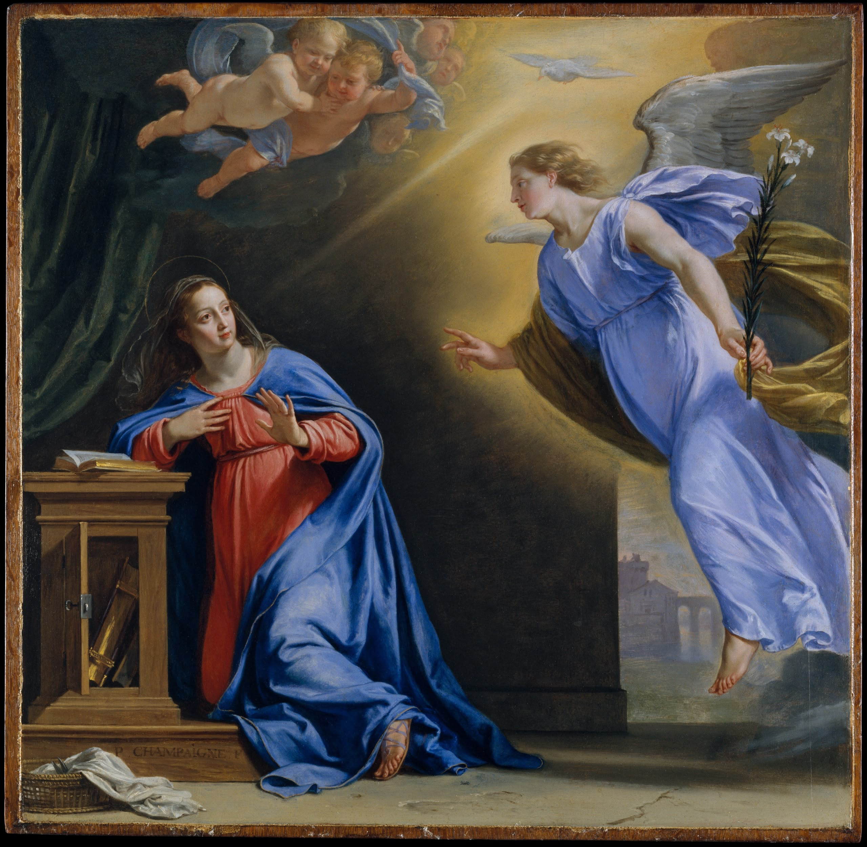
The first joyful mystery: THE ANNOUNCIATION

The Angel Gabriel announces the incarnation to Mary.

THE SCRIPTURAL ANALYSIS
Luke 1:28-35, 38. And coming to her, he said,
“Hail, favored one! The Lord is with you.” But she
was greatly troubled at what was said and
pondered what sort of greeting this might be.
Then the angel said to her, “Do not be afraid,
Mary, for you have found favor with God. Behold,
you will conceive in your womb and bear a son,
and you shall name him Jesus. He will be great
and will be called Son of the Most High, and the
Lord God will give him the throne of David his
father, and he will rule over the house of Jacob
forever, and of his kingdom there will be no
end.” But Mary said to the angel, “How can this
be, since I have no relations with a man?” And
the angel said to her in reply, “The Holy Spirit will
come upon you, and the power of the Most High
will overshadow you. Therefore the child to be
born will be called holy, the Son of God. … Mary
said, “Behold, I am the handmaid of the Lord.
May it be done to me according to your word.”
Then the angel departed from her.

THE GUIDE FOR MEDITATION
God makes our redemption dependent on
Mary’s free decision (Catechism of the Catholic
Church No. 488).
Mary said “Yes “in the name of all human nature”
(Catechism of the Catholic Church No. 511).
What Eve lost through disobedience, Mary
gained again by obedience (Catechism of the
Catholic Church No. 494)
This is the moment of the Incarnation: The Word
becomes flesh. God becomes a tiny embryo.
“The first man was from earth, a man of the dust;
the second man is from heaven” (Catechism of
the Catholic Church No. 504).
Since Christians are the mystical body of Christ,
Mary became our mother, too, at the
Annunciation (Catechism of the Catholic Church
No. 973).
As he does with Mary, God wants to become
intimately and closely associated with me.
Messengers of God, in daily circumstances and
opportunities, come to me, too. I need only pay
attention.
Mary says Yes to God without knowing the
whole picture what will happen and how it all
will end. I shouldn’t demand God give me the
whole picture, either.
God became an embryo I shouldn’t refuse
opportunities that would be good even if I think
them “beneath me.”

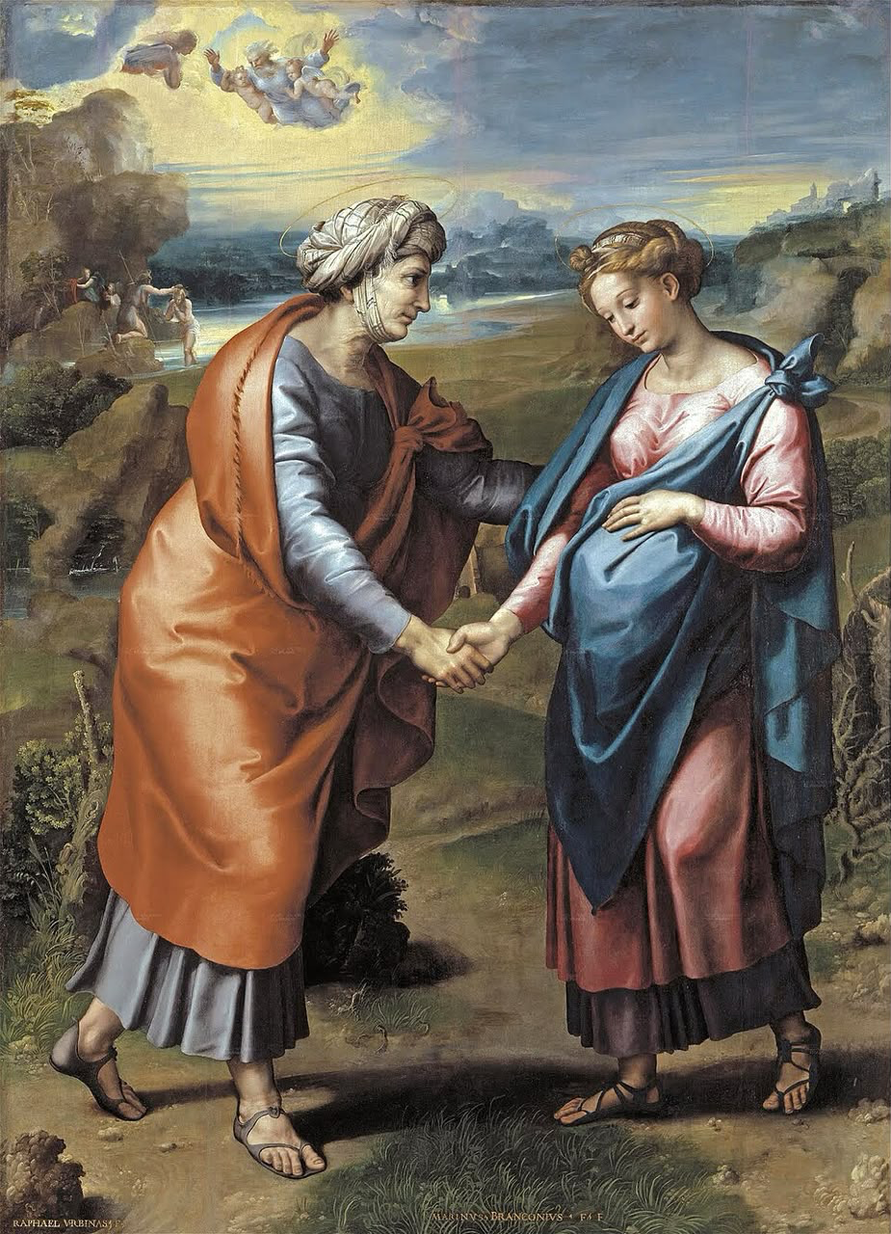
The Second Joyful Mystery: THE VISITATION

Mary visits Elizabeth.

THE SCRIPTURAL ANALYSIS
Luke 1:39-48. During those days Mary set out
and traveled to the hill country in haste to a town
of Judah, where she entered the house of
Zechariah and greeted Elizabeth. When Elizabeth
heard Mary’s greeting, the infant leaped in her
womb, and Elizabeth, filled with the Holy Spirit,
cried out in a loud voice and said, “Most blessed
are you among women, and blessed is the fruit
of your womb. And how does this happen to me,
that the mother of my Lord should come to me?
For at the moment the sound of your greeting
reached my ears, the infant in my womb leaped
for joy. Blessed are you who believed that what
was spoken to you by the Lord would be
fulfilled.” And Mary said: “My soul proclaims the
greatness of the Lord; my spirit rejoices in God
my savior. For he has looked upon his
handmaid’s lowliness; behold, from now on will
all ages call me blessed.”

THE GUIDE FOR MEDITATION
(Catechism of the Catholic Church: No 495-497,
717)
Mary is quick to aid Elizabeth; she will be quick
to aid me.
The practice of authentic Christian charity is the
essence of Christianity.
Elizabeth calls the unborn Jesus “Lord” (and John
the Baptist witnesses to him) at the very
beginning of Mary’s pregnancy.
The angel Gabriel’s words and Elizabeth’s
together make up the bulk of the Hail Mary
prayer.
Mary is humble but says the Magnificat (which
begins in the passage given here). The humble
recognize their giftedness and worth, which
come from God.
Christ is the center of these scenes, but he stays
hidden, unseen, as he does in our lives.
Like Elizabeth, we should be eager to recognize
Christ in others.
Like Mary, we should bring Christ into the homes
of others.
Mary’s first Christian apostolate was doing
household chores. Mostly, our Christian life
means small things done with love.
It is Christ in her that makes Mary attractive and
that draws people’s attention. He wants to use
me in the same way.

The Third Joyful Mystery: THE NATIVITY
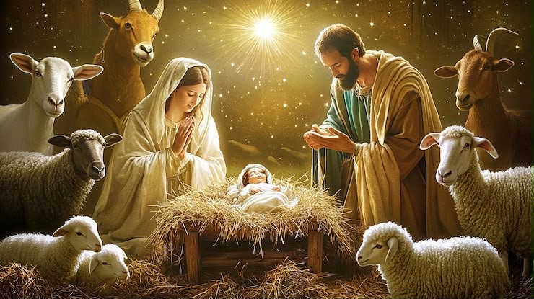

Jesus is born in Bethlehem.

THE SCRIPTURAL ANALYSIS
Luke 2: 6-14. While they were there, the time
came for her to have her child, and she gave
birth to her firstborn son. She wrapped him in
swaddling clothes and laid him in a manger,
because there was no room for them in the inn.
Now there were shepherds in that region living
in the fields and keeping the night watch over
their flock. The angel of the Lord appeared to
them and the glory of the Lord shone around
them, and they were struck with great fear. The
angel said to them, “Do not be afraid; for behold,
I proclaim to you good news of great joy that
will
be for all the people. For today in the city of
David a savior has been born for you who is
Messiah and Lord. And this will be a sign for you:
you will find an infant wrapped in swaddling
clothes and lying in a manger.” And suddenly
there was a multitude of the heavenly host with
the angel, praising God and saying: “Glory to
God in the highest and on earth peace to men of
good will.”

THE GUIDE FOR MEDITATION
Imagine being all powerful God and limiting
yourself to the abilities of a baby. That’s love.
Shepherds, not known for their piety, were the
first to receive the good news.
“The Magi’s coming to Jerusalem in order to pay
homage to the King of the Jews shows that they
seek in Israel the King of the nations” (Catechism
of the Catholic Church No 528).
The world usually either bitterly opposes Christ,
like Herod, or is indifferent to him, like the
innkeepers.
Baby Jesus had no words to offer, only his
presence. And it was enough to attract a lot of
attention.
Christ can be quiet, almost imperceptible. He’s
also the God of glory, angel choirs and
supernovas.
An innkeeper who could have been transformed
by Christ even his business might have
prospered refused. How often do we refuse to
let Christ into our lives?
We can count on God’s answers to our prayers,
but often in unexpected ways a stable instead of
a room.
The Wise Men read the books, learned where to
find Christ, and traveled for days to meet him.
For us he’s a short drive away, in the tabernacle.
The Wise Men give their best to God. Do we give
our best time, best efforts, best talents? Or what
we don’t want anyway?

The Fourth Joyful Mystery: THE PRESENTATION
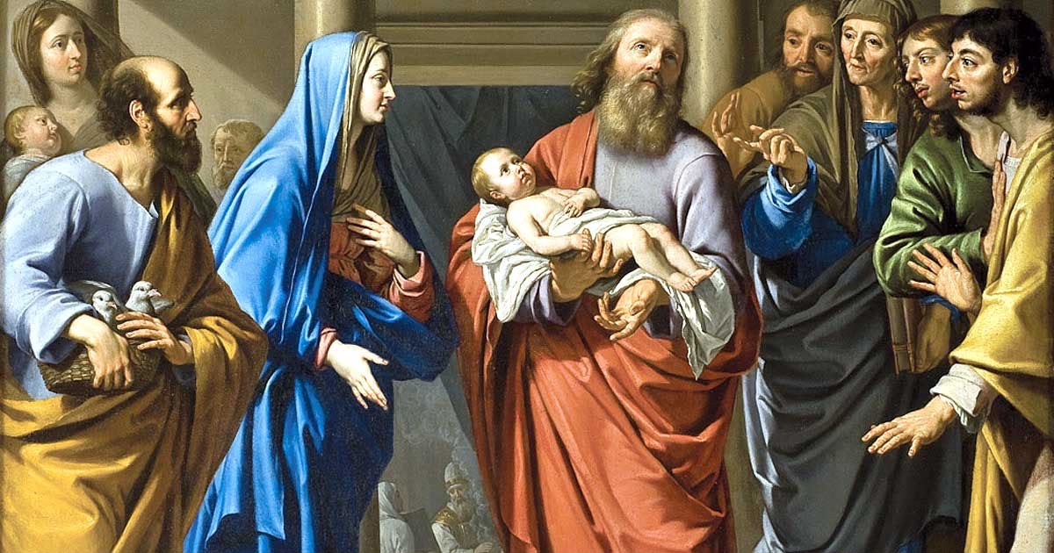

Mary and Joseph present Jesus in the Temple.

THE SCRIPTURAL ANALYSIS
Luke 2:25-35. Now there was a man in Jerusalem
whose name was Simeon. This man was
righteous and devout, awaiting the consolation
of Israel, and the Holy Spirit was upon him. It had
been revealed to him by the holy Spirit that he
should not see death before he had seen the
Messiah of the Lord. He came in the Spirit into
the temple; and when the parents brought in the
child Jesus to perform the custom of the law in
regard to him, he took him into his arms and
blessed God, saying: “Now, Master, you may let
your servant go in peace, according to your
word, for my eyes have seen your salvation,
which you prepared in sight of all the peoples,
light for revelation to the Gentiles, and glory for
your people Israel.” The child’s father and
mother were amazed at what was said about
him; and Simeon blessed them and said to Mary
his mother, “Behold, this child is destined for the
fall and rise of many in Israel, and to be a sign
that will be contradicted and you yourself a
sword will pierce, so that the thoughts of many
hearts may be revealed.”

THE GUIDE FOR MEDITATION
“The presentation of Jesus in the Temple shows
him to be the firstborn son who belongs to the
Lord” (Catechism of the Catholic Church No.529).
Simeon’s faith allowed him to recognize Christ.
“The sword of sorrow predicted for Mary
announces Christ’s cross” (Catechism of the
Catholic Church No 529). Simeon foretells pain
for Christ and his followers.
Trust in God’s promises sustained Simeon.
Christ’s religious life was that of a Jew obedient
to the law (Catechism of the Catholic Church No
31).
Joseph’s offering was a poor man’s alternative to
a lamb. God wants me to sacrifice even in small
things, too.
Simeon was content after one glimpse of Christ.
The Eucharist gives me many glimpses.
This encounter with Christ takes place in the
Temple. For us, it happens in the Church.
I should present Christ in the “temple of the Holy
Spirit,” my body.
Anna, in the scene that follows this passage, “
“Talked about the child to all.” My encounters
with Christ should lead to evangelization.

The Fifth Joyful Mystery: THE FINDING AT THE TEMPLE
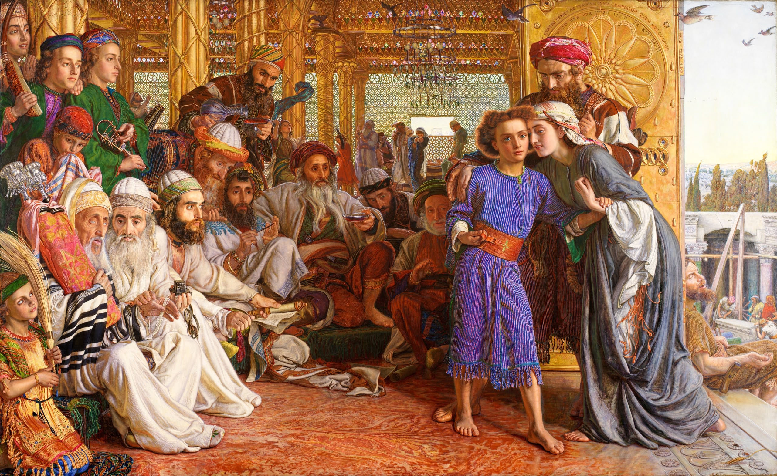

Mary and Joseph find Jesus in the Temple.

THE SCRIPTURAL ANALYSIS
Luke 2:41-51. Each year his parents went to
Jerusalem for the feast of Passover, and when he
was twelve years old, they went up according to
festival custom. After they had completed its
days, as they were returning, the boy Jesus
remained behind in Jerusalem, but his parents
did not know it. Thinking that he was in the
caravan, they journeyed for a day and looked for
him among their relatives and acquaintances,
but not finding him, they returned to Jerusalem
to look for him. After three days they found him
in the temple, sitting in the midst of the teachers,
listening to them and asking them questions,
and all who heard him were astounded at his
understanding and his answers. When his
parents saw him, they were astonished, and his
mother said to him, “Son, why have you done
this to us? Your father and I have been looking
for you with great anxiety.” And he said to them,
“Why were you looking for me? Did you not
know that I must be in my Father’s house?” But
they did not understand what he said to them.
He went down with them and came to Nazareth,
and was obedient to them; and his mother kept
all these things in her heart.

THE GUIDE FOR MEDITATION
Joseph and Mary assumed Jesus was with
members of their close knit extended family in
which cousins were “brothers.”
Here Jesus lets us catch a glimpse of the mystery
of his total consecration to his mission: “I must
be about my Father’s work” (Catechism of the
Catholic Church No 534).
“Even the closest of human relationships are
challenged by the absolute demands of the
Kingdom” (John Paul II, Rosarium Virginis
Mariae, 20)
Jesus’ obedience to his mother and legal father
fulfills the fourth commandment perfectly and
mirrors his obedience to his Father in heaven”
(Catechism of the Catholic Church No 532)
In the hidden years of Jesus we learn the
importance of: Silence, family life, work and the
ordinary events of daily life (Catechism of the
Catholic Church No 533).
The holy Family made a pilgrimage to Jerusalem
every year. Do I take my family on special trips
to holy places?
Feel like you’ve lost Christ? You can always find
him in the tabernacle.
Jesus imparts wisdom to the rabbis who listen in
the Temple. He will give me wisdom if I spend
time with him in the tabernacle.
Mary’s question is direct, simple and honest:
“Why have you done this to us?” our prayers
should be direct, simple and honest.
Joseph and Mary “do not understand” Jesus’
answer, and yet they accept it (Catechism of the
Catholic Church No 534). Do I accept, or demand
to know it all up front?

SECTION TWO
SORROWFUL MYSTERY:
First Sorrowful Mystery: THE AGONY IN THE GARDEN
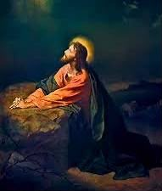

Jesus prays in Gethsemane on the night before
his death.

THE SCRIPTURAL ANALYSIS
Luke 22:39-46. Then going out he went, as was
his custom, to the Mount of Olives, and the
disciples followed him. When he arrived at the
place he said to them, “Pray that you may not
undergo the test.” After withdrawing about a
stone’s throw from them and kneeling, he
prayed, saying, “Father, if you are willing, take
this cup away from me; still, not my will but yours
be done.” And to strengthen him an angel from
heaven appeared to him. He was in such agony
and he prayed so fervently that his sweat
became like drops of blood falling on the
ground. When he rose from prayer and returned
to his disciples, he found them sleeping from
grief. He said to them, “Why are you sleeping?
Get up and pray that you may not undergo the
test.”

THE GUIDE FOR MEDITATION
In Gethsemane, “Jesus encounters all the
temptations and confronts all the sins of
humanity” (Pope John Paul II, Rosarium Virginis
Mariae 22).
This Yes of Christ reverses the No of our first
parents in the Garden of Eden (Rosarium, 22).
“The cup of the new covenant, which Jesus
offered at the Last Supper, is afterward accepted
by him from his Father’s hands in his agony of
the garden” (Catechism of the Catholic Church
No 612).
Jesus “expresses the horror that death
represented for his human nature” (Catechism of
the Catholic Church No 612).
“By accepting in his human will that the Father’s
will be done, he accepts his death as redemptive”
(Catechism of the Catholic Church No 612).
The everyday obedience of Jesus to Joseph and
Mary both announced and anticipated the
obedience of Holy Thursday (Catechism of the
Catholic Church No 532).
“Could you not stay one hour with me?” Christ
would like us to make a holy hour in the
presence of the Eucharist (weekly, if possible).
“Father, if you are willing “ It is no shame to
pray, and hope for, pain to pass me by
“Still, not my will but yours” But I should
remember that sometimes God wants me to
accept suffering for a greater purpose.
The disciples disobey Christ’s command not
because they are “wicked” but because they give
in to their desire for easy comfort. That’s often
the reason I sin.

The Second Sorrowful Mystery: THE SCOURGING
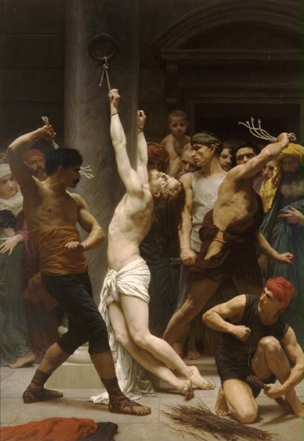
AT THE PILLA

Christ is Scourged by the soldiers at Pilate’s command.

THE SCRIPTURAL ANALYSIS
Mark 15:6-15. Now on the occasion of the feast he used to release to them one prisoner whom they requested. A man called Barabbas was then in prison along with the rebels who had committed murder in a rebellion. The crowd came forward and began to ask him to do for them as he was accustomed. Pilate answered, “Do you want me to release to you the king of the Jews?” For he knew that it was out of envy that the chief priests had handed him over. But the chief priests stirred up the crowd to have him release Barabbas for them instead. Pilate again said to them in reply, “Then what do you want me to do with the man you call the king of the Jews?” They shouted again, “Crucify him.” Pilate said to them, “Why? What evil has he done?” They only shouted the louder, “Crucify him.” So Pilate, wishing to satisfy the crowd, released Barabbas to them and, after he
had Jesus scourged, handed him over to be crucified.

THE GUIDE FOR MEDITATION
A handle held together three leather whips in the
kind of scourges used on Christ. At the ends
were spiky pieces of bone or lead.
Roman scourges would tear away flesh and the
victim would lose blood, weakening him for
crucifixion. The soldiers avoided striking over the
heart, to keep the condemned man alive.
That the manner of his death was foreseen “does
not mean that those who handed him over were
merely passive players in a scenario written in
advance by God” (Catechism of the Catholic
Church No 599).
“The Church does not hesitate to impute to
Christians the gravest responsibility for the
torments inflicted upon Jesus” (Catechism of the
Catholic Church No 598).
“Christ’s whole life was lived under the sign of
persecution. His own share it with him” (
(Catechism of the Catholic Church No 530).
If he suffered this for me, there is nothing I
should refuse to do for him.
Consider small “scourges” to suffer for love of
Christ. Eating and not getting quite full?
Accepting slights in traffic? Forgoing TV?
In the garden, heaven’s help was obvious an
angel. In the scourging, the interior grace of
hope is his only help. I can expect the same
sometimes.
When I give in to angry or vengeful thoughts and
make cutting remarks or judgmental gossip, I
behave like the soliders.
When I leave cutting remarks unanswered or let
judgmental thoughts die in my mind, I behave
like Christ.

The Third Sorrowful Mystery: THE CROWN WITH
THORN
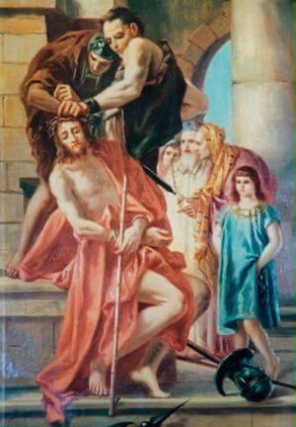

Soldiers weave a crown of thorns and place it on
Christ’s head.

THE SCRIPTURAL ANALYSIS
John 19:1-8 . Then Then Pilate took Jesus and
had him scourged. And the soldiers wove a
crown out of thorns and placed it on his head,
and clothed him in a purple cloak, and they came
to him and said, “Hail, King of the Jews!” And
they struck him repeatedly. Once more Pilate
went out and said to them, “Look, I am bringing
him out to you, so that you may know that I find
no guilt in him.” So Jesus came out, wearing the
crown of thorns and the purple cloak. And he
said to them, “Behold, the man!” When the chief
priests and the guards saw him they cried out,
“Crucify him, crucify him!” Pilate said to them, “
“Take him yourselves and crucify him. I find no
guilt in him.” The Jews answered, “We have a law,
and according to that law he ought to die,
because he made himself the Son of God.” Now
when Pilate heard this statement, he became
even more afraid.

THE GUIDE FOR MEDITATION
When he fed the multitudes, they wanted to
make him king. But thorns were the only crown
he accepted.
That there was something special about Christ
was obvious to many at a glance. This is what
gave the soldiers their delight when they
mocked him.
“Jesus atoned for our faults and made
satisfaction for our sins to the Father (Catechism
of the Catholic Church No 615).
“There is not, never has been, and never will be
a single human being for whom Christ did not
suffer” (Catechism of the Catholic Church No
605).
The blood vessels in the face bleed profusely.
The crown of thorns made it difficult for Christ to
see.
The crown of thorns is an antidote to self pity, to
prevent me crowning myself for my own slight
sufferings.
Empty religious practice is like crowning Christ
with thorns.
We might avoid evangelizing because we’re
afraid of ridicule. But without risking ridicule,
we’ll never fully imitate Christ.
Giving a deep, honest, thorough confession is
one way to imitate Christ, who exposed himself
to contempt.
Even the Rosary can be an empty crown if I “say”
it without trying to “pray” it.

The Fourth Sorrowful Mystery: TH CARRYING OF
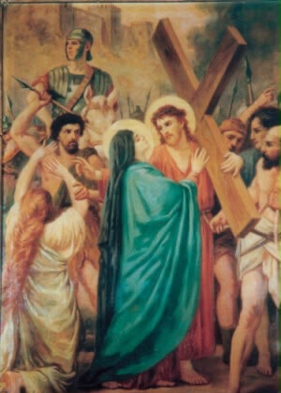
THE CROSS

Jesus struggles up Calvary with his own cross on
his shoulders.

THE SCRIPTURAL ANALYSIS
John 19:16-22. Then he handed him over to
them to be crucified. So they took Jesus, and
carrying the cross himself he went out to what is
called the Place of the Skull, in Hebrew,
Golgotha. There they crucified him, and with him
two others, one on either side, with Jesus in the
middle. Pilate also had an inscription written and
put on the cross. It read, “Jesus the Nazorean, the
King of the Jews.” Now many of the Jews read
this inscription, because the place where Jesus
was crucified was near the city; and it was written
in Hebrew, Latin, and Greek. So the chief priests
of the Jews said to Pilate, “Do not write ‘The King
of the Jews,’ but that he said, ‘I am the King of
the Jews.’” Pilate answered, “What I have written,
I have written.”

THE GUIDE FOR MEDITATION
Christ accepted his heavy cross without
professing his innocence because he was
carrying it for the guilty. For me.
It was horrible for Mary to have to watch this; she
would rather she were allowed to suffer it
herself.
In the stories of Simon and Veronica, we see that
Christ accepted the assistance of others as he
redeemed the world.
It is easy to imagine Christ struggling in front of
our admiring eyes. But, abandoned by his friends
and rejected by the crowd, it’s truer to think of
him being alone.
Christ was a strong man. He fell three times,
tradition tells us. Sleepless, scourged, crowned
with thorns and carrying a heavy cross, he kept
getting back up.
The cross I’ve been given has been hand tested
by Christ so that it will be neither too heavy nor
too light.
The Blessed Mother of Jesus was close when her
son was suffering. She’s close when we, her other
sons and daughters, suffer.
Christ carries his cross and helps carry ours as
well.
Am I sick of trying to be holy and always failing?
My struggle for holiness, with all of its falls, is my
lifelong way of the cross.
“The fruitfulness of the Church depends on the
cross of Christ,” said Pope Leo XIV. “For example,
a priest who personally carries a heavy cross, yet
tries to do his best or a father or mother of a
family who lives in a difficult situation
contributes to the fruitfulness of the Church.”

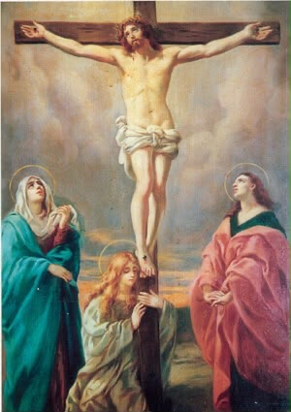
The Fifth Sorrowful Mystery: THE CRUCIFIXION
Jesus is nailed to the cross and dies.

THE SCRIPTURAL ANALYSIS
John 19:25-30. Standing by the cross of Jesus
were his mother and his mother’s sister, Mary the
wife of Clopas, and Mary of Magdala. When
Jesus saw his mother* and the disciple there
whom he loved, he said to his mother, “Woman,
behold, your son.” Then he said to the disciple, “
“Behold, your mother.” And from that hour the
disciple took her into his home. After this, aware
that everything was now finished, in order that
the scripture might be fulfilled, Jesus said, “I
thirst.” There was a vessel filled with common
wine. So they put a sponge soaked in wine on a
sprig of hyssop and put it up to his mouth. When
Jesus had taken the wine, he said, “It is finished.”
And bowing his head, he handed over the spirit.
(John 19:25-30)

THE GUIDE FOR MEDITATION
“It is love ‘to the end’ that confers on Christ’s
sacrifice its value as redemption and reparation,
as atonement and satisfaction” (Catechism of the
Catholic Church No 616).
It took a great effort for Christ to speak from the
cross; he had to raise himself up on his wounded
hands. Yet he did to forgive.
“He knew and loved us all when he offered his
life” (Catechism of the Catholic Church No 616).
Christ died for the very people who were
mocking him, blaspheming him and killing him.
“Apart from the cross there is no other ladder by
which we may get to heaven” (Catechism of the
Catholic Church No 618).
“Since our sins made the Lord Jesus Christ suffer
the torment of the cross, those who plunge
themselves into disorders and crimes crucify the
Son of God anew” (Catechism of the Catholic
Church No 598).
The crucifix teaches us about God’s mercy – but
also about his anger at sin. We must remember
both.
To crucify my pride is necessary for me, because
I am by nature egotistical and prone to hurt
others selfishly.
To imitate Christ’s forgiveness is necessary for
me, because those I am close with are by nature
egotistical and prone to hurt me selfishly.
The Church, following the apostles, teaches that
Christ died for all men without exception (
(Catechism of the Catholic Church No. 605).

SECTION THREE
GLORIOUS MYSTERY:

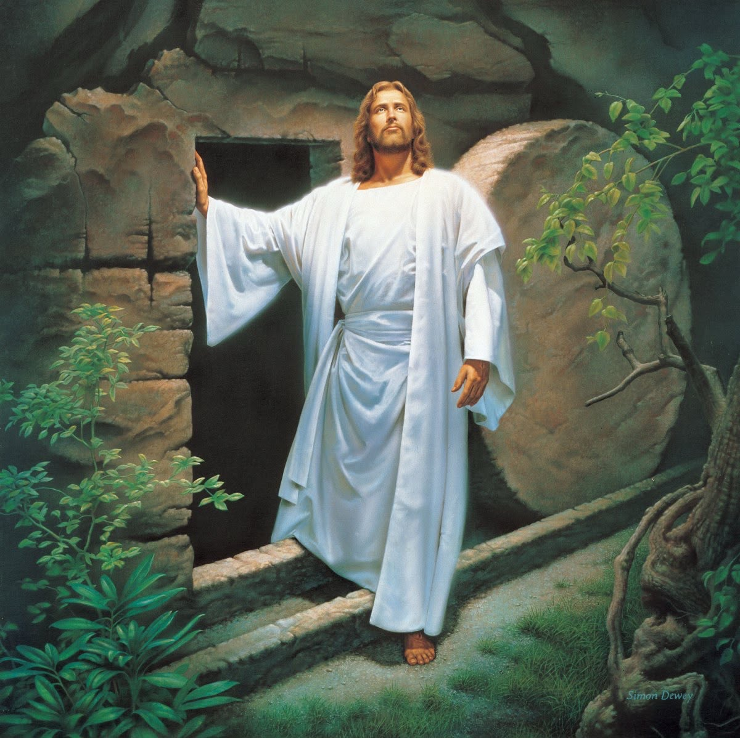
The First Glorious Mystery: THE RESURRECTION

Jesus rises from the dead three days after his crucifixion.

THE SCRIPTURAL ANALYSIS
Matthew 28:1-8. After the Sabbath, as the first
day of the week was dawning, Mary Magdalene
and the other Mary came to see the tomb. And
behold, there was a great earthquake; for an
angel of the Lord descended from heaven,
approached, rolled back the stone, and sat upon
it. His appearance was like lightning and his
clothing was white as snow. The guards were
shaken with fear of him and became like dead
men. Then the angel said to the women in reply,
“Do not be afraid! I know that you are seeking
Jesus the crucified. He is not here, for he has
been raised just as he said. Come and see the
place where he lay. Then go quickly and tell his
disciples, ‘He has been raised from the dead, and
he is going before you to Galilee; there you will
see him.’ Behold, I have told you.” Then they went
away quickly from the tomb, fearful yet
overjoyed, and ran to announce this to his
disciples.

THE GUIDE FOR MEDITATION
Christ’s resurrection is a real event that was
historically verified (Catechism of the Catholic
Church No 639).
The faith of the first Christians in the Resurrection
was based on the witness of concrete men living
among them. Paul speaks clearly of more than
500 to whom Jesus appeared on a single
occasion (Catechism of the Catholic Church No
642).
Even when faced with the reality of the risen
Jesus the disciples are still doubtful, so
impossible did the thing seem. The hypothesis
that the Resurrection was produced by the
apostles’ credulity will not hold up (Catechism of
the Catholic Church No 644).
“Mary must have had an intense experience of
the new life of her glorified Son” (Pope John Paul
II, Rosarium Virginis Mariae, 23).
Risen, Jesus can be touched. He eats. Yet his risen
body is not limited by space and time Christ’s
resurrection was not a return to earthly life
(Catechism of the Catholic Church No. 646).
Do I think of the Resurrection like a fairy tale? If
it isn’t literally true, Christianity is wicked the
cross without redemption.
The women who visited the tomb were so filled
with joy, they ran to tell the others. My encounter
with Christ should be that real.
Christ’s appearance on the road to Emmaus is
like Mass. He tells the disciples about the
Scriptures, breaks bread, then disappears. The
message: We must now seek him in the Eucharist.
Christ, risen, still bears his wounds. You can’t
have Christ without the crucifix.
Sunday is the feast of the Resurrection, the Lord’s
day. How do I make it holy?

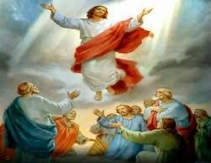
The Second Glorious Mystery: THE ASCENSION

Forty days after rising from the dead, Christ
ascends into heaven.

SCRIPTURAL ANALYSIS
Acts 1:8-11. Jesus said to them: “You will receive
power when the Holy Spirit comes upon you, and
you will be my witnesses in Jerusalem,
throughout Judea and Samaria, and to the ends
of the earth.” When he had said this, as they were
looking on, he was lifted up, and a cloud took
him from their sight. While they were looking
intently at the sky as he was going, suddenly two
men dressed in white garments stood beside
them. They said, “Men of Galilee, why are you
standing there looking at the sky? This Jesus who
has been taken up from you into heaven will
return in the same way as you have seen him
going into heaven.”

THE GUIDE FOR MEDITATION
“Jesus’ final apparition ends with the irreversible
entry of his humanity into divine glory where he
is seated from that time forward at God’s right
hand” (Catechism of the Catholic Church No,
659).
Before the Ascension, Christ was to be found on
earth, always in one place. Now we can find him
anywhere.
“Only the one who ‘came from the Father’ can
return to the Father: Christ Jesus” (Catechism of
the Catholic Church No, 661).
By telling the apostles to convert the nations and
then departing, Christ’s message was obvious:
We are to do his work now.
We can imagine that Mary would have told the
apostles to “do whatever he tells you” after Jesus’
ascension, when she joined them in awaiting the
Holy Spirit (Rosarium, 14).
“All authority in heaven and on earth is given to
me.” We can have great confidence that, with
Christ, we are on the winning team.
All authority has been given to Christ. That
means over every aspect of my life.
“Why are you standing there looking at the sky
“Christianity isn’t stargazing it’s serving, praying,
and acting in this world.
We have faith, even though Christ is covered in
clouds. We have hope, because we know all
authority is his. We have love, because he has
entrusted us with so much.
Christ will return in the same way. Am I ready?

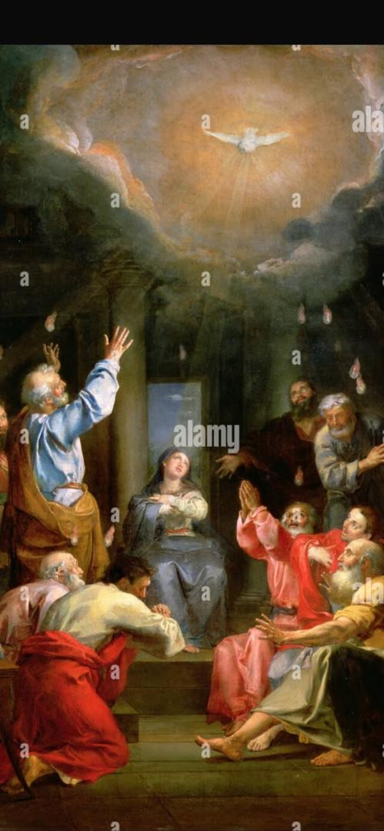
The Third Glorious Mystery: THE DESCENT OF HOLY SPIRIT

The Holy Spirit descends on Mary and the
Apostles.

SCRIPTURAL ANALYSIS
Acts 2:1-6, 38-41. When the time for Pentecost
was fulfilled, they were all in one place together.
And suddenly there came from the sky a noise
like a strong driving wind, and it filled the entire
house in which they were. Then there appeared
to them tongues as of fire, which parted and
came to rest on each one of them. And they were
all filled with the Holy Spirit and began to speak
in different tongues, as the Spirit enabled them
to proclaim. Now there were devout Jews from
every nation under heaven staying in Jerusalem.
At this sound, they gathered in a large crowd, but
they were confused because each one heard
them speaking in his own language. Peter said to
them, “Repent and be baptized, every one of you,
in the name of Jesus Christ for the forgiveness of
your sins; and you will receive the gift of the Holy
Spirit.”

THE GUIDE FOR MEDITATION
On that Pentecost, the Holy Trinity is fully
revealed (Catechism of the Catholic Church No,
732).
The Bible itself says that only a small portion of
Christ’s teaching is contained in it. The rest is
given to the Church through the Holy Spirit.
“By his coming, which never ceases, the Holy
Spirit causes the world to enter into the ‘last
days,’ the time of the Church” (Catechism of the
Catholic Church No, 732).
“Through the Holy Spirit we are restored to
paradise, led back to the Kingdom of heaven and
adopted as children, given confidence to call God
‘Father’ and to share in Christ’s grace, called
children of light and given a share in eternal
glory” (Catechism of the Catholic Church No,
736).
Christ is a teacher, model, savior. The Holy Spirit
is our animating principle, our partner.
“The fruit of the Spirit: love, joy, peace, patience,
kindness, goodness, faithfulness, gentleness,
self control” (Catechism of the Catholic Church
No, 736).
The Holy Spirit turned the cowardly apostles into
fearless martyrs. He will transform me, too.
All heard the apostles in their own language. The
Holy Spirit can help me overcome interpersonal
difficulties I have.
The Holy Spirit was poured out on me at
confirmation. Have I squandered this great gift?
Or learned to use it?
We know the Holy Spirit: in the Scriptures he
inspired, in the Tradition, in the Church’s
magisterium, in the sacramental liturgy, in
prayer, in the charisms and ministries by which
the Church is built up, in apostolic and
missionary life, in the witness of saints
(Catechism of the Catholic Church No, 688).

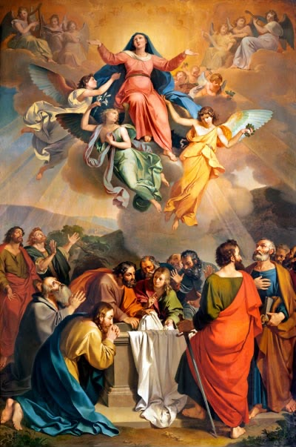
The Fourth Glorious Mystery: THE ASSUMPTION

At the end of her life, Mary is taken body and soul
into heaven.

SCRIPTURAL ANALYSIS
Revelation 12:1, 13-14. A great sign appeared in
the sky, a woman clothed with the sun, with the
moon under her feet, and on her head a crown
of twelve stars. When the dragon the rebellious
angel, the devil saw that it had been thrown
down to the earth, it pursued the woman who
had given birth to the male child. But the woman
was given the two wings of the great eagle so
that she could fly to her place in the desert,
where, far from the serpent, she was taken care of.

THE GUIDE FOR MEDITATION
“The Most Blessed Virgin Mary, when the course
of her earthly life was completed, was taken up
body and soul into the glory of heaven”
(Catechism of the Catholic Church No, 974).
In heaven, Mary “already shares in the glory of
her Son’s resurrection, anticipating the
resurrection of all members of his body”
(Catechism of the Catholic Church No, 974).
In the Church’s prayers to Mary we “magnify” the
Lord for the “great things” he did for his lowly
servant and through her for all human beings
(Catechism of the Catholic Church No, 2675).
The Mother of Jesus, “in the glory which she
possesses in body and soul in heaven, is the
image and beginning of the Church as it is to be
perfected in the world to come” (Catechism of
the Catholic Church No, 972).
“What the Catholic faith believes about Mary is
based on what it believes about Christ”
(Catechism of the Catholic Church No, 487).
Mary was, “from the first moment of her
conception, by a singular grace and privilege of
almighty God and by virtue of the merits of Jesus
Christ, savior of the human race, preserved
immune from all stain of original sin” (Catechism
of the Catholic Church No, 487).
“To become the mother of the Savior, Mary was
enriched by God with gifts appropriate to such a
role” (Catechism of the Catholic Church No, 490).
Mary “shines forth on earth until the day of the
Lord shall come, a sign of certain hope and
comfort to the pilgrim people of God”
(Catechism of the Catholic Church No, 972).
We are told that God has prepared a “mansion”
for us in heaven our “dream house” in a place of
joy with no sufferings or tears.
Without the reality of heaven, our call to the
cross would be an abomination. I should make
heaven my hope.

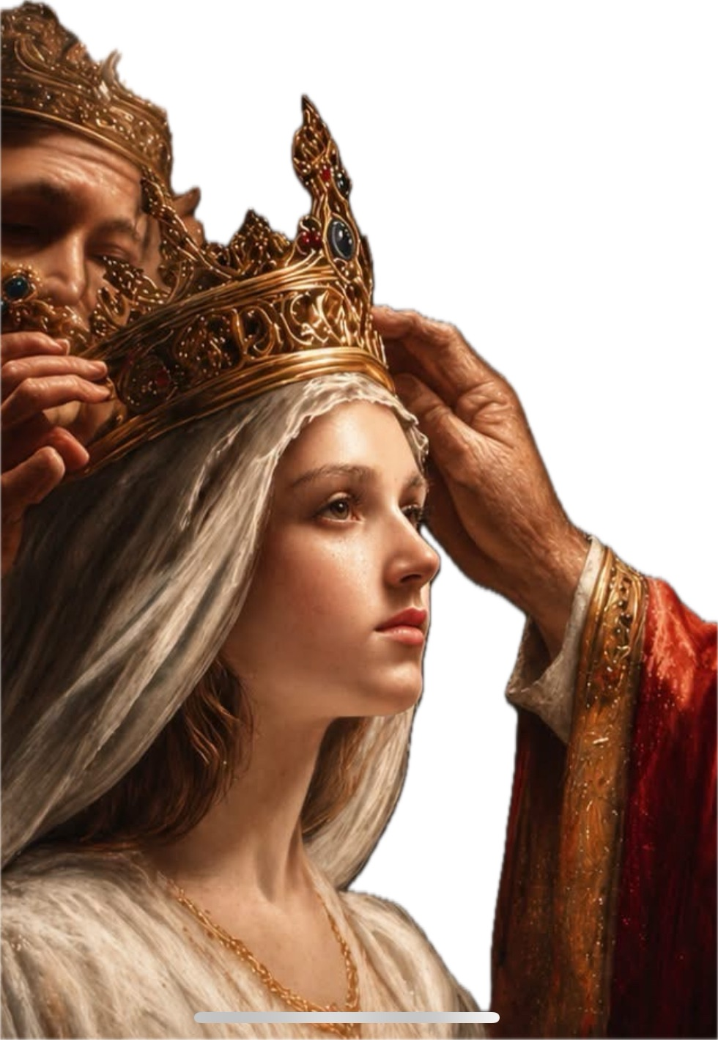
The Fifth Glorious Mysteries: THE CORONATION

Mary is crowned queen of Heaven and earth.

SCRIPTURAL ANALYSIS
Luke 1:46-55. Mary said: “My soul proclaims the
greatness of the Lord, my spirit rejoices in God
my Savior for he has looked with favor on his
lowly servant.
From this day all generations will call me blessed:
the Almighty has done great things for me, and
holy is his Name.
He has mercy on those who fear him in every
generation.
He has shown the strength of his arm, he has
scattered the proud in their conceit.
He has cast down the mighty from their thrones,
and has lifted up the lowly.
He has filled the hungry with good things, and
the rich he has sent away empty.
He has come to the help of his servant Israel for
he has remembered his promise of mercy, the
promise he made to our fathers, to Abraham and
his children for ever.”

THE GUIDE FOR MEDITATION
“Since the fifth century, Christians have given
Mary the title of queen in acknowledgment of
her sublime dignity as the mother of God” (Pope
John Paul II, General Audience, June 1997).
Christians call Mary our queen also because of
“her importance in the life of the Church and in
the lives of individuals” (General Audience, 1997).
The Second Vatican Council teaches that Mary
“has been exalted by the Lord as queen of all, in
order that she might be more fully conformed to
her Son, the Lord of lords” (Lumen Gentium, 59).
“Crowned in glory as she appears in the last
glorious mystery Mary shines forth as queen of
the angels and saints” (Rosarium, 23).
Mary is “the anticipation and the supreme
realization of the heavenly state of the Church”
(Rosarium, 23).
“As the queen who reigns in the glory of God’s
Kingdom, Mary remains close to us at every step
of our earthly pilgrimage, supporting us in our
trials and sharing with us the life and love of
Jesus her Son” (Pope John Paul II, June 1997).
“We believe that the Holy Mother of God, the
new Eve, Mother of the Church, continues in
heaven to exercise her maternal role on behalf of
the members of Christ” (Pope Paul VI, Credo of
the People of God).
“The Father blessed Mary more than any other
created person ‘in Christ with every spiritual
blessing in the heavenly places’” (Catechism of
the Catholic Church No, 492).
By calling her our queen, the Church teaches us
that we can put enormous faith in Mary’s ability
to intercede for us.
If Mary is my queen, she is queen of all aspects
of my life; not just my religious life, but my social
life, work life, home life and private life as well.

SECTION FOUR
LUMINOUS MYSTERY:
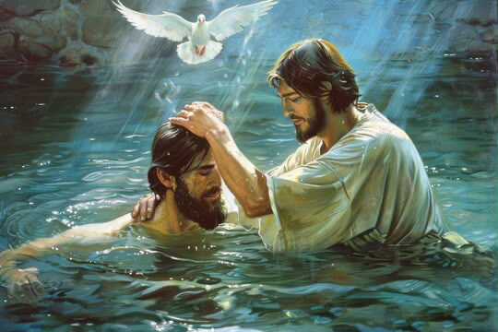
The First Luminous Mystery: THE BAPTISM OF THE LORD
Jesus is baptized by John in the Jordan River.

SCRIPTURAL ANALYSIS
Matthew 3:13-17. Then Jesus came from Galilee
to John at the Jordan to be baptized by him.
John tried to prevent him, saying, “I need to be
baptized by you, and yet you are coming to me?
“ Jesus said to him in reply, “Allow it now, for thus
it is fitting for us to fulfill all righteousness.
“Then he allowed him.”After Jesus was baptized,
he came up from the water and behold, the
heavens were opened for him and he saw the
Spirit of God descending like a dove and coming
upon him. And a voice came from the heavens,
saying, “This is my beloved Son, with whom I am
well pleased.”

THE GUIDE FOR MEDITATION
At the beginning, the Father grants his Son the
consolation of his voice. He won’t on the cross.
“The baptism of Jesus is on his part the
acceptance and inauguration of his mission as
God’s Suffering Servant” (Catechism of the
Catholic Church No, 536).
In baptism, Christ “procured for us a ‘shortcut’ to
salvation” (Catechism of the Catholic Church No,
518).
“Already he is coming to “fulfill all righteousness’,
that is, he is submitting himself entirely to his
Father’s will” (Catechism of the Catholic Church
No, 536).
“The Christian must go down into the water
with Jesus in order to rise with him, be reborn of
water and the Spirit so as to become the Father’s
beloved son in the Son and walk in newness of
life” (Catechism of the Catholic Church No, 537).
John didn’t point to anything but Christ: He was
created for that.
That’s what I was created for, too.
For John, only Christ’s standards mattered, not
the world’s.
What are my priorities?
Water is necessary for life; similarly, baptism is
necessary for eternal life.
I should be anxious to give that life to others.
People were attracted to John, despite his
appearance, because of his fidelity to God and
his principles.
John isn’t afraid to challenge people to change,
and so he betters their lives and is remembered
by history

The Second Luminous Mystery: THE WEDDING FEAST AT CANA
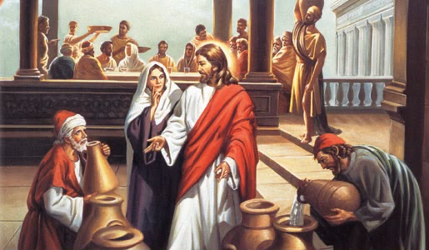
Jesus performs his first public miracle at his mother’s request.

SCRIPTURAL ANALYSIS
John 2:1-11. On the third day there was a
wedding in Cana in Galilee, and the mother of
Jesus was there. Jesus and his disciples were also
invited to the wedding. When the wine ran short,
the mother of Jesus said to him, “They have no
wine.” And Jesus said to her, “Woman, how does
your concern affect me? My hour has not yet
come.” His mother said to the servers, “Do
whatever he tells you.” Now there were six stone
water jars there for Jewish ceremonial washings,
each holding twenty to thirty gallons. Jesus told
them, “Fill the jars with water.” So they filled them
to the brim. Then he told them, “Draw some out
now and take it to the headwaiter.” So they took
it. And when the headwaiter tasted the water that
had become wine, without knowing where it
came from (although the servers who had drawn
the water knew), the headwaiter called the
bridegroom and said to him, “Everyone serves
good wine first, and then when people have
drunk freely, an inferior one; but you have kept
the good wine until now.” Jesus did this as the
beginning of his signs in Cana in Galilee and so
revealed his glory, and his disciples began to
believe in him.

THE GUIDE FOR MEDITATION
Here we find “the great maternal counsel, which
Mary addresses to the Church of every age: ‘Do
whatever he tells you’” (Pope John Paul II,
Rosarium Virginis Mariae, 21).
“What is this to me?” is not so much a rebuke as
a recognition that a public miracle will lead to
Jesus’ death.
From the beginning, Christ imparts the faith to
his disciples through Mary, “the first among
believers” (Rosarium, 21).
Jesus at Cana “gives a sign, in which he proclaims
his hour, the hour of the wedding feast, the hour
of union between God and man” (Pope Benedict
XVI, Homily, Sept. 11 2006).
Jesus “transforms the human wedding-feast into
an image of the divine wedding feast in which he
gives us every good thing, represented by the
abundance of wine” (Pope Benedict XVI, 2006
Homily).
Christ “revealed his glory” by making wine.
He also reveals his glory to us by enriching our
lives in very human ways.
“His disciples began to believe in him” based on
this miracle.
We see a greater miracle at each Mass.
Christ chose this for his first public miracle in part
to show his regard for marriage.
If we bring our needs to Mary, she will take care
of them with her son.
Christ announced his ministry in the Temple,
then began it in Cana.
My Christian mission is launched in Church but it
takes place in the world.
Christ transforms ordinary things (water) into
extraordinary things (wine).
He can transform my marriage.

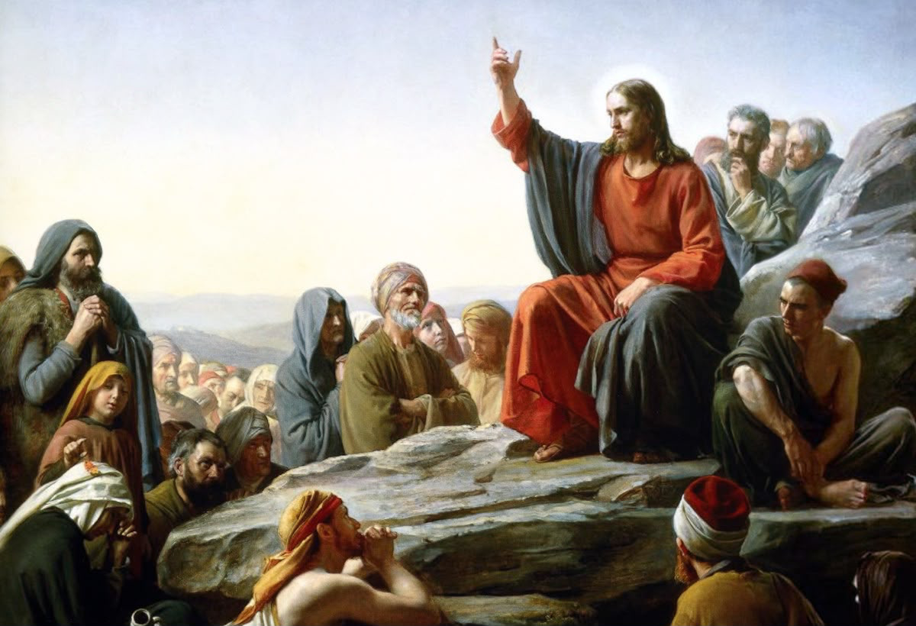
The Third Luminous Mystery: THE PROCLAMATION OF THE KINGDOM

Jesus announces the coming of the Kingdom and forgives sins.

SCRIPTURAL ANALYSIS
Mark 2:3-12. Unable to get near Jesus because of
the crowd, they opened up the roof above him.
After they had broken through, they let down the
mat on which the paralytic was lying.
When Jesus saw their faith, he said to the
paralytic, “Child, your sins are forgiven.”
Now some of the scribes were sitting there
asking themselves, “Why does this man speak
that way? He is blaspheming.
Who but God alone can forgive sins?” Jesus
immediately knew in his mind what they were
thinking to themselves, so he said, “Why are you
thinking such things in your hearts? Which is
easier, to say to the paralytic, ‘Your sins are
forgiven,’ or to say, ‘Rise, pick up your mat and
walk’? But that you may know that the Son of
Man has authority to forgive sins on earth”he
said to the paralytic, “I say to you, rise, pick up
your mat, and go home.”
He rose, picked up his mat at once, and went
away in the sight of everyone.
They were all astounded and glorified God,
saying, “We have never seen anything like this.”

THE GUIDE FOR MEDITATION
“The kingdom of heaven was inaugurated on earth by Christ.
The Church is the seed and beginning of this kingdom.
Its keys are entrusted to Peter” (Catechism of the Catholic
Church No, 567) Christ’s whole early life his words and deeds,
his silences and sufferings, indeed his manner of being and speaking tell us
who God is and what he is like (Catechism of the Catholic Church No, 561).
“To become a child in relation to God is the
condition for entering the kingdom.
For this, we must humble ourselves and become
little” (Catechism of the Catholic Church No, 561).
“Everyone is called to enter the kingdom”
(Catechism of the Catholic Church No, 543)
One must enter the kingdom, that is, become a
disciple of Christ, in order to “know its secrets. “
“Outside” it, everything remains enigmatic
(Catechism of the Catholic Church No, 546).
“Jesus invites sinners to the table of the
kingdom” (Catechism of the Catholic Church No,
545) and “forgives the sins of all who draw near
him in humble trust” (Rosarium, 21) Christ is king
of everything: truth, my leisure time, the business
world, my family.
Do I let him reign? I pray “Thy kingdom come”
but the next part of the Our Father demands
something of me: “Thy will be done.”
“Thereis no human activity even in secular affairs
which can be withdrawn from God’s dominion”
(Lumen Gentium, 36).
Praying “Thy kingdom come” “means working to
enrich American society and culture with the
beauty and truth of the Gospel, and never losing
sight of that great hope which gives meaning
and value to all the other hopes which inspire our
lives” (Pope Benedict XVI, Yankee Stadium, 2008).

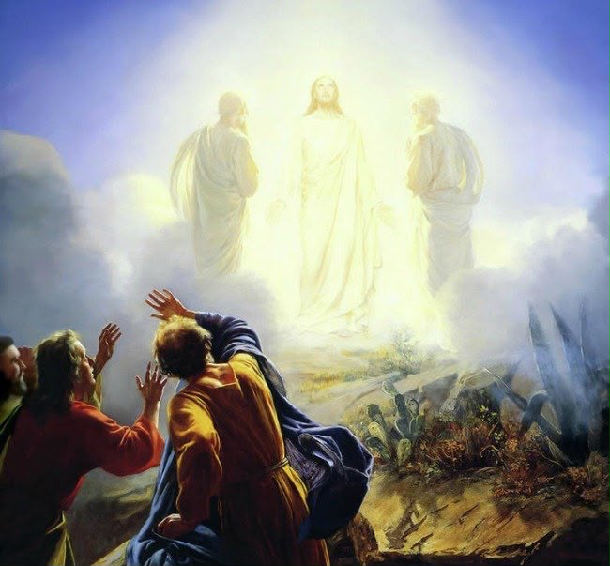
The Fourth Luminous Mystery: THE TRANSFIGURATION

Jesus is transfigured, dazzling white, on Mount
Tabor.

SCRIPTURAL ANALYSIS
Matthew 17 1-9. After six days Jesus took Peter,
James, and John his brother, and led them up a
high mountain by themselves. And he was
transfigured before them; his face shone like the
sun and his clothes became white as light. And
behold, Moses and Elijah appeared to them,
conversing with him. Then Peter said to Jesus in
reply, “Lord, it is good that we are here. If you
wish, I will make three tents here, one for you,
one for Moses, and one for Elijah.” While he was
still speaking, behold, a bright cloud cast a
shadow over them, then from the cloud came a
voice that said, “This is my beloved Son, with
whom I am well pleased; listen to him.” When the
disciples heard this, they fell prostrate and were
very much afraid. But Jesus came and touched
them, saying, “Rise, and do not be afraid.” And
when the disciples raised their eyes, they saw no
one else but Jesus alone. As they were coming
down from the mountain, Jesus charged them,
“Do not tell the vision to anyone until the Son of
Man has been raised from the dead.”

THE GUIDE FOR MEDITATION
“Christ’s Transfiguration aims at strengthening
the apostles’ faith in anticipation of his passion:
The ascent on the high mountain prepares for
the ascent to Calvary” (Catechism of the Catholic
Church No, 568).
“For a moment Jesus discloses his divine glory,
confirming Peter’s confession” (Catechism of the
Catholic Church No, 555).
“Moses and Elijah had seen God’s glory on the
mountain; the law and the prophets had
announced the Messiah’s sufferings” (Catechism
of the Catholic Church No, 555).
“The whole Trinity appeared: the Father in the
voice, the Son in the man, the Spirit in the shining
cloud” (Catechism of the Catholic Church No,
555).
“The Transfiguraion gives us a foretaste of
Christ’s glorious coming But it also recalls that ‘it
is through many persecutions that we must enter
the kingdom of God’“ (Catechism of the Catholic
Church No, 556).
“According to the senses, the light of the sun is
the most intense ever known in nature.
But according to the spirit, the disciples saw for
a short time a brightness more intense: that of
the divine glory of Jesus” (Pope Benedict XVI,
Angelus, 2011).
The three apostles were rewarded for 1)saying
Yes to Christ’s invitation, 2) praying, and 3)
staying close to him.
They saw who Christ really was.
I saw the beauty of who my spouse really is.
do I guard that “Tabor vision”? or do I focus on
my spouse’s falts? (cf. von Hildebrand)
Think of the Transfiguration when praying the
Glory Be prayer.
St. John wrote that if your love for God is cold
you should recall to your mind a time when it was
fresh and exciting so that your passion will
return.

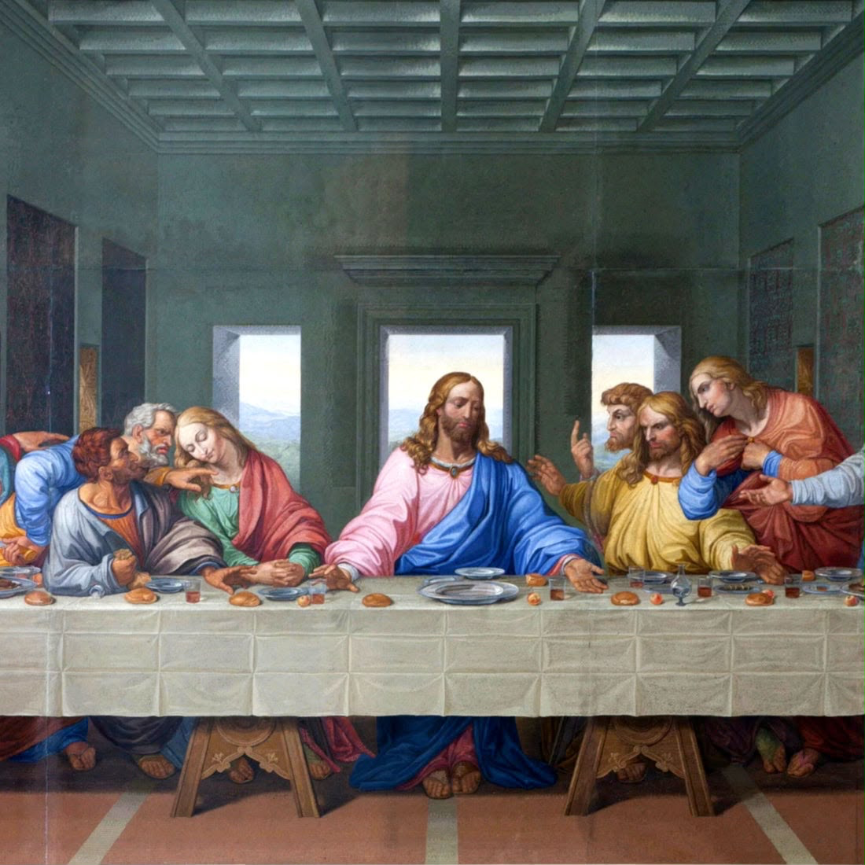
The Fifth Luminous Mystery: THE INSTITUTION OF THE HOLY EUCHARIST

At the Last Supper, Christ changes bread and
wine into his body and blood.

SCRIPTURAL ANALYSIS
1Corinthians 11: 23-29. For I received from the
Lord what I also handed on to you, that the Lord
Jesus, on the night he was handed over, took
bread, and, after he had given thanks, broke it
and said, “This is my body that is for you. Do this
in remembrance of me.” In the same way also the
cup, after supper, saying, “This cup is the new
covenant in my blood. Do this, as often as you
drink it, in remembrance of me.” For as often as
you eat this bread and drink the cup, you
proclaim the death of the Lord until he comes.
Therefore whoever eats the bread or drinks the
cup of the Lord unworthily will have to answer for
the body and blood of the Lord. person should
examine himself, and so eat the bread and drink
the cup. For anyone who eats and drinks without
discerning the body, eats and drinks judgment
on himself.

THE GUIDE FOR MEDITATION
God said, “Let there be light.” And there was.
Here he says, “This is my body.” And it is.
“Jesus freely offered himself for our salvation.
During the Last Supper, he both symbolized this
offering and made it really present” (Catechism
of the Catholic Church No, 621).
“Jesus includes the apostles in his own offering
and bids them perpetuate it. By doing so, the
Lord institutes his apostles as priests”
(Catechism of the Catholic Church No, 611).
Eleven of Christ’s first 12 priests betrayed or
abandoned him.
Pope Benedict XVI called the Eucharist “a gift of
love that is truly worth more than all the rest of
life.”
Through real communion with his body and
blood, “Christ enables us to live in him all that he
himself lived, and he lives it in us” (Catechism of
the Catholic Church No, 521).
If I were given a hammer and nails, or a sword, at
Mass, the message would be obvious: Build
something, or fight. I’m given Christ.
I am to bring him to the world.
Christ is present in the Eucharist whether I feel
his presence or not but if I forgive more, pray
more and serve more, I will “feel” his presence
more, too.
Heaven is like a big, joyous wedding feast. And it
starts at Mass.
The Eucharist is the encounter with Christ par
excellence.
Who was the last person I invited back to Mass?

CHAPTER SIX
SECTION ONE
Prayer for aborted babies…………..

OPENING HYMN
AVE MARIA, O MAIDEN, O MTHER
1. AVe Maria ! O maiden, O Mother,
Proudly thy children are calling on thee,
Thine are the graces unclaimed by another sinless and beautiful, star of the sea!

Chorus
Mater amabilis, Ora pronobis,
Pray for thy children who call upon thee,
AVe santissima! AVe purissima!
Sinless and beautiful, star of the sea.

2. AVe Maria! The night shades are falling,
Softly our voices arise unto thee,
Earth’s lonely exiles for succor are calling,
Sinless and beautiful, star of the sea!

3. AVe Maria! Thou portal of heaven,
Harbor of refuge, to thee do we flee,
Lost in the darkness, by stormy winds driven shine on our pathway,
fair star of the sea!

How to pray Marian Rosary
Come Holy Spirit...I,believe in God...Our
Father.... 3,Hail Mary.......Glory be.......The
mystery…..........

At the end Hail Holy Queen.......................

Most Sacred Heart of Jesus.......have mercy on us
Immaculate Heart of Mary.........pray for us
St Joseph....................pray for us
St Louis Marie de montfort...........pray for us
Mary help of orphans..............pray for us

Litany of the blessed Virgin Mary
Lord, have mercy on us.
Christ, have mercy on us.
Lord, have mercy on us.
Christ hear us.
Christ, graciously hear us.
God the Father of heaven, Have mercy on us.
God the Son, Redeemer of the world, Have mercy on
us.
God the Holy Spirit, Have mercy on us.
Holy Trinity, one God, Have mercy on us.

Holy Mary, Pray for us. (repeat after each line)
Holy Mother of God,
Holy Virgin of virgins,
Mother of Christ,
Mother of the Church,
Mother of mercy,
Mother of divine grace,
Mother of hope,
Mother most pure,
Mother most chaste,
Mother inviolate,
Mother undefiled,
Mother most amiable,
Mother most admirable,
Mother of good counsel,
Mother of our Creator,
Mother of our Savior,
Virgin most prudent,
Virgin most venerable,
Virgin most renowned,
Virgin most powerful,
Virgin most merciful,
Virgin most faithful,
Mirror of justice,
Seat of wisdom,
Cause of our joy,
Spiritual vessel,
Vessel of honor,
Singular vessel of devotion,
Mystical rose,
Tower of David,
Tower of ivory,
House of gold,
Ark of the covenant,
Gate of heaven,
Morning star,
Health of the sick,
Refuge of sinners,
Comfort of Migrants,
Comforter of the afflicted,
Help of Christians,
Queen of Angels,
Queen of Patriarchs,
Queen of Prophets,
Queen of Apostles,
Queen of Martyrs,
Queen of Confessors,
Queen of Virgins,
Queen of all Saints,
Queen conceived without original sin,
Queen assumed into heaven,
Queen of the most holy Rosary,
Queen of Families,
Queen of Peace,

Lamb of God, you take away the sins of the world,
Spare us, O Lord.
Lamb of God, you take away the sins of the world,
Graciously hear us, O Lord.
Lamb of God, you take away the sins of the world,
Have mercy on us.
Pray for us, O holy Mother of God, That we may be
made worthy of the promises of Christ.

Let us pray,
Grant, we beseech you, Lord God, that
we your servants may rejoice in continual health of
mind and body and, by the glorious intercession of
Blessed Mary, ever Virgin, may we be delivered from
present sorrow to delight in joy eternal. Through
Christ our Lord. Amen.

Act of Reparation to the Sacred Heart of Jesus.
(All) O Lord Jesus Christ, kneeling here before your altar, we wish to make reparation to you for all the coldness, irreverence, ingratitude, by which the greater part of mankind repay so cruelly the love of your most sacred heart.
Priest
For the forgetfulness and ingratitude of mankind...................people response
We wish to make reparation.
For the hatred of those who do not believe in you..................
For the unfaithfulness of those who call themselves your friends........................
For the neglect shown to you in the Blessed Sacrament........................
For the irreverence and sacrileges which profane the sacrament of your love...........
For the insults to your divinity..................
For the manifold offense against Christian modesty and holy purity............
For the frequent violation of Sunday’s and Holy days...................
For the insults to which your vicar on earth is subjected......................
For the public crimes of nations...............
For our own sins and bad examples..........
For our abuse and neglect of your grace......................
For our tepid it’s in your holy service.......

Let us pray
O sacred heart of Jesus, lover of souls, we promise to make reparation to you in the future, by faithful service to the Orphans and poorest of the poor. Mere words are worth little, if our lives are not pleasing to you we promise to be more attentive to our religious duties, to be fervent and regular in the reception of the Holy Communion, and to avoid giving you offenses again. We are weak and we are selfish, help us, Lord, to make reparation for the past and console you for the remainder of our lives. Remember, Lord bless, the promises, which in the infinite mercy of your divine heart you made to st. Margaret Mary. Be the protector of our lives, the mainstay of our weakness, the repairer of our faults, the completion of our virtues, and above all our site refuge at the hour of death, Amen.
(to be said at every first Saturday Devotion)

SECTION TWO
Act of Reparation to the Immaculate Heart of Mary.
O Immaculate Heart of Mary, Mother of Jesus the savior, our Lady of Fatima, inspire me to grieve sincerely for the sins that weigh heavily upon the souls of men. Sorrowful, I recall the bitter and harsh punishments heaped upon thy Son, when He was cruelly scourged at the pillar, unmercifully crowned with thorns. I recall His sad journey to Calvary, His crucifixion and Ignominious death on the cross. Yet they were but the instruments of pain. It was my sins that really caused His precious blood to be shed. His excessive love willed that He should suffer for my salvation. Thus, I will give my little love to make amends and atone for a thoughtless and unappreciative world. O Immaculate Heart of Mary, you who suffered and shared with Him every pain caused and inflicted by my sins, intercede for us that we may be privileged to unite our hearts with yours in an effort to make reparation for our sins, and the sins of an ungrateful mankind. Amen our Lady of Fatima, inflame our hearts with love of reparation.
(to be said at every first Saturday Devotion)

Consecration to the Immaculate Heart of Mary
O Immaculate Heart of Mary. Queen of Heaven and earth, and tender Mother of men in accordance with your ardent wish made known at Fatima, I consecrate to you myself, my brethren, my country, and the whole human race.
Reign over us and teach us how to make the Heart of Jesus reign and triumph in us and around us, as it has reigned and triumphed in you. Reign over us, dearest Mother, that we may be yours in prosperity and in adversity; in you and in sorrow; In health and in sickness; in life and in death. O most compassionate Heart of Mary, Queen of virgins, watch over our minds and hearts, and preserve them from the deluge of impurity, which you lamented so sorrowfully at Fatima. We want to be pure like you. We want to atone for the many crimes committed against Jesus and you. We want to call down upon our country Nigeria and whole human race the peace of God in justice and charity.

Therefore, we now promise to imitate your virtues by the practices of a Christian life without regard to human respect. We resolve to receive Holy Communion on the first Saturday of every month, and to offer you five decade of the Rosary each day together with our sacrifices in the spirit of reparation and penance, Amen.

Prayer to the Blessed Mary to obtain deliverance from hell.
My most beloved Lady, I thank thee for having delivered me from hell as many times as I have deserved it by my sins. Miserable creature that I was, I was once condemned to that prison, and perhaps already, after the first sin, the sentence would have been execution, if thou in thy, compassion hadst not helped me. Thou, without even being asked by me, and only in thy goodness, didst restrain divine justice; and then, conquering my obduracy, thou didst draw me to have confidence in thee.

The O, into how many other sins should I have afterwards fallen in the dangers in which I have been, hadst not thou, my loving master, preserved me by the grace which thou didst obtain for me!

Ah, my queen, continue to guard me from hell; for what will thy mercy, and the favors which thou hast shown me, avail me if I am lost? If i did not always love thee, now at last, after God, I love thee above all things. Never allow me to have the misfortune to hate thee and curse thee for all eternity in hell. Wilt thou endure to see a servant of thine, who loves thee lost? O Mary, what sayers thou? I shall be lost if I abandon thee. But who can ever more have the heart to leave thee? How can I ever forget the love thou hast born me?

My Lady, since thou hast done so much to save me, complete the work, continue the aid. With thou help me? But what do I say? If at a time when I lived forgetful of thee thou didst favor me so much, how much more may I not hope for now that I love thee and recommend myself to thee! No, he can never be lost who recommends himself to thee; he alone is lost who has not recourse to thee. Save me, my hope, save me from hell; but in the first place, save me from sin, which lone can condemn me to it, Amen.
(Recite this on every first Saturday Reparation )

Christian Emmanuel Prayer for Seminarians
O God of vocation you are the one who called us out into this field in answering to your call, as you say to your disciples "follow me,and I will make you fishers of men" (Matthew 4 v 19).
look with pity on us O Lord for we are weak and as a mortal being. Send forth your holy spirit to come and enlighten our hearts and minds, and grant us the grace never to weaken in the practicing of virtues, the grace to persevere to the end. O Lord the giver of vocation look kindly on the hearts of many young man who are inspiring to join the seminary, enkindle in them the fire of your love, selfless service to your church. We beg you Almighty God to see to all the needs of the seminarians pour down your healing grace upon our sick brothers (seminarians), save the souls of our suffering brothers (seminarians) in purgatory and grant unto them the joy of an everlasting life. We make this prayer through Christ our Lord.l, Amen.
Mary Queen Of Vocation, Pray for Us.

SECTION THREE
CHAPLET OF DIVINE MERCY

Make the Sign of the Cross
In the name of the Father, and of the Son, and of the Holy Spirit.

Optional Opening Prayers

You expired, Jesus, but the source of life gushed forth for souls, and the ocean of mercy opened up for the whole world. O Fount of Life, unfathomable Divine Mercy, envelop the whole world and empty Yourself out upon us.
O Blood and Water, which gushed forth from the Heart of Jesus as a fountain of Mercy for us, I trust in You!

Our Father
Our Father, Who art in heaven, hallowed be Thy name; Thy kingdom come; Thy will be done on earth as it is in heaven. Give us this day our daily bread; and forgive us our trespasses as we forgive those who trespass against us; and lead us not into temptation, but deliver us from evil.

Hail Mary
Hail Mary, full of grace. The Lord is with thee. Blessed art thou amongst women, and blessed is the fruit of thy womb, Jesus. Holy Mary, Mother of God, pray for us sinners, now and at the hour of our death, Amen.

The Apostle's Creed
I believe in God, the Father Almighty, Creator of Heaven and earth; and in Jesus Christ, His only Son, Our Lord, Who was conceived by the Holy Ghost, born of the Virgin Mary, suffered under Pontius Pilate, was crucified; died, and was buried. He descended into Hell; the third day He arose again from the dead; He ascended into Heaven, sitteth at the right hand of God, the Father Almighty; from thence He shall come to judge the living and the dead. I believe in the Holy Spirit, the holy Catholic Church, the communion of saints, the forgiveness of sins, the resurrection of the body, and the life everlasting.

The Eternal Father
Eternal Father, I offer you the Body and Blood, Soul and Divinity of Your Dearly Beloved Son, Our Lord, Jesus Christ, in atonement for our sins and those of the whole world.

On the Ten Small Beads of Each Decade
For the sake of His sorrowful Passion, have mercy on us and on the whole world.

Repeat for the remaining decades
Saying the "Eternal Father" (6) on the "Our Father" bead and then 10 "For the sake of His sorrowful Passion" (7) on the following "Hail Mary" beads.

Conclude with Holy God (Repeat three times)
Holy God, Holy Mighty One, Holy Immortal One, have mercy on us and on the whole world.

Optional Closing Prayer
Eternal God, in whom mercy is endless and the treasury of compassion--inexhaustible, look kindly upon us and increase Your mercy in us, that in difficult moments we might not despair nor become despondent, but with great confidence submit ourselves to Your holy will, which is Love and Mercy itself.

SECTION FOUR
HOW TO MAKE A GOOD CONFESSION
Confession is a sacrament instituted by Jesus Christ in his love and mercy to offer sinners forgiveness for offenses against God and against your sisters and brothers. Confession brings reconciliation between God and the penitent, between the penitent and others, and to the individual penitent.

One goes to Confession privately behind a screen or face-to-face with the priest. Preparation for the Sacrament of Penance consists of a good examination of conscience. This examination, guided by the Ten Commandments, prepares one to confess sins to the priest. Confession presumes the penitent is truly sorry with a firm resolve not to sin again.

Confession begins with :
1. Sign of the Cross and the penitent greeting the priest with the words.
2.“Bless me, Father, for I have sinned. My last confession was ….” (weeks, months, years).
3. Then confesses your sins to the priest, who stands in the name of Christ and the Church. The priest will help you make a good confession. If you are unsure or uneasy, ask the priest to help. Place your trust in God, a merciful Father who wants to forgive you. Following the confession of sins, say,
4.With the one I remember and the one I didn’t remember. I am truly sorry for them.”The priest will assign you a penance.
5.The penance takes into account your personal situation and supports your spiritual good. It may be a prayer, an offering, works of mercy, service, or sacrifice; whatever the penance, the individual is joined in some way to Christ and the cross.
6. Act of Contrition. This prayer expresses true sorrow for the sins confessed. This prayer may be expressed in one’s own words or one may use one of the formal prayers of sorrow.
7. Then the priest will absorb you with Absolution prayer, as the prayer is ending,
8. Make Sign of the Cross and responds, “Amen.”
9. The priest will offer his blessing then you leaves,
10. Go to quiet place and do your assigned penance, if it is prayer, but if it is other works of mercy, try and do it as soon as possible.

Prayer of St. Francis of Assisi
ord, make me an instrument of your peace.
Where there is hatred, let me sow love.
Where there is injury, pardon.
Where there is doubt, faith.
Where there is despair, hope.
Where there is darkness, light.
Where there is sadness, joy.
O Divine Master,
grant that I may not so much seek to be consoled, as to console;
to be understood, as to understand;
to be loved, as to love.
For it is in giving that we receive.
It is in pardoning that we are pardoned,
and it is in dying that we are born to Eternal Life.

THE ANGELUS

The Angel of the Lord declared to Mary:
And she conceived of the Holy Spirit.

Hail Mary, full of grace, the Lord is with thee; blessed art thou among women and blessed is the fruit of thy womb, Jesus. Holy Mary, Mother of God, pray for us sinners, now and at the hour of
our death. Amen.

Behold the handmaid of the Lord: Be it done unto me according to Thy word.

Hail Mary . . .

And the Word was made Flesh: And dwelt among us.

Hail Mary . . .

Pray for us, O Holy Mother of God, that we may be made worthy of the promises of Christ.

Let us pray:

Pour forth, we beseech Thee, O Lord, Thy grace into our hearts; that we, to whom the incarnation of Christ, Thy Son, was made known by the message of an angel, may by His Passion and Cross be brought to the glory of His Resurrection, through the same Christ Our Lord

Prayer to St. Michael the Archangel

St. Michael the Archangel,
defend us in battle.
Be our defense against the wickedness and snares of the Devil.
May God rebuke him, we humbly pray,
and do thou,
O Prince of the heavenly hosts,
by the power of God,
thrust into hell Satan,
and all the evil spirits,
who prowl about the world
seeking the ruin of souls.

Guardian Angel Prayer
Angel of God,
my guardian angel,
,To whom God's love commits me here,
Ever this day,
be at my side,
To light and guard,
Rule and guide. Amen

Prayer for the Seven Gifts of the H0ly Spirit
O Lord Jesus Christ, Who before ascending into heaven, promised to send the Holy Ghost to finish Your work in the souls of Your Apostles and Disciples, deign to grant the same Holy Spirit to me, that He may perfect in my soul the work of Your grace and Your love.

GRANT ME
1.the Spirit of WISDOM,
that I may despise the perishable things of this world, and aspire only after the things that are eternal;
2. the Spirit of UNDERSTANDING,
to enlighten my mind with the light of Your divine truth;
3. the Spirit of COUNSEL,
that I may ever choose the surest ways of pleasing God and gaining heaven;
4. the Spirit of FORTITUDE,
that I may bear my cross with You, and that I may overcome with courage all the obstacles that oppose my salvation;
5. the Spirit of KNOWLEDGE,
that I may know God and know myself and grow perfect in the science of the Saints;
6. the Spirit of PIETY,
that I may find the service of God sweet and amiable; and
7. the Spirit of FEAR,
that I may be filled with a loving reverence towards God and may dread in any way to displease Him.
Mark me, dear Lord, with the sign of Your true disciples, and animate me in all things with Your spirit. Amen

CHAPTER SEVEN
SECTION ONE
FIFTEEN PROMISES OF OUR LADY TO THOSE PRAY THEIR MEDITATIVELY
1. Signal graces: Shall Receive Special Graces and Divine Help.
2. Special protection: Shall Obtain protection and great graces.
3. Armor against hell: Shall Destroy vice, decrease sin, and defeat error.
4. Flourishing virtue: Shall Cause good works to thrive and obtain God's mercy.
5. Soul preservation: Shall Keep the soul recommending itself to Mary from perishing.
6. Immunity to despair: Shall Never be conquered by misfortune when meditating on the mysteries.
7. Spared justice: Shall Avoid dying an unprovided or sudden death out of God's grace.
8. Church sacraments: Shall Not die without receiving the sacraments of the Church.
9. Divine light: Shall Have God's light and fullness of grace at life and death.
10. Merits of saints: Shall Participate in the merits of the heavenly saints upon death.
11. Deliverance from Purgatory: Shall Be promptly freed from Purgatory by Mary.
12. High heavenly glory: Shall Earn a high degree of glory in heaven.
13. Obtaining requests: Shall Receive what is asked through the Rosary.
14. Aid in necessities: Shall Receive help from Mary when propagating the Rosary.
15. Celestial intercession: Shall Have the entire court of heaven as intercessors during life and death.

SECTION TWO
LITURGICAL CALENDAR (Every true Roman Catholic, should know the Solemnity, Feast and Memorial, in order to fulfill their Christian obligations)
JANUARY
1. Mary, Holy Mother of God (Solemnity); The Circumcision of Jesus
2. St. Basil the Great and St. Gregory Nazianzen, Bishops and Doctors of the Church (Memorial)
3. The Most Holy Name of Jesus (Optional Memorial)
4. St. Elizabeth Ann Seton, Religious (Memorial)
5. St. John Neumann, Bishop (Memorial)
6. St. Andre Bessette, Religious (Optional Memorial); The Solemnity of the Epiphany (Solemnity)
7. St. Raymond of Penyafort, Priest (Optional Memorial)
8. St. Thorfinn, Bishop
9. St. Adrian, Abbot
10. St. Peter Orseolo
11. St. Hyginus, Pope, Martyr
12. St. Benedict Biscop, Abbot
13. St. Hilary, Bishop and Doctor of the Church (Optional Memorial); Commemoration of the Baptism of Our Lord Jesus Christ
14. St. Hilary, Bishop, Confessor, Doctor/St. Felix, Priest, Martyr
15. St. Paul the Hermit, Confessor/St. Maurus, Abbot
16. St. Marcellus, Pope, Martyr
17. St. Anthony the Hermit, Abbot (Memorial)
18. St. Prisca, Virgin, Martyr
19. St. Marius & Companions, Martyrs/St. Canute, King, Martyr
20. St. Fabian, Pope and Martyr (Optional Memorial), St. Sebastian, Martyr
21. St. Agnes, Virgin, Martyr (Memorial)
22. Day of Prayer for the Legal Protection of Unborn Children; St. Vincent Deacon and Martyr; St. Anastasius, Martyr
23. Sts. Vincent Deacon and Martyr (Optional Memorial); St. Raymond of Penyafort, Priest
24. St. Francis de Sales, Bishop and Doctor of the Church (Memorial); St. Timothy, Bishop, Martyr
25. The Conversion of St. Paul the Apostle (Feast); St. Peter, Apostle
26. Sts. Timothy and Titus, Bishops (Memorial); St. Polycarp, Bishop, Martyr
27. St. Angela Mercy, Virgin (Optional Memorial); St. John Chrysostom, Bishop, Doctor, Confessor
28. St. Thomas Aquinas, Priest and Doctor of the Church (Memorial); St. Peter Nolasco, Confessor/Apparition of St. Agnes, Virgin, Martyr
29. St. Francis de Sales, Bishop, Confessor, Doctor
30. St. Martina, Virgin, Martyr
31. St. John Bosco, Priest and Confessor

FEBRUARY
1. St. Ignatius of Antioch, Bishop, Martyr
2. The Presentation of the Lord (Feast); Purification of the Blessed Virgin Mary
3. St. Blaise, Bishop and Martyr (Optional Memorial); St. Ansgar, Bishop (Optional Memorial)
4. St. Andrew Corsini, Bishop, Confessor
5. St. Agatha, Virgin and Martry (Memorial)
6. St. Paul Miki and Companions, Martyrs (Memorial); St. Titus, Bishop, Confessor; St. Dorothy, Virgin, Martyr
7. St. Romuald, Abbot
8. St. Jerome Emiliani (Optional Memorial); St. Josephine Bakhita, Virgin (Optional Memorial); St. John of Matha, Confessor
9. St. Cyril of Alexandria, Bishop, Confessor, Doctor/St. Apollonia, Virgin, Martyr
10. St. Scholastica, Virgin (Memorial)
11. Apparition of the Blessed Virgin Mary at Lourdes (Optional Memorial)
12. Seven Holy Founders of the Servite Order, Confessors
13. St. Hilary, Bishop and Doctor
14. St. Cyril, Monk, and St. Methodius, Bishop (Memorial); St. Valentine, Priest, Martyr
15. St. Faustinus and St. Jovita, Martyrs
16. St. Honoratus, Bishop
17. Seven Holy Founders of the Servite Order, Confessors (Optional Memorial)
18. St. Simeon, Bishop, Martyr
19. St. Boniface
20. St. Eustochia Calafato
21. St. Peter Damian, Bishop and Doctor of the Church (Optional Memorial)
22. The Chair of St. Peter the Apostle (Feast)
23. St. Polycarp, Bishop and Martyr (Memorial); St. Peter Damian, Confessor and Doctor
24. St. Matthias, Apostle
25. St.Tarasius, Patriarch of Constantinople
26. St. Alexander, Bishop
27. St. Gabriel of Our Lady of Sorrows, Confessor
28. St. Romanas, Abbott

MARCH
Easter Sunday – Date varies by year between March 22 and April 25.
1. St. David (or Dewi), Bishop
2. St. Chad (or Ceadda), Bishop
3. St. Katharine Drexel, Virgin (Optional Memorial)
4. St. Casimir, Confessor (Optional Memorial); St. Lucius, Pope, Martyr
5. St. John Joseph of the Cross
6. St. Perpetua and St. Felicitas, Martyrs
7. St. Perpetua and St. Felicitas, Martyrs (Memorial)
St. Thomas Aquinas, Confessor, Doctor
8. St. John of God, Religious and Confessor (Optional Memorial)
9. St. Francis of Rome, Religious (Optional Memorial)
10. Forty Holy Martyrs of Sebaste
11. St. Oengus, Bishop and Abbott
12. St. Gregory I the Great, Pope and Doctor
13. St. Euphrasia (or Eupraxia), Vigin
14. St. Leobinus (or Lubin), Bishop
15. St. Louise de Marrilac
16. St. Abraham Kdunaia
17. St. Patrick, Bishop, Confessor (Optional Memorial)
18. St. Cyril of Jerusalem, Bishop, Confessor and Doctor of the Church (Optional Memorial)
19. St. Joseph, Spouse of the Blessed Virgin Mary, Confessor (Solemnity)
20. St. Cuthbert, Bishop
21. St. Benedict, Abbot
22. St. Nicholas Owen, Martyr
23. St. Turibus of Mogrovejo, Bishop (Optional Memorial)
24. St. Gabriel, Archangel
25. The Annunciation of the Lord (Solemnity)
26. St. Barulio, Bishop
27. St. John Damascene, Confessor, Doctor
28. St. John Capistran, Confessor
29. St. Rupert, Bishop
30. St. Leonard Murialdo
31. St. Guy of Pomposa

APRIL
Easter Sunday – Date varies by year between March 22 and April 25.
1. St. Hugh, Bishop
2. St. Francis of Paola, Hermit and Confessor (Optional Memorial)
3. St. Richard of Wyche, Bishop
4. St. Isidore, Confessor, Bishop and Doctor of the Church (Optional Memorial)
5. St. Vincent Ferrer, Priest and Confessor (Optional Memorial)
6. St. William of Eskilsoä, Abbott
7. St. John Baptist de la Salle, Priest (Memorial)
8. St. Julia Billiart, Virgin
9. St. Waldetrudis (or Waudru)
10. St. Fulbert, Bishop
11. St. Stanislaus, Bishop and Martyr (Memorial); St. Leo I, Pope, Confessor and Doctor
12. St. Alferius, Abbott
13. St. Martin I, Pope and Martyr (Optional Memorial); St. Hermenegild, Martyr
14. St. Justin, Martyr; Sts. Tiburtius, Valerian, and Maximus, Martyrs
15. St. Hunna
16. St. Bernadette, Virgin
17. St. Anicetus, Pope, Martyr
18. St. Galdinus, Bishop
19. St. Alphege, Bishop
20. St. Agnes of Montepulciano, Virgin
21. St. Anselm, Bishop and Doctor, Martyr (Optional Memorial)
22. St. Soter, Pope and Martyr, St. Caius, Pope and Martyr
23. St. George, Martyr (Optional Memorial); St. Adalbert, Bishop and Martyr (Optional Memorial)
24. St. Fidelis of Sigmaringen, Martyr (Optional Memorial)
25. St. Mark, Evangelist (Feast)
26. St. Cletus, Pope and Martyr, and St. Marcellius, Pope and Martyr
27. St. Peter Canisius, Confessor and Doctor of the Church
28. St. Peter Chanel, Priest and Martyr (Optional Memorial); St. Louis Grignion de Montfort, Priest (Optional Memorial); St. Paul of the Cross, Confessor
29. St. Catherine of Sienna, Virgin and Doctor of the Church (Memorial); St. Peter of Verona, Martyr
30. St. Pius V, Pope (Optional Memorial); St. Catherine of Siena, Virgin and Doctor of the Church

MAY
Thursday of the sixth week of Eastertide: Solemnity of the Ascension of the Lord – Date varies by year between May 1 and June 4.
1. St. Joseph the Worker, Spouse of the Blessed Virgin Mary (Memorial)
2. St. Athanasius, Bishop, Confessor and Doctor of the Church (Memorial)
3. St. Philip and St. James, Apostles (Feast); St. Alexander I, Eventius & Theodulus, Martyrs, and St. Juvenal, Confessor and Bishop
4. St. Monica
5. St. Pius V, Pope and Confessor
6. St. Petronax, Abbott
7. St. Stanislaus, Bishop and Martyr
8. St. Maddalen of Canossa
9. St. Gregory Naziazen, Bishop, Confessor and Doctor of the Church
10. St. Damian de vaster, Priest (Optional Memorial); St. Antoninus, Bishop and Confessor, St. Gordian & St. Epimachus, Martyrs
11. St. Phillip and St. James, Apostles
12. St. Nerius and St. Achilleus, Martyrs (Optional Memorial); St. Pancras, Martyr (Optional Memorial); St. Flavia, St. Domitilla, and St. Pancras, Martyrs
13. Our Lady of Fatima (Optional Memorial); St. Robert Bellarmine, Bishop, Confessor and Doctor of the Church
14. St. Matthias, Apostle (Feast); St. Boniface of Tarsus, Martyr
15. St. Isidore (Optional Memorial); St. John Baptist de la Salle, Confessor
16. St. Ubald, Bishop and Confessor
17. St. Pascal Baylon, Confessor
18. St. John 1, Pope and Martyr (Optional Memorial); St. Verantius, Martyr
19. St. Peter Celestine, Pope and Confessor; St. Pudentiana, Virgin
20. St. Bernardine of Siena, Priest and Confessor (Optional Memorial)
21. St. Christopher Magallanes, Priest, and Companions, Martyrs (Optional Memorial)
22. St. Rita of Cascia, Religious (Optional Memorial)
23. St. John Baptist Rossi
24. St. Vincent Lérins
25. St. Bede the Venerable, Priest and Doctor of the Church (Optional Memorial); St. Gregory VII, Pope and Confessor (Optional Memorial); St. Mary Magdalene de; Pazzi, Virgin (Optional Memorial); St. Urban I, Pope and Martyr
26. St. Philip Neri, Priest and Confessor (Memorial); St. Eleutherius, Pope and Martyr
27. St. Augustine of Canterbury, Bishop (Optional Memorial); St. Bede the Venerable, Confessor and Doctor of the Church; St. John I, Pope and Martyr
28. St. Augustine of Canterbury, Bishop
29. St. Mary Magdalen of Pazzi, Virgin
30. St. Felix I, Pope and Martyr
31. The Visitation of the Blessed Virgin Mary (Feast); The Queenship of the Blessed Virgin Mary/St. Petronilla, Virgin

JUNE
Thursday of the sixth week of Eastertide: Solemnity of the Ascension of the Lord – Date varies by year between May 1 and June 4.
1. St. Justin, Martry (Memorial); St. Angela of Merici, Virgin
2. St. Peter and St. Marcilllinus of Rome, Martyrs (Optional Memorial); St. Erasmus, Bishop and Martyr
3. St. Charles Lwanga and Companions, Martyrs (Memorial)
4. St. Francis Caracciolo, Confessor
5. St. Boniface, Bishop and Martyr (Memorial)
6. St. Norbert, Bishop and Confessor (Optional Memorial)
7. St. Antony Gianelli, Bishop
8. St. William, Bishop
9. St. Ephrem, Deacon and Doctor of the Church (Optional Memorial); St. Primus and St. Felician, Martyrs
10. St. Margaret, Queen of Scots
11. St. Barnabas, Apostle (Memorial)
12. St. John of San Facundo, Confessor; St. Asilides, St. Carinus, St. Nabor and St. Nazarius, Martyrs
13. St. Anthony of Padua, Priest, Confessor and Doctor of the Church (Memorial)
14. St. Basil the Great, Bishop, Confessor and Doctor of the Church
15. St. Vitus, St. Modestus and St. Crescentia, Martyrs
16. St. Lutgardis, Virgin
17. St. Gregory Barbarigo, Bishop and Confessor
18. St. Ephrem, Deacon, Confessor and Doctor of the Church, St. Mark and St. Marcellian, Martyrs
19. St. Romuald, Abbot (Optional Memorial); St. Juliana Falconieri, Virgin, St. Gervase and St. Protase, Martyrs
20. St. Silverius, Pope and Martyr
21. St. Aloysius Gonzaga, Religious and Confessor (Memorial)
22. St. Paulinus of Nola, Bishop and Confessor (Optional Memorial); St. John Fisher, Bishop, and St. Thomas More, Martyrs (Optional Memorial)
23. Vigil of St. John the Baptist; St. Thomas Garnet, Martyr
24. The Nativity of St. John the Baptist (Solemnity)
25. St. William, Abbot
26. St. Josemaria Escrivá (Optional Memorial); St. John and St. Paul, Martyrs
27. St. Cyril of Alexandria, Bishop and Doctor of the Church (Optional Memorial)
28. St. Irenaeus, Bishop and Martyr (Memorial); Vigil of St. Peter and St. Paul, Apostles
29. St. Peter and Paul (Solemnity)
30. The First Martyrs of the Holy Roman Church (Optional Memorial); St. Paul and St. Peter

JULY
1. Blessed Junipero Serra, Priest (Optional Memorial); The Feast of the Most Precious Blood of Our Lord
2. The Visitation of the Blessed Virgin Mary; St. Processus and St. Martinian, Martrys
3. St. Thomas, Apostle (Feast); St. Irenaeus, Bishop and Martyr
4. Independence Day (Optional Memorial)
5. St. Anthony Mary Zaccaria, Confessor (Optional Memorial); St. Elizabeth of Portugal (Optional Memorial)
6. St. Maria Goretti, Virgin and Martyr (Optional Memorial)
7. St. Cyril and St. Methodius, Bishops and Confessors
8. St. Elizabeth, Queen of Portugal
9. St. Augustine Zhao Rong, Priest, and Companions, Martyrs (Optional Memorial)
10. The Seven Holy Brothers, sons of St. Felicitas, Saints and Martyrs; St. Rufina and St. Secunda, Virgins and Martyrs
11. St. Benedict, Abbot (Memorial); St. Pius I, Pope and Martyr
12. St. John Gualbert, Abbot; St. Nabor & St. Felix, Martyrs
13. Blessed Kateri Tekakwitha, Virgin (Memorial)
14. St. Bonaventure, Bishop, Confessor and Doctor of the Church
15. St. Henry II, Emperor and Confessor
16. Our Lady of Mount Carmel (Optional Memorial)
17. St. Alexius, Confessor
18. St. Camillus de Lellis, Priest and Confessor (Optional Memorial); St. Symphorose & her Seven Sons, Saints and Martyrs
19. St. Vincent de Paul, Confessor
20. St. Apollinaris, Bishop and Martyr (Optional Memorial); St. Jerome Emilian, Confessor; St. Margaret, Virgin and Martyr
21. St. Lawrence of Brindisi, Priest, Confessor and Doctor of the Church (Optional Memorial); St. Praxedes, Virgin
22. St. Mary Magdalen (Memorial)
23. St. Bridget, Religious (Optional Memorial); St. Apollinaris, Bishop and Martyr; St. Liborius, Bishop and Confessor
24. St. Sharbel Makhlūf, Priest (Optional Memorial); St. Christina, Virgin and Martyr
25. St. James, Apostle (Feast); St. Christopher, Martyr
26. St. Joachim and Anne, Parents of the Blessed Virgin Mary (Memorial)
27. St. Pantaleon, Martyr
28. St. Nazarius and St. Celsus, Martyrs; St. Victor, Pope and Martyr; St. Innocentius, Pope and Confessor
29. St. Martha, Virgin (Memorial); St. Felix II, Pope and Martyr; St. Simplicius, St. Faustinus and St. Beatrice, Martyrs
30. St. Peter Chrysologus, Bishop and Doctor of the Church (Optional Memorial); St. Abdon and St. Sennen, Martyrs
31. St. Ignatius of Loyola, Priest and Confessor (Memorial)

AUGUST
1. St. Alphonsus Liguori, Bishop and Doctor of the Church (Memorial); The Seven Maccabees, Martyrs
2. St. Eusebius of Vercelli, Bishop (Optional Memorial); St. Peter Julian Eymard, Priest (Optional Memorial); St. Alphonsus Liguori, Bishop, Confessor and Doctor of the Church; St. Stephen I, Pope and Martyr
3. St. Waltheof (or Walthen), Abbot
4. St. John Vianney, Priest (Memorial); St. Dominic, Confessor
5. The Dedication of the Basilica of St. Mary Major or, as earlier known, St. Mary of the Snows (Optional Memorial)
6. The Transfiguration of the Lord (Feast); St. Sixtus II, Pope, St. Felicissimus and St. Agapitus, Martyrs
7. St. Sixtus II, Pope, and Companions, Martyrs (Optional Memorial); St. Cajetan, Priest and Confessor (Optional Memorial); St. Donatus, Bishop and Martyr
8. St. Dominic, Priest (Memorial); St. John Mary Vianney, Confessor; St. Cyriacus, St. Largus and St. Smaragdus, Martyrs
9. T. Teresa Benedicta of the Cross, Virgin and Martyr (Optional Memorial); Vigil of St. Lawrence, Martyr; St. Romanus, Martyr
10. St. Lawrence, Deacon and Martyr (Feast)
11. St. Clare, Virgin (Memorial); St. Tiburtius and St. Susanna, Martyrs
12. St. Jane Frances de Chantal, Religious (Optional Memorial); St. Clare, Virgin
13. St. Pontian, Pope, and St. Hippolytus, Martyrs (Optional Memorial); St. Cassian, Martyr
14. St. Maximillian Mary Kolbe, Priest and Martyr (Memorial); Vigil of the Assumption of the Blessed Virgin Mary; St. Eusebius, Priest and Confessor
15. The Assumption of the Blessed Virgin Mary (Solemnity)
16. St. Stephen of Hungary (Optional Memorial); St. Joachim, Father of the Blessed Virgin Mary, Confessor
17. St. Hyacinth, Confessor
18. St. Agapitus, Martyr
19. St. John Eudes, Priest and Confessor (Optional Memorial)
20. St. Bernard, Abbot and Doctor of the Church (Memorial)
21. St. Pius X, Pope (Memorial); St. Jane Frances Fremiot de Chantal
22. The Queenship of the Blessed Virgin Mary (Memorial); The Immaculate Heart of Mary; Sts. Timotheus, St. Hippolytus and St. Symphorianus, Martyrs
23. St. Rose of Lima, Virgin (Optional Memorial); St. Philip Benizi, Confessor
24. St. Bartholomew, Apostle (Feast)
25. St. Louis IX, King of France, Confessor (Optional Memorial); St. Joseph Calasanz, Priest (Optional Memorial)
26. St. Zephyrinus, Pope and Martyr
27. St. Monica (Memorial); St. Joseph Calasanctius, Confessor
28. St. Augustine of Hippo, Bishop, Confessor and Doctor of the Church (Memorial); St. Hermes, Martyr
29. The Passion of Saint John the Baptist (Memorial); St. Sabina, Martyr
30. St. Rose of Lima, Virgin; St. Felix and St. Adauctus, Martyrs
31. St. Raymond Nonnatus, Confessor

SEPTEMBER
1. St. Giles, Abbot; The Twelve Holy Brothers, Martyrs
2. St. Stephen, King of Hungary, Confessor
3. St. Gregory the Great, Pope and Doctor of the Church (Memorial); St. Pius X, Pope and Confessor
4. St. Rose of Viterbo, Virgin
5. St. Lawrence Justinian, Bishop and Confessor
6. St. Bega (or Bee), Virgin
7. St. Clodoald (or Cloud)
8. The Nativity of the Blessed Virgin Mary (Feast); St. Adrian, Martyr
9. St. Peter Claver, Priest and Religious (Memorial); St. Gorgonius, Martyr
10. St. Nicholas of Tolentino, Confessor
11. St. Protus and St. Hyacinth, Martyrs
12. The Most Holy Name of Mary (Optional Memorial);
13. St. John Chrysostom, Bishop and Doctor of the Church (Memorial)
14. The Exaltation of the Holy Cross (Feast)
15. Our Lady of Sorrows (Memorial); St. Nicomedes, Martyr
16. St. Cornelius, Pope and Martyr, St. Cyprian, Bishop and Martyr (Memorial); St. Euphemia, St. Lucy and St. Geminianus, Martyrs
17. St. Robert Bellarmine, Bishop and Doctor of the Church (Optional Memorial); Stigmata of St. Francis of Assisi, Confessor
18. St. Joseph Cupertino, Confessor
19. St. Januarius, Bishop and Martyr (Optional Memorial)
20. St. Andrew Kim Tae-gon, Priest, Paul Chong Ha-sang, and Companions, Martyrs (Memorial); St. Eustace and Companions, Martyrs
21. St. Matthew, Apostle and Evangelist (Feast)
22. St. Thomas of Villanova, Bishop and Confessor; St. Maurice and Companions, Martyrs
23. St. Pius of Pietrelcina, Priest (Memorial); St. Linus, Pope and Martyr; St. Thecla, Virgin and Martyr
24. Our Lady of Ransom
25. St. Albert, Patriarch of Jerusalem
26. St. Cosmas and Damian, Martyrs (Optional Memorial); St. Cyprian and St. Justina, Martyrs
27. St. Vincent de Paul, Priest (Memorial); St. Cosmas and St. Damian, Martyrs
28. St. Wenceslaus, Martyr (Optional Memorial)
29. St. Michael, St. Gabriel and St. Raphael, Archangels (Feast)
30. St. Jerome, Priest, Confessor and Doctor of the Church (Memorial)

OCTOBER
1. St. Thérèse of the Child Jesus, Virgin and Doctor of the Church (Memorial); St. Remigius, Bishop and Confessor
2. The Holy Guardian Angels (Memorial)
3. St. Thérèse of the Child Jesus, Virgin and Doctor of the Church
4. St. Francis of Assisi, Confessor (Memorial)
5. St. Placid and Companions, Martyrs
6. St. Bruno, Priest and Confessor (Optional Memorial); Blessed Rose Durocher, Virgin (Optional Memorial)
7. Our Lady of the Rosary (Memorial)
8. St. Bridget of Sweden; St. Mark, Pope and Confessor; St. Sergius and St. Bacchus, Martyrs; St. Marcellus & St. Apuleius, Martyrs
9. St. Denis, Bishop and Companions, Martyrs (Optional Memorial); St. John Leonardi, Priest (Optional Memorial); St. Rusticus, Priest, and St. Eleutherius, Martyrs
10. St. Francis Borgia, Confessor
11. The Motherhood of the Blessed Virgin Mary
12. St. Wilfrid, Bishop
13. St. Edward, King of England, Confessor
14. St. Callistus I, Pope and Martyr (Optional Memorial)
15. St. Teresa of Jesus (Avila), Virgin and Doctor of the Church (Memorial)
16. St. Hedwig, Religious (Optional Memorial); St. Margaret Mary Alacoque, Virgin (Optional Memorial)
17. St Ignatius of Antioch, Bishop and Martyr (Memorial); St. Margaret Mary Alacoque, Virgin
18. St. Luke, Evangelist (Feast)
19. St. John de Brébeuf and Isaac Jogues, Priests, and Companions, Martyrs (Memorial); St. Peter of Alcantara, Confessor
20. St. Paul of the Cross, Priest (Optional Memorial); St. John Cantius, Confessor
21. St. Hilarion, Abbot; St. Ursula and Companions, Virgins, Martyrs
22. St. Philip and Companions, Martyrs
23. St. John of Capistrano, Priest (Optional Memorial); St. Anthony Mary Claret, Bishop and Confessor
24. St. Anthony Mary Claret, Bishop and Confessor (Optional Memorial); St. Raphael the Archangel
25. St. Chrysanthus and St. Daria, Martyrs
26. St. Evaristus, Pope and Martyr
27. St. Frumentius, Bishop
28. St. Simon and St. Jude, Apostles (Feast)
29. St. Theuderius (or Chef)
30. St. Alphonsus Rodriguez
31. St. Wolfgang, Bishop

NOVEMBER
1. All Saints Day (Solemnity)
2. All Souls Day (Commemoration)
3. St. Martin de Porres, Religious (Optional Memorial)
4. St. Charles Borromeo, Bishop and Confessor (Memorial); St. Vitalis and St. Agricola, Martyrs
5. St. Bertilla, Virgin
6. St. Illtud (or Illtyd), Abbot
7. St. Willibrord, Bishop
8. St. Severus, St. Severianus, St. Carpophorus and St. Victorianus, Martyrs
9. Dedication of the Lateran Basilica (Feast); St. Theodore, Martyr
10. St. Leo of the Great, Pope and Doctor of the Church (Memorial); St. Andrew Avellino, Confessor; St. Tryphon, St. Respicius and St. Nympha, Virgin, Martyrs
11. St. Martin of Tours, Bishop and Confessor (Memorial); St. Mennas, Martyr
12. St. Josaphat, Bishop and Martyr (Memorial); St. Martin I, Pope and Martyr
13. St. Francis Xavier Cabrini (Memorial); St. Didacus, Confessor
14. St. Josaphat, Bishop and Martyr
15. St. Albert the Great, Bishop, Confessor and Doctor of the Church (Optional Memorial)
16. St. Margaret of Scotland (Optional Memorial); St. Gertrude, Virgin (Optional Memorial)
17. St. Elizabeth of Hungary, Religious (Memorial); St. Gregory Thaumaturgus (“Wonderworker), Bishop and Confessor
18. Dedication of the Basilicas of St. Peter and St. Paul (Optional Memorial); St. Rose Philippine Duchesne, Virgin (Optional Memorial)
19. St. Elizabeth of Hungary; St. Pontianus, Pope and Martyr
20. St. Felix of Valois, Confessor
21. Presentation of the Blessed Virgin Mary (Memorial)
22. St. Cecilia, Virgin and Martyr (Memorial)
23. St. Clement I, Pope and Martyr (Optional Memorial); St. Columban, Abbot (Optional Memorial); Blessed Miguel Agustin Pro, Priest and Martyr (Optional Memorial); St. Felicity, Martyr
24. St. Andrew Dūng-Lac, Priest and Companions, Martyrs (Optional Memorial); St. John of the Cross, Confessor and Doctor of the Church; St. Chrysogonus, Martyr
25. St. Catherine of Alexandria, Virgin, Martyr (Optional Memorial)
26. St. Sylvester, Abbot; St. Peter of Alexandria, Bishop and Martyr
27. St. Francis Antony of Lucera
28. St. Catherine LaBouré, Virgin
29. St. Saturninus, Martyr
30. St. Andrew, Apostle (Feast)

DECEMBER
1. St. Edmund Campion, Martyr
2. St. Bibiana, Virgin and Martyr
3. St. Francis Xavier, Priest and Confessor (Memorial)
4. St. John Damascene, Priest and Doctor of the Church (Optional Memorial); St. Peter Chrysologus, Bishop, Confessor and Doctor of the Church; St. Barbara, Virgin and Martyr
5. St. Sabbas, Abbot
6. St. Nicholas, Bishop and Confessor (Optional Memorial)
7. St. Ambrose, Bishop, Confessor and Doctor of the Church (Memorial)
8. The Immaculate Conception of the Blessed Virgin Mary (Solemnity)
9. St. Juan Diego Cuahtlatoatzin (Optional Memorial)
10. St. Melchiades, Pope and Martyr
11. St. Damasus I, Pope and Confessor (Optional Memorial)
12. Our Lady of Guadalupe (Feast)
13. St. Lucy, Virgin and Martyr (Memorial)
14. St. John of the Cross, Priest and Doctor of the Church (Memorial)
15. St. Mary Di Rosa, Virgin
16. St. Eusebius, Bishop and Martyr
17. St. Sturmi, Abbot
18. St. Flannan, Bishop
19. St. Anastasius I, Pope
20. St. Dominic of Silos, Abbot
21. St. Peter Canisius, Priest and Doctor of the Church (Optional Memorial); St. Thomas, Apostle
22. St. Chaeremon, St. Ischyrion and Companions, Martyrs
23. St. John of Kanty, Priest (Optional Memorial)
24. Vigil of the Nativity of Our Lord
25. The Nativity of Our Lord – Christmas (Solemnity); St. Anastasia, Martyr
26. St. Stephen, The First Martyr (Feast)
27. St. John, Apostle and Evangelist (Feast)
28. The Holy Innocents, Martyrs (Feast)
29. St. Thomas Becket, Bishop and Martyr (Optional Memorial)
30. St. Egwin, Bishop
31. St. Sylvester I, Pope (Optional Memorial)

SECTION THREE
MARIAN HYMNS (Sing to blessed Virgin Mary)
Catholic Hymn Book 267
1. O come, thus wisdom whose decree.
Doth govern all things peacefully;
The way of prudent here below
And life hereafter deign to show.

Chorus:
Rejoice, rejoice, Emmanuel
Is born to save thee, Israel.

2. O come, thus everlasting Lord,
Who once by Israel’s host adored,
Thy dread commandment madest known,
In majesty of glory show.

3. O Rod of Jesse, mystic bough,
From Satan’s cruel snares do thou,
From death’s grim dungeon, we implore,
And hell’s abyss thine own restore.

4. O come, thou key of David’s store,
Unlock the heavenly gates once more;
Safe journey to thy courts bestow,
And shut the way that leads below.

5. O Come, thus Daystar seen on high,
With healing for our heart draw nigh;
Do thou the mist night dispel,
And death’s foreboding darkness quell.

6. O Come, of Gentle hearts the king,
A world that needs thee ransoming,
And save thy servant, who confess
With humbled hearts their faithlessness.

7. O Come, O Come, Emmanuel,
Redeem thy captive Israel,
That doth in exile homeless mourn
Until her saviour Christ be born.

Catholic Hymn Book 160
1. Hail O Mary full of grace,
Daughter true of David’s race,
Thou of women first and blest,
Art beyond all others blest.

2. Fear not, thou shalt bear a Son,
Aided by the Holy One,
Greater than the greatest He
Son of God Most High shall be.

3. Thus the Holy Angel said.
Blessed Mary bowed her head,
Lo! The handmaid of the Lord,
With His word may all accord.

4. So to hearts still undefiled,
Comes this promise of a Child,
Full of joy akin to tears,
Full of hope, yet full of tears.

5. Happy she who answers still,
Be it Lord at Thy sweet will,
All I am to Thee I owe,
All Thy purpose Thou dost know.

6. What Thou givest to be mine,
May it ne’er be aught but mine,
Be it good or be it ill,
Still be all at Thy sweet will.

7. Holy Mary, taught by thee,
Let us vain forboding flee,
God is giving fear must cease,
In His will is perfect peace.

Catholic Hymn Book 157
1. Come Thou long expected Saviour,
Born at set Thy people free;
From our fears and sins release us;
Let us find our rest in Thee,
Israel’s strength and consolation,
Hope of all the earth Thou art;
Fond desire of every nation,
Joy of every longing heart.

2. Born Thy people to deliver,
Born a child and yet a king,
Born to reign in us forever,
Now Thy gracious Kingdom bring.
By thine own eternal spirit,
Rule in our hearts alone;
By thine all sufficient merit,
Raise us to Thy glorious throne.

Catholic Hymn Book 159
Refrain:
O come we are waiting,
O come we are waiting,
O come we are waiting,
Emmanuel.

1. (Isaiah 9, 1-4)
All who walk in darkness,
Will see a great light,
On a land of deep shadow,
A bright light will shine,
There will be rejoicing,
Like men sharing spoil,
The rod of oppression,
He’ll break and destroy.

2. (Isaiah 7, 14-15; 8,6)
A sign God will give us,
A maid is with child,
He’ll choose only goodness,
And evil destroy,
And the ruling of nations,
On His shoulders will dwell,
And He shall be called Emmanuel.

3. (Isaiah 8, 7-8)
The peace He will bring us,
It never will end,
Over the kingdom of David,
His power will extend;
His justice and mercy
Will never more cease,
Wonderful Counsellor,
Mighty God, Prince of peace

4. (Isaiah 11, 1-4)
A shoot spring from Jesse,
A branch from it stems,
And the spirit of Yahweh
Shall rest upon Him.
With the poor and the meek,
His justice will stay,
With the breath from His lips
The wicked He’ll slay.

5. (Isaiah 11, 6-9)
The wolf and the leopard,
With the lamb they shall lie,
The lion and the calf
Shall be led by a boy,
On the nest to the viper,
The young child shall trod,
For the earth shall be filled
With the knowledge of God.

Catholic Hymn Book 163
1. We long to see Thee so,
To see the newly Born,
We long for Christmas morn,
The sands of time run slow.

Chorus:
O come, O come, O come,
Our Saviour dear to be,
O come, O come, O come,
We have no King but Thee.

2. We long to see Thee so,
To see the angels glory,
to hear their midnight story,
And with the shepherds go.

3. We long to see Thee so,
No other joys can please us,
We want Thee Baby Jesus,
The sands of time run slow.

Catholic Hymn Book 156
Refrain:
Come, Lord Jesus the light is dying,
The night keeps crying: Come, Lord Jesus.

1. Christ, come quickly,
There’s danger at the door,
Poverty aplenty,
Hearts gone wild with war,
There hunger in the City
And famine on the plain.​

2. Want demands a hearing
In far too many lands,
The sick go unattended.
Death deals a heavy hand
The dreams of men are empty,
Their cup of sorrow full.

3. The world awaits in darkness
A mighty burst of light,
To set the lame men leaping
To give the blind man sight.
We have the prophets’ promise,
We await the Prince of peace.

4. The clouds shall send a Saviour
Like softly falling rain.
Yet mighty in his power,
To free us from our chains,
His shield will be compassion,
His weapon liberty.

Catholic Hymn Book 164
Refrain:
When He comes back, When He comes back,
Our lamps will be burning to welcome Him
When He comes back.

1. The Master has promised that He will return
On a night when there’s no one expecting
To see Him at all,
Keep oil in the lamps so they’re ready to burn
On the night of His secret,
When those who are waiting He’ll call.

2. Look not for the Master in heaven’s dark space,
By the light of our living on earth
We’ll discover His face,
The face of the Master is always at hand:
In the face of the stranger, the poor,
In the face of a man.

3. This Stranger will search for His home in the night;
And then how will He find it
Unless all the windows are bright?
But if we are waiting – why then He’ll come in
And there’ll be a homecoming
With dancing and singing within.

Catholic Hymn Book 158
1. Dear maker of the starry skies,
Light never lost by faithful eyes,
Christ, the salvation sent to all,
Be near thy servants when they call.

2. Thy love that pitied from on high
A guilty race foredoomed to die,
Was fain that sentence to repeal,
Those failing energies to heal.

3. So, at the eventide of earth,
From that bride chamber of thy birth
Our mortal flesh thou didst assume,
Born of a spotless virgin’s womb.

4. O thou, at whose August decree,
Once heard, creation bends the knee,
While heaven and earth obey thy will,
Trembling before thee, and are still.

5. Holiest of holy ones, from whom
Eternity receives its doom,
In this brief world of time, we pray,
Keep Satan’s treacherous darts at bay.

6. To God the Father, God the Son,
And God the Spirit, Three in One,
Glory and power and majesty
Through everlasting ages be.

Catholic Hymn Book 162
1. The coming of our God​
Our thoughts must now employ,
Then let us meet him on the road
With songs of holy joy.

2. The co-eternal Son,
A maiden’s offspring see;
A servant’s form Christ putteth on,
To set his people free.

3. Daughter of Zion, rise
To greet thine infant King;
Nor let thy stubborn heart despise
The pardon he doth bring.

4. In glory from his throne
Again will Christ descend,
And summon all that are his own
To joys that never end.

5. Let deeds of darkness fly
Before the approaching morn,
For unto sin `tis ours to die,
And serve’ the Virgin born.

6. Our joyful praises sing
To Christ, that set us free;
Like tribute to the Father bring,
And, Holy Ghost, to thee.

SECTION FOUR
LENT HYMNS (shall be used on our Gethsemane night)

Catholic Hymn Book 179
1. Man of sorrows, wrapt in grief,
Bow thine ear to our relief,
Thou for us the path hast trod
Of the dreadful wrath of God;
Thou the cup of fire hast drained
Till its light alone remained.
Lamb of Love! We look to thee.
Hear our mournful litany.

2. By the garden, fraught with woe,
Whither thou full oft wouldst go;
By thine agony of prayer
In the desolation there;
By the dire and deep distress
Of that mystery fathomless
Lord, our tears in mercy see;
Harken for our litany.

3. By the chalice brimming o’er
With disgrace and torment sore;
By those lips which fain would pray
That it might but pass away;
By the heart which drank it dry,
Lest a rebel race should die,
Be thy pity, Lord, our plea:
Hear our solemn litany.

4. Man of sorrows! Let thy grief
Purchase for us our relief:
Lord of mercy! Bow thine ear,
Slow to anger, swift to hear:
By the cross’s royal road
Lead us to the throne of God,
There for aye to sing to thee
Heaven’s triumphant litany.

Catholic Hymn Book 191
All ye who seek a comfort sure
In trouble and distress,
Whatever sorrow vex the mind,
Or guilt the soul oppress.

Chorus:​​
Jesus, who gave himself for you
Upon the cross to die,
Opens to you his sacred heart.
Oh, to that heart draw nigh.

Ye hear how kindly he invites;
Ye hear his words so blest;
“All ye that labour, come to me,
And I will give you rest.”

What meeker than the Saviour’s heart
As on the cross he lay?
It did his murderers forgive,
And for their pardon pray.

Catholic Hymn Book 192
1. Blessed Lamb! On Calvary’s mountain,
Slain to take our sins away:
Let the drops of that rich fountain
Our tremendous ransom pay:
Sacred Saviour! Sacred Saviour!
Lowly at thy feet we pray!

2. Blessed Lamb! Vouchsafe us pardon,
In thy love our souls confide:
By thy groans within the garden,
By the death which thou has died,
Let thy Passion let Thy Passion
Evermore with us abide!

3. So shall peace, sweet peace be given,
Purchase of thy precious pain:
So shall earth but lead to heaven,
Since for us the Lamb was slain:
Dear Redeemer! Dear Redeemer!
Thou canst not have died in vain.

Catholic Hymn Book 193
1. Glory be to Jesus,
Who in bitter pains,
Pour’d for me the life-blood
From his sacred Veins.

2. Grace and life eternal.
In that blood I find:
Blest be his compassion.
Infinitely Kind.

3. Blest through endless ages.
Be the precious stream,
Which from endless torments
Doth the world redeem.

4. There the fainting spirit
Drinks of life her fill:
There as in a fountain
Laves herself at will.

5. Abel’s blood for vengeance
Pleaded to the skies;
But the blood of Jesus
For our pardon cries.

6. Oft as it is sprinkled
On our guilty hearts,
Satan in confusion
Terror-struck departs.

7. Oft as earth exulting
Wafts its praise on high,
Angel hosts rejoicing
Make their glad reply.

8. Lift ye, then, your voices;
Swell the mighty flood;
Louder still and louder.
Praise the precious Blood.

Catholic Hymn Book 194
1. God of mercy and compassion,
Look with pity upon me;
Father, let me call thee Father,
‘Tis thy child returns to thee.

Chorus:​
Jesus Lord, I ask for mercy,
Let me not implore in vain;
All my sins I now detest them,
Never will I sin again.

2. By my sins I have deserved
Death and endless misery;
Hell with all its pains and torments.
And for all eternity.

3. By my sins I have abandoned
Right and chain to heaven above:
Where the saints rejoice forever
In a boundless sea of love.

4. See our Saviour, bleeding, dying;
On the Cross of Calvary
To that cross my sins have nailed him.
Yet He bleeds and dies for me.

Catholic Hymn Book 195
1. God our Father, forgive our sins,
For we are very weak,
God our Father, we hope in Thee
Throughout our lives.

Chorus:
Remember the Lord,
The king of earth,
And of the sea,
Of heaven above.

2. Lord, show us Thy way,
To do according to Thy will.
Lord, show us Thy way,
To be ever worth love of Thee.

3. Christ our Redeemer,
We pray to love, to save Thy children;
Christ our Redeemer to be our tongue,
To our heavenly King.

4. Let us be righteous in Communion,
As Body of Christ,
Let us be righteous to overcome,
The devil’s work.

5. Wash away our sins with Thy tongue,
And precious blood,
Wash away our sins,
To save us from the death of hell.

6. Mary our Mother pray for us thy children,
On earth,
Mary our Mother,
Give us on earth a mother’s care.

Catholic Hymn Book 196
1. Jesus, my Lord, behold at length the day,
When I resolve from sin to turn away

Chorus:
O pardon me, Jesus;
Thy mercy I implore;
I will never more offend Thee,
No, never more.

2. Since my poor soul
Thy precious Blood has cost;
Suffer it not
To be for ever lost.

3. Kneeling in tears,
Behold me at Thy feet:
Like Magdalene,
Forgiveness I entreat.

Catholic Hymn Book 197
1. Man of sorrows, wrapt in grief,
Bow thine ear to our relief,
Thou for us the path hast trod
Of the dreadful wrath of God;
Thou the cup of fire hast drained
Till its light alone remained.
Lamb of Love! We look to thee.
Hear our mournful litany.

2. By the garden, fraught with woe,
Whither thou full oft wouldst go;
By thine agony of prayer
In the desolation there;
By the dire and deep distress
Of that mystery fathomless
Lord, our tears in mercy see;
Harken for our litany.

3. By the chalice brimming o’er
With disgrace and torment sore;
By those lips which fain would pray
That it might but pass away;
By the heart which drank it dry,
Lest a rebel race should die,
Be thy pity, Lord, our plea:
Hear our solemn litany.

4. Man of sorrows! Let thy grief
Purchase for us our relief:
Lord of mercy! Bow thine ear,
Slow to anger, swift to hear:
By the cross’s royal road
Lead us to the throne of God,
There for aye to sing to thee
Heaven’s triumphant litany.

Catholic Hymn Book 198
1. My God, I love You though there were
No heaven for me to win,
No hell to punish those who dare,
Against Your love to sin.

2. Upon the Cross Your wide embrace
Made me, dear Lord, Your own;
The nails, the spear, the long disgrace
For me should all atone.

3. That night of fear, those hours of pain,
Those bitter griefs of Yours,
That death itself was borne, to gain,
A sinner’s love ‘twas mine.

4. And shall the fear of hell below
Or hope of heaven above
Be all the reason heart can know
This loving Lord to love.

5. The love that asks not anything,
Love like Your own love free,
Jesus I give, who are my King,
Who are my God, to you.

Catholic Hymn Book 199
1. Nearer, my God to thee;
Nearer to thee;
E’en though it be a cross
that raiseth me
Still all my song shall be
nearer my God to thee
nearer to thee.

2. Deep in Thy Sacred Heart
Let me abide:
Thou that hast bled for me
Sorrowed and died.
Sweet shall my weeping be,
Grief surely leading me
Nearer to Thee;

3. Friends may depart from me,
Night may come down;
Clouds of adversity,
Darken and frown;
Still through my tears I’ll see
Hope gently leading me,
Nearer to Thee.

Catholic Hymn Book 200
1. O come and mourn with me awhile,
See Mary calls us to her side;
O come and let us mourn with her,
Jesus, our love, is crucified.

2. Have we no tears to shed for Him:
While soldiers scoff and Jews deride?
Ah, look how patiently He hangs;
Jesus, our love, is crucified.
​
3. How fast his feet and hands are nailed;
His blessed tongue with thirst is tied;
His failing, eyes are blind with blood;
Jesus, our love is crucified.

4. Seven times he spoke, seven words of love;
And all three hours in silence cried
For mercy on the souls of men
Jesus, our love is crucified

5. O break, O break hard heart of mine:
Thy weak self- love and guilty pride
His Pilate and his Judas were;
Jesus, our love, is crucified.

6. A broken heart, a fount of tears,
Ask and they will not be denied;
A broken heart love’s cradle is;
Jesus, our love is crucified.

7. O love of God! O sin of man!
In this dread act your strength is tried
And victory remains with love;
Jesus, our love is crucified.

Catholic Hymn Book 201
1. Sleep, holy babe,​
Upon thy Mother’s breast;​
Great Lord of earth and sea and sky,​
How sweet it is to see thee lie​
In such a place of rest.

2. Sleep, holy babe;
Thine angels watch around,
All bending low, with folded wings,
Before the incarnate King of Kings,
In reverent awe profound.

3. Sleep, holy babe,
While I with Mary gaze
In joy upon that face awhile,
Upon the loving infant smile,
Which there divinely plays.

4. Sleep, holy babe,
Ah, take thy brief repose;
Too quickly will thy slumbers break
And thou to lengthened pains awake,
That death alone shall close.

5. O Lady blest,
Sweet Virgin, hear my cry;
Forgive the wrong that I have done
To thee, in causing thy dear Son
Upon the cross to die.

Catholic Hymn Book 202
1. When I survey the wondrous cross
On which the Prince of Glory died,
My richest gain I count but loss,
And pour contempt on all my pride.

2. Forbid it, Lord, that I should boast
Save in the cross of Christ my God:
All the vain things that charm me most,
I sacrifice them to his blood.

3. See! From his head, his hands, his feet,
Sorrow and love flow mingling down;
Did e’er such love and sorrow meet,
Or thorns compose so rich a crown?

4. Were the whole realm of nature mine,
That were an offering far too small;
Love so amazing, so divine,
Demands my soul, my life my all.

Catholic Hymn Book 303
1. On a hill far away,
Stood an old rugged Cross
The emblem of suffering and pain
And I love that old Cross
Where the dearest and best,
For a world of lost sinners was stained.
​​
Chorus:
So I’ll cherish the old rugged Cross
Till my trophies at last I lay down
I’ll cling to the old rugged Cross
And exchange it someday for a Crown.

2. On that old rugged Cross
So despised by the world,
Has a wondrous attraction for me;
For the dear Lamb of God;
Left his glory above
To bear it to dark Calvary.

3. In the old rugged Cross
Stained with blood so divine,
A wondrous beauty I see,
For `twas on that old Cross,
Jesus suffered and died,
To pardon and sanctify me.

4. To the old rugged Cross
I’ll ever be true.
Its shame and reproach gladly bear,
Then he will call me someday
To my home far away,
Where his glory for ever I’ll share.

Catholic Hymn Book 315
1. Pilate said I’ve found no fault in Him.
The people said we found a fault in Him
But he went and journeyed to the cross.
Praise the Lord for Jesus died for you, died for me.

Chorus:
Praise the Lord for God so loved the world
Praise the Lord He gave His only Son
Praise the Lord to carry sins of men
Praise the Lord for Jesus died for you, died for me.

2. It is finished said saviour on the cross,
It is finished the half on heaven melt,
It is finished for Jesus died for you,
Praise the Lord for Jesus died for you, died for me.

3. Jesus hung between heaven and earth,
Jesus bled and died upon the cross,
Just to save the soul of men from death,
Praise the Lord for Jesus died for you, died for me.

4. He has promised, to give eternal life,
Only to those who believe in His name,
If you believe, you’ll have eternal life,
Praise the Lord for Jesus died for you, died for me.

Catholic Hymn Book 321
Refrain:
Attende, Domine, et miserere,
Quia peccavimus tibi.

Ad te, Rex summe, omnium Redemptor,
Occulos nostros sublevamus flentes:
Exaudi, Christe, supplicantum preces.

Dextera Patris, lapis angularis,
via salutis janua caelestis,
ablue nostri maculas delicti.

Catholic Hymn Book 332
1. Said Judas to Mary, “Now what will you do
With your ointment so rich and so rare?”
“I’ll pour it over the feet of the Lord,
I’ll wipe it away with my hair”, she said
I’ll wipe it away with my hair.

2. “Oh Mary, oh Mary oh think of the poor,
This ointment it could have been sold,
And think of the blankets and think of the bread
You could buy with the silver and gold”, he said
You could buy with the silver and gold.

3. Tomorrow, tomorrow I’ll think of the poor
“Tomorrow”, she said, “not today”
‘For dearer than all the poor of the world
Is my Lord who is going away,” she said,
“My love who is going away.”

4. Said Jesus to Mary, “your love is so deep,
Today you may do as you will,
Tomorrow, you say, I am going away.
But my body I leave with you still, He sais
“My body I leave with you still.”

5. “The poor of the world is my body,” He said
To the end of the world they shall be;
The bread and blankets you give to the poor
You’ll find you’ve given to me” He said
“You’ll find you have given to me.”

6. “My body will hang on the cross of the world
Tomorrow, He said, and today,
And Martha and Mary will find me again
“And wash all my sorrow away,” He said
“And wash all my sorrow away.”

Catholic Hymn Book 333
Parce Domine, parce populo tuo;
Ne in aeternum irascaris nobis. / 3ce

Pie Iesu Domine
Dona eis requiem, sempiternam.

Iube, Domine Benedicere.

Catholic Hymn Book 390
1. This is my will, my one command,
That love should dwell among you all,
This is my will that you should love,
As I have shown that I love you.

2. No greater love a man can have
Than that he die to save his friends
You are my friends if you obey,
All I command that you should do,

3. I call you now no longer slaves,
No slave knows all his master does
I call you friends, for all I hear,
My Father say you hear from me.

4. You choose not me, but I chose you
That you should go and bear much fruit
I called you out that you in me,
Should bear much fruit that will abide.

5. All that you ask My Father dear,
For my name’s sake you shall receive
This is my will my one command
That love should dwell in each in all.

SECTION FIVE
CATHOLIC LATIN HYMNS

Catholic Hymn Book 318
Refrain:​
Adoremus in aeternum
Sanctissimum Sacramentum

Laudate Dominum, omnes gentes;
Laudate eum omnes populi.
Quoniam confirmata est
super nos Misericordia ejus;
Et veritas Domini manet in aeternum.

Gloria Patri, et Filio, et Spiritui Sancto,
Sicut erat in principio, et nunc,
Et simper, Et in saecula saeculorum. Amen.

Catholic Hymn Book 319
Adoro te devote latens Deitas,
Quae sub his figuris vere latitas;
Tibi se cor meum totum subjicit,
Quia, te contemplans totum deficit.

Visus, tactus, gustus, in te fallitur,
Sed auditu solo tuto creditor:
Credo quidquid dixit dei filius,
Nil hoc verbo veritatis verius.

In cruce latebat sola Deitas
At hic latet simul et humanitas;
Ambo tamen credens, atque confitens
Peto quod petivit latro poenitens.

Plagas sicut Thomas non intueor,
Deum tamen meum te Confiteor;
Fac me tibi simper magis credere,
In te semper habere, to diligere.

O memoriale lortis Domini,
Panis vivus, vitam praestans homini:
Praesta meae menti de te vivere,
Et te illi simper dulce sapere.

Pie pellicane, Jesu Domine,
Me immundum munda tuo sanguine:
Cujus una stilla salvum facere
Totum mundum quit ab omni scelere.

Jesu, quem velatum nunc aspicio,
Oro fiat illud, quod tam sitio,
Ut, te revelata cernens facie,
Visu sim beatus tuae gloriae.

Catholic Hymn Book 320
Anima Christi, sanctifica me,
Corpus Christi, salva me,
Sanguis Christi, inebria me,
Aqua lateris Christi, lava me
Passio Christi, conforta me.
O bone lesu, exaudi me,
Intra tua vulnera absconde me
Ne permittas me separari a te
Ab hoste malign defende me
In hora mortis meae voca me,
Et iube me venire ad te,
Ut cum Sanctis tuis laudem te
In saecula saeculorum. Amen.

Catholic Hymn Book 325
Benedictus qui venit,
In nomine Domini.
Benedictus qui venit,
In nomine Domini.
Hosanna! Hosanna!
Hosanna in excelsis.

Catholic Hymn Book 327
1. Iesu dulcis memoria,
Dans vera cordis gaudia:
Sed super mel, et omnia,
Eius dulcis praesentia.

2. Nil canitur suavius,
Nil auditor iucundis,
Nil cogitator dulcius,
Quam lesu Dei Filius!

3. Iesu spes poenitentibus,
Quam pius es petentibus!
Quam bonus te quaerentibus!
Sed quid invenientibus?

4. Nec lingua valet dicere
Nec littera exprimere:
Expertus potest credere,
Quid sit lesum diligere.

5. Sis, lesu, nostrum gaudium,
Qui es futurus praemium,
Sit nostra in te gloria,
Per cuncta semper saecula. Amen.

Catholic Hymn Book 328
1. Lauda, Sion, Salvatorem,
Lauda ducem et pastorem,
In hymnis et canticis:
Quantum potes, tantum aude,
Quia maior omni laude,
Nec laudare sufficis.

2. Laudis thema specialis,
Panis vivus et vitalis
Hodie proponitur;
Quem in sacrae mensa coenae,
Turbae fratrum duodenae
Datum non ambigitur.

3. Sit laus plena, sit Sonora,
Sit iucunda, sit decora
Mentis iubilatio:
Dies enim solemnis agitur,
In qua mensae prima recolitur
Huius institution.

4. In hac mensa novi Regis,
Novum Pascha novae legis,
Phase vetus terminat:
Vetustatem novitas,
Umbram fugat veritas,
Noctem lux eliminate.

Catholic Hymn Book 331
1. O Sanctissima, O Piissima,
Dulcis virgo Maria!
Mater amata, intemerata,
Ora, ora pro nobis.

2. Tu solacium et refugium,
Virgo mater Maria!
Quidiquid optamus, per te speramus,
Ora, ora pro nobis.

3. Ecce debiles, perquam flebiles,
Salva nos, O Maria
Tolle languores, sana Dolores,
Ora, ora pro nobis.

4. Virgo, respice, Mater adspice,
Audi nos, O Maria!
Tu medicinam portas divinam,
Ora, ora pro nobis.

5. Tua guadia et suspiria
Juvent nos, O Maria!
In et speramus, ad te clamamus,
Ora, ora pro nobis

Catholic Hymn Book 337
( Come Holy Ghost Creator Come)

1. veni, Creator Spiritua,
Mentha tuorum, visita,
imple superna gratia,
Quae tu creasti, pectora.

2. Qui diceris Paraclitus,
Altissimi donum Dei,
Fons vivus, ignis, caritas,
Et spiritalis unction.

3. Tu septiformis munere,
Digitus paternae dexterae,
Tu rite promissum Patris
Sermone ditans guttural.

4. Accende lumen sensibus,
Infunde amorem cordibus,
Infirma nostril corporis
Virtute firmans perpeti.

5. Hostem repellas longius,
Pacemque dones protinus,
Ductore sic te praevio,
Vitemus omne noxium.

6. Per te sciamus da Patrem,
Noscamus atque Filium,
Teque utriusque Spiritum
Credamus omni tempore.

7. Deo Patri sit Gloria,
Et Filio qui a mortuis
Surrexit, ac Paraclito,
In saeculorum saecula. Amen.

V. Emitte spiritum tuum et creabuntur.
V. Send forth Your Spirit, and they shall be created.

R. Et renovabis faciem terrae.
R. And You shall renew the face of the earth.

Catholic Hymn Book 338
1. Veni Iesu Amor mi,
Veni, veni, veni Amor Iesu,
veni Iesu Amor mi veni,
O Amor mi.

2. Veni Iesu Amor mi
V-E-N-I, veni Amor mi;
Veni Iesu Amor mi
Veni, veni O Amor mi.
V-E-N-I, veni Amor mi;
V-E-N-I, veni Amor mi.

Catholic Hymn Book 339
1. Vexilla Regis prodeunt:
Fulget crucis mysterium;
Qua vita mortem pertulit,
Et morte vitam protulit.

2. Quae vulnerata lanceae
Mucrone diro, criminum
Ut nos lavaret sordibus,
Manavit unda et sanguine.

3. Impleta sunt, quae concinit
David fideli carmine,
Dicendo nationibus:
Regnavit a lingo Deus.

4. Arbor decora et fulgida,
Ornate Regis purpura,
Electa digno stipites
Tam sancta membra tangere.

5. Beata cuius brachiis
Pretium pependit saeculi,
Statera facta corporis,
Tulitque praedam tartari.

6. O Crux, ave, spes unica,
Hoc Passionis tempore
Piis adauge gratiam
Reisque dele crimina.

7. Te, fons salutis, Trinitas,
Collaudet omnis spiritus:
Quibus crucis victoriam
Largiris, adde praemium. Amen.

Catholic Hymn Book………
Antiphon:
Rorate caeli desuper,
et nubs pluant justum.

1. Ne irascaris domine,
ne ultra memineris iniquitatis:
ecce civitas Sancti facta est deserta:
Sion deserta facta est:
Jerusalem desolate est: domus
sanctificationis tuae et gloriae tuae,
ubi laudaverunt te patres nostri.

2. Peccavimus, et facti sumus tamquam
immundus nos, te cecidimus quasi folium
universi: et iniquitates nostrae quasi
ventus abstulerunt nos: abscondisti
faciem tuam a nobis, et allisisti nos
in manu iniquitatis nostrae.

3. vide, Domine, afflictionem populi tul,
Et mitte quem missurus es:
Emitte Agnum dominatorem terrae,
De petra Deserti ad montem filiae sion:
Ut auferat ipse jugum captivitatis nostrae.

4. consolamini, consolamini, popule meus
Cito veniet salus tua:
Quare maerore consumeris,
Quia innovavit te dolor?
Salvabo te, noli timere.
Ego enim sum Dominus deus tuus,
Sanctus Israel, Redemptor tuus.

Catholic Hymn Book………..
Asperges me, Domine, hyssopo,
et mundabor:

Lavabis me, et supernivem de albabor.
Miserere mei, Deus,

secundum magnam misercordiam tuam.
Gloria Patri, et Filio, et Spiritui Sancto,

Sicut erat in principio, et nunc et simper,
Et in saecula saeculorum. Amen.

CHURCH DOCUMENTS
Catechism of the Roman Catholic Church,
Popular and Definitive Edition, 2000.

Marian Doctrine and Dogma of the Church,
( from Corpus Christi Catholic Church, Diocese of Phoenix).

Roman Catholic Church Hymn Book, New Edition.

